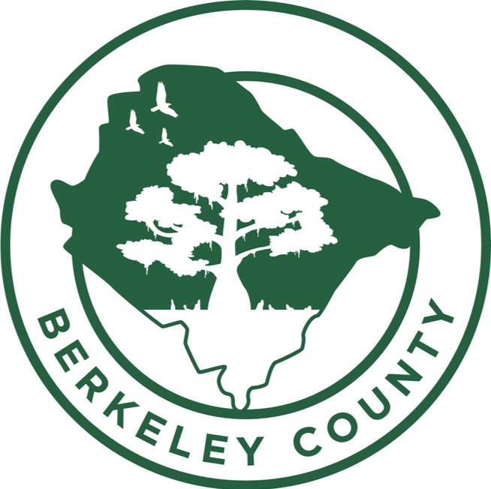
BERKELEY COUNTY
CONSOLIDATED PLAN
2021-2025
Final Draft

Table of Contents
Executive Summary 5
ES-05 Executive Summary - 24 CFR 91.200(c), 91.220(b) 5
The Process 10
PR-05 Lead & Responsible Agencies 24 CFR 91.200(b) 10
PR-10 Consultation – 91.100, 91.110, 91.200(b), 91.300(b), 91.215(I) and 91.315(I) 11
PR-15 Citizen Participation – 91.105, 91.115, 91.200(c) and 91.300(c) 20
Needs Assessment 27
NA-05 Overview 27
NA-10 Housing Needs Assessment - 24 CFR 91.205 (a,b,c) 29
NA-15 Disproportionately Greater Need: Housing Problems – 91.205 (b)(2) 45
NA-20 Disproportionately Greater Need: Severe Housing Problems – 91.205 (b)(2) 49
NA-25 Disproportionately Greater Need: Housing Cost Burdens – 91.205 (b)(2) 53
NA-30 Disproportionately Greater Need: Discussion – 91.205(b)(2) 55
NA-35 Public Housing – 91.205(b) 58
NA-40 Homeless Needs Assessment – 91.205(c) 62
NA-45 Non-Homeless Special Needs Assessment - 91.205 (b,d) 66
NA-50 Non-Housing Community Development Needs – 91.215 (f) 68
Housing Market Analysis 69
MA-05 Overview 69
MA-10 Number of Housing Units – 91.210(a)&(b)(2) 70
MA-15 Housing Market Analysis: Cost of Housing - 91.210(a) 76
MA-20 Housing Market Analysis: Condition of Housing – 91.210(a) 81
MA-25 Public and Assisted Housing – 91.210(b) 88
MA-30 Homeless Facilities and Services – 91.210(c) 91
MA-35 Special Needs Facilities and Services – 91.210(d) 93
MA-40 Barriers to Affordable Housing – 91.210(e) 96
MA-45 Non-Housing Community Development Assets – 91.215 (f) 97
MA-50 Needs and Market Analysis Discussion 108
MA-60 Broadband Needs of Housing occupied by Low- and Moderate-Income Households - 91.210(a)(4), 91.310(a)(2) 111
MA-65 Hazard Mitigation - 91.210(a)(5), 91.310(a)(3) 115
Strategic Plan 116
SP-05 Overview 116
SP-10 Geographic Priorities – 91.215 (a)(1) 117
SP-25 Priority Needs - 91.215(a)(2) 120
SP-30 Influence of Market Conditions – 91.215 (b) 122
SP-35 Anticipated Resources - 91.215(a)(4), 91.220(c)(1,2) 123
SP-40 Institutional Delivery Structure – 91.215(k) 125
SP-45 Goals Summary – 91.215(a)(4) 128
SP-50 Public Housing Accessibility and Involvement – 91.215(c) 130
SP-55 Barriers to affordable housing – 91.215(h) 131
SP-60 Homelessness Strategy – 91.215(d) 133
SP-65 Lead based paint Hazards – 91.215(i) 135
SP-70 Anti-Poverty Strategy – 91.215(j) 137
SP-80 Monitoring – 91.230 138
Expected Resources 140
AP-15 Expected Resources – 91.220(c)(1,2) 140
Annual Goals and Objectives 143
AP-20 Annual Goals and Objectives 143
Projects 144
AP-35 Projects – 91.220(d) 144
AP-38 Project Summary 145
AP-50 Geographic Distribution – 91.220(f) 149
Affordable Housing 150
AP-55 Affordable Housing – 91.220(g) 150
AP-60 Public Housing – 91.220(h) 151
AP-65 Homeless and Other Special Needs Activities – 91.220(i) 152
AP-75 Barriers to affordable housing – 91.220(j) 155
AP-85 Other Actions – 91.220(k) 157
Program Specific Requirements 159
AP-90 Program Specific Requirements – 91.220(l)(1,2,4) 159

Executive Summary

ES-05 Executive Summary - 24 CFR 91.200(c), 91.220(b)
1. Introduction
Berkeley County strives to provide safe, decent, and affordable housing; a suitable living environment; and economic opportunities – especially for low- to moderate-income households and special needs communities. In 2021, the County became a U.S. Department of Housing and Urban Development (HUD) entitlement community, enabling it to be eligible for federal funds allocated through HUD’s Community Planning Development program. The County’s Grants Administration Department administers the federal HUD Community Development Block (CDBG) grant funds and ensures compliance of HUD regulations and guidelines. Partnerships with neighborhood nonprofit organizations and other local agencies and municipalities allow the County to improve quality of life for its citizens.
Berkeley County is located in southeast South Carolina nearby the Atlantic coast. As of 2019, the County has a population of 205,044. The County has been experiencing a population growth for the last several decades and saw a 43.7% increase from 2000 to 2019 (142,651 to 205,044). To help ensure that Berkeley County has healthy growth, the following Consolidated Plan will help assist the County in identifying the priority needs of its citizens and developing goals to address these needs.
Minor Amendment: The County was notified by HUD on May 17, 2021 that there was an error in the PY 2021 CDBG allocation. The allocation was revised from $1,209,927 to the new amount of $1,227,757 which was an increase of $17,830. The additional funds were added to the admin project, which does not exceed the 20% admin cap.
2. Summary of the objectives and outcomes identified in the Plan Needs Assessment Overview
Berkeley County developed its strategic plan based on an analysis of the data presented in this plan and the community participation and stakeholder consultation process. Through these efforts, the County has identified three priority needs and associated goals to address those needs. The priority needs are:
- Expand & Improve Public Facilities
- Reduce Slum & Blight in Residential Areas
- Public Services & Quality of Life Improvements
To provide for those needs, the goals for the next five years are as follows:
- 1A Improve Access to Public Facilities
- 2A Reduce Slum & Blight in Residential Areas
- 3A Provide Supportive Services for Special Needs Populations
- 3B Provide Vital Services for LMI Households
- 3C Provide for Improvements to Owner-occupied Housing
3. Evaluation of past performance
In 2020, Berkeley County accepted Urban County status as an entitlement community designated by HUD and began program evaluations starting with the first program year of the Consolidated Plan. Prior to this plan, the County followed its 5-Year Comprehensive Plan. In 2015, the Comprehensive Plan was reviewed, approved, and adopted by the County Council. After a review of the County’s Comprehensive Plan, it was deemed that there were five guiding principles the County was to adhere to. They were:
1. Berkeley County will protect and promote the existence of distinctive and diverse, sustainable communities within its boundaries.
2. Berkeley County will manage development and expansion of infrastructure systems efficiently in order to effectively serve residents and employees within Berkeley County.
3. Berkeley County will respect and enhance historic, cultural, and natural resources, while providing expanded public access to them.
4. Berkeley County will adopt a clear, fair plan that can be implemented through simplified costs and streamlined processes.
5. Berkeley County will encourage public participation in achieving goals to ensure that all communities have a voice.
These guiding principles remain and helped to influence the priority needs and goals of the Consolidated Plan.
4. Summary of citizen participation process and consultation process
Berkeley County believes that a wide-reaching effort for citizen participation and consultation in the County’s CDBG program is vital to its success. The County continues to work with key nonprofit organizations for consultation of the plan, and to encourage the participation of the citizens they serve, including low- and moderate-income residents who are the primary targets of their CDBG funded programs.
The County presented information on the CDBG grant program and the Consolidated Plan at a series of community needs meetings. CDBG basic concepts and planning considerations were covered, along with questions, answer and feedback from stakeholders and citizens. Citizen comments and questions are encouraged at all public meetings and hearings. A public review period of 30-days was advertised and opened for the public to give comments on the plan. Furthermore, the County opened a community survey online for the public, stakeholders and for community organizations to give feedback on the priority needs of the community.
A summary of citizen outreach efforts is described below:
- A stakeholder meeting was held on March 14, 2019, at 10:00-11:30AM at the Berkeley County Admin Building at Room 106B. It was attended by 13 community organizations or agencies. Members were given the opportunity to take a survey to help determine the priority needs of the community.
- A stakeholder survey was opened on March 14, 2019, to give stakeholders and community organizations an opportunity to help determine issues and priority needs of the community.
- A community survey was opened on March 14, 2019, to give members of the public an opportunity to help determine the priority needs of the community.
- Community Needs Meeting at: Goose Creek Library, 325 Old Moncks Corner Road, Goose Creek, SC 29445 at March 18, 2019, from 6:00-7:30PM
- Community Needs Meeting at: St. Stephen Library, 113 Ravenell Drive, Saint Stephen, SC 29479 on March 19, 2019, from 6:00-7:30PM.
- Community Needs Meeting at: Hanahan Library, 1216 Old Murray Court, Hanahan, SC 29410 on March 21, 2019, from 6:00-7:30PM.
- Community Needs Meeting at: Sangaree Library, 595 Sangaree Parkway, Summerville, SC 29486 on March 28, 2019, from 6:00-7:30PM.
- Community Needs Meeting at: Moncks Corner Library, 1003 Highway 52, Moncks Corner, SC 29461 on April 1, 2019, from 6:00-7:30PM.
- Community Needs Meeting at: Cainhoy Elementary School Multi-Purpose Room, 2442 Cainhoy Rd., Huger, SC 29450 on April 2, 2019, from 6:00-7:30PM.
- Community Services Committee Meeting at: Berkeley County Administration Building Assembly Room, 1003 Highway 52, Moncks Corner, SC 29461 on May 13, 2019, at 6:00PM.
2021 Citizen Participation
The County held a 30-day public comment period from April 1, 2020 to April 30, 2021 to give members from the public an opportunity to review and make comments on the draft Consolidated Plan. The plan was available on the County website and at the County Administrative Building. Comments could be submitted online at the County website or emailed to cecilia.anthony@berkeleycounty.gov. Details of the public comment period has been uploaded to the AD-25.
A public hearing was held to discuss the plan on April 22, 2021 at 5:00-6:00PM at the County Administrative Building in Room 125.
Minor Amendment:
The County was notified by HUD on May 17, 2021 that there was an error in the PY 2021 CDBG allocation. The allocation was revised from $1,209,927 to the new amount of $1,227,757 which was an increase of $17,830. The additional funds were added to the admin project, which does not exceed the 20% admin cap. This minor modification to the funding did not trigger a substantial amendment and therefore did not require going back out for public comment.
5. Summary of public comments
A summary of comments is found in PR-15 Citizen Participation.
6. Summary of comments or views not accepted and the reasons for not accepting them
All comments were accepted.
7. Summary
The priority needs of the County were identified through a comprehensive citizen participation outreach effort which included a series of community needs assessment meetings held throughout the County; a community survey that was offered online and in paper form to allow for rural citizen input; a stakeholder survey for community nonprofit organizations; consultation by nonprofit partners and regional service partners such as the South Carolina Regional Housing Authority No. 3 (PHA) and the Lowcountry Homeless Coalition Continuum of Care (COC); and finally a review of the needs assessment and housing market analysis in this plan.
Primary data sources for the Consolidated Plan include: 2000 Census, 2015-2019 American Community Survey (ACS) 5-Year Estimates, 2013-2017 Comprehensive Housing Affordability Strategy (CHAS) data, Longitudinal Employer-Household Dynamics (LEHD), Homeless Management Information System (HMIS), Inventory Management System/PIH Information Center (PIC), HUD Income Limits, HUD Fair Market Rents and HOME Rent Limits and other local data sources. Data for map analysis came from the 2015-2019 ACS.
A disparity exists between data tables throughout the plan in that tables which utilize ACS contain 2015-2019 data and tables that utilize CHAS contain 2017 data. At the time of writing only 2013-2017 CHAS data was available from HUD. However, 2015-2019 ACS data was available, and thus the County thought it best to utilize the most current data source where possible. Incongruencies in the source years were outweighed by the more accurate demographic and housing picture painted by the most recent ACS data.

The Process

PR-05 Lead & Responsible Agencies 24 CFR 91.200(b)
1. Describe agency/entity responsible for preparing the Consolidated Plan and those responsible for administration of each grant program and funding source
The following are the agencies/entities responsible for preparing the Consolidated Plan and those responsible for administration of each grant program and funding source.
Agency Role | Name | Department/Agency

CDBG Administrator | BERKELEY COUNTY | Grants Administration Department
Table 1 – Responsible Agencies

Narrative
Berkeley County is an Entitlement Jurisdiction and receives federal HUD CDBG funds. The Grants Administration Department administers CDBG funds in Berkeley County.
Consolidated Plan Public Contact Information
Cecilia Anthony, CDBG Grants Specialist
Berkeley County
P. O. Box 6122
Moncks Corner, South Carolina 29461
T: 843-719-4766
cecilia.anthony@berkeleycountysc.gov

PR-10 Consultation – 91.100, 91.110, 91.200(b), 91.300(b), 91.215(I) and 91.315(I)
1. Introduction
Berkeley County is engaged in ongoing efforts to increase coordination among the public, private, and non-profit organizations that deliver housing and community development services to the community. As the administrator of HUD's CDBG program, the County's Grants Administration Department acts as a central point of contact for coordinating combined efforts of housing and community and economic development in the area. Open lines of communication are maintained between the County and the area's nonprofit and social service agencies.
Provide a concise summary of the jurisdiction’s activities to enhance coordination between public and assisted housing providers and private and governmental health, mental health and service agencies (91.215(I)).
The County is engaged in several efforts and initiatives to enhance coordination among the community's network of providers and service frameworks. A variety of organizations, both public and private, that provide vital services were contacted and participated in the stakeholder survey. Included in this outreach was organizations that serve special needs populations such as services to children, elderly residents, and fair housing providers. The consultation with these groups helped determine how County resources and investments will be directed.
Describe coordination with the Continuum of Care and efforts to address the needs of homeless persons (particularly chronically homeless individuals and families, families with children, veterans, and unaccompanied youth) and persons at risk of homelessness
The Lowcountry Continuum of Care (COC) plans, develops, and implements comprehensive and coordinated strategies to address homelessness in Beaufort, Berkeley, Charleston, Colleton, Dorchester, Hampton, and Jasper Counties in South Carolina. The Lowcountry COC has focused on expanding access points into the Coordinated Entry System (CES)—a process designed to efficiently facilitate connecting persons experiencing homelessness to available housing resources. These steps include coordinating participant intake, assessment, provision of referrals, and placement into housing. When implemented correctly, CES allows communities to move beyond a traditional “first come, first served” approach to one that looks across the COC to serve those most in need of assistance.
Describe consultation with the Continuum(s) of Care that serves the jurisdiction's area in determining how to allocate ESG funds, develop performance standards and evaluate outcomes, and develop funding, policies and procedures for the administration of HMIS
Not applicable.
2. Describe Agencies, groups, organizations and others who participated in the process and describe the jurisdictions consultations with housing, social service agencies and other entities

Table 2 – Agencies, groups, organizations who participated
1 | Agency/Group/Organization | BERKELEY COUNTY
1 | Agency/Group/Organization Type | Other government - County
1 | What section of the Plan was addressed by Consultation? | Housing Need Assessment  Economic Development  Market Analysis  Quality of Life Improvements
1 | How was the Agency/Group/Organization consulted and what are the anticipated outcomes of the consultation or areas for improved coordination? | Berkeley County is the lead organization for the Consolidated Plan.
2 | Agency/Group/Organization | South Carolina Regional Housing Authority No. 3
2 | Agency/Group/Organization Type | Housing  PHA  Services - Housing
2 | What section of the Plan was addressed by Consultation? | Public Housing Needs
2 | How was the Agency/Group/Organization consulted and what are the anticipated outcomes of the consultation or areas for improved coordination? | South Carolina Regional Housing Authority No. 3 is the local public housing authority. The PHA consulted through the stakeholder survey to help identify the local community needs.
3 | Agency/Group/Organization | Lowcountry Homeless Coalition dba Crisis Ministries, Inc.
3 | Agency/Group/Organization Type | Services-homeless  Regional organization  Planning organization  Continuum of Care
3 | What section of the Plan was addressed by Consultation? | Homelessness Strategy  Homeless Needs - Chronically homeless  Homeless Needs - Families with children  Homelessness Needs - Veterans  Homelessness Needs - Unaccompanied youth
3 | How was the Agency/Group/Organization consulted and what are the anticipated outcomes of the consultation or areas for improved coordination? | Lowcountry Homeless Coalition is the local Continuum of Care. Lowcountry Homeless Coalition provided a housing needs assessment and homeless services of the community through a stakeholder survey.
4 | Agency/Group/Organization | Changed Lives Ministry
4 | Agency/Group/Organization Type | Services-homeless  Nonprofit
4 | What section of the Plan was addressed by Consultation? | Housing Need Assessment  Homelessness Strategy  Quality of Life Improvements
4 | How was the Agency/Group/Organization consulted and what are the anticipated outcomes of the consultation or areas for improved coordination? | Changed Lives Ministry provided housing needs assessment of the community through a stakeholder survey.
5 | Agency/Group/Organization | Hope Repair
5 | Agency/Group/Organization Type | Nonprofit
5 | What section of the Plan was addressed by Consultation? | Housing Need Assessment  Quality of Life Improvements
5 | How was the Agency/Group/Organization consulted and what are the anticipated outcomes of the consultation or areas for improved coordination? | Hope Repair provided a needs assessment and quality of life improvements of the community through a stakeholder survey.
6 | Agency/Group/Organization | Alvin Recreational League Inc.
6 | Agency/Group/Organization Type | Services-Children
6 | What section of the Plan was addressed by Consultation? | Housing Need Assessment  Non-Homeless Special Needs  Quality of Life Improvements
6 | How was the Agency/Group/Organization consulted and what are the anticipated outcomes of the consultation or areas for improved coordination? | Alvin Recreational League Inc. provided quality of life improvements of the community through a stakeholder survey.
7 | Agency/Group/Organization | Operation Home
7 | Agency/Group/Organization Type | Housing  Services - Housing  Nonprofit
7 | What section of the Plan was addressed by Consultation? | Housing Need Assessment  Quality of Life Improvements
7 | How was the Agency/Group/Organization consulted and what are the anticipated outcomes of the consultation or areas for improved coordination? | Operation Home provided a needs assessment and quality of life improvements of the community through a stakeholder survey.
8 | Agency/Group/Organization | City of Goose Creek
8 | Agency/Group/Organization Type | Other government - Local
8 | What section of the Plan was addressed by Consultation? | Housing Need Assessment  Quality of Life Improvements
8 | How was the Agency/Group/Organization consulted and what are the anticipated outcomes of the consultation or areas for improved coordination? | City of Goose Creek provided a needs assessment and quality of life improvements of the community through a stakeholder survey.
9 | Agency/Group/Organization | East Cooper Community Outreach
9 | Agency/Group/Organization Type | Services-Health  Nonprofit
9 | What section of the Plan was addressed by Consultation? | Housing Need Assessment  Quality of Life Improvements
9 | How was the Agency/Group/Organization consulted and what are the anticipated outcomes of the consultation or areas for improved coordination? | East Cooper Community Outreach provided a needs assessment and quality of life improvements of the community through a stakeholder survey.
10 | Agency/Group/Organization | TOWN OF ST. STEPHEN
10 | Agency/Group/Organization Type | Other government - Local
10 | What section of the Plan was addressed by Consultation? | Housing Need Assessment  Quality of Life Improvements
10 | How was the Agency/Group/Organization consulted and what are the anticipated outcomes of the consultation or areas for improved coordination? | The Town of St. Stephen participated in the multi-jurisdiction roundtable and offered input on needs for the town.
11 | Agency/Group/Organization | TOWN OF JAMESTOWN
11 | Agency/Group/Organization Type | Other government - Local
11 | What section of the Plan was addressed by Consultation? | Housing Need Assessment  Quality of Life Improvements
11 | How was the Agency/Group/Organization consulted and what are the anticipated outcomes of the consultation or areas for improved coordination? | The Town of Jamestown participated in the multi-jurisdiction roundtable and offered input on needs for the town.
12 | Agency/Group/Organization | City of Hanahan
12 | Agency/Group/Organization Type | Other government - Local
12 | What section of the Plan was addressed by Consultation? | Housing Need Assessment  Quality of Life Improvements
12 | How was the Agency/Group/Organization consulted and what are the anticipated outcomes of the consultation or areas for improved coordination? | The City of Hanahan participated in the multi-jurisdiction roundtable and offered input on needs for the city.
13 | Agency/Group/Organization | TOWN OF MONCKS CORNER
13 | Agency/Group/Organization Type | Other government - Local
13 | What section of the Plan was addressed by Consultation? | Housing Need Assessment  Quality of Life Improvements
13 | How was the Agency/Group/Organization consulted and what are the anticipated outcomes of the consultation or areas for improved coordination? | The Town of Moncks Corner participated in the multi-jurisdiction roundtable and offered input on needs for the town.
14 | Agency/Group/Organization | South Carolina Association for Community Economic Development
14 | Agency/Group/Organization Type | Nonprofit
14 | What section of the Plan was addressed by Consultation? | Housing Need Assessment  Economic Development  Workforce Development
14 | How was the Agency/Group/Organization consulted and what are the anticipated outcomes of the consultation or areas for improved coordination? | County staff met with SCACED to identify opportunities to meet rural resident needs for higher paying jobs, transportation and affordable housing. SCACED will assist the County to develop capacity to meet the needs of this population.
15 | Agency/Group/Organization | BEGIN (Berkeley Economic Growth Impact Network)
15 | Agency/Group/Organization Type | Nonprofit
15 | What section of the Plan was addressed by Consultation? | Housing Need Assessment  Economic Development  Workforce Development, Quality of Life
15 | How was the Agency/Group/Organization consulted and what are the anticipated outcomes of the consultation or areas for improved coordination? | County staff met with members of BEGIN to identify opportunities to meet rural resident needs for jobs, transportation and affordable housing.
16 | Agency/Group/Organization | Berkeley County School District
16 | Agency/Group/Organization Type | Services-Education  Other government - County
16 | What section of the Plan was addressed by Consultation? | Homelessness Strategy  Quality of Life
16 | How was the Agency/Group/Organization consulted and what are the anticipated outcomes of the consultation or areas for improved coordination? | The Berkeley County School District was consulted through a roundtable work group designed to address substance abuse, mental health challenges and homelessness in Berkeley County.
17 | Agency/Group/Organization | Berkeley Community Mental Health Center
17 | Agency/Group/Organization Type | Health Agency  Other government - State
17 | What section of the Plan was addressed by Consultation? | Homelessness Strategy  Quality of Life
17 | How was the Agency/Group/Organization consulted and what are the anticipated outcomes of the consultation or areas for improved coordination? | The Mental Health Center was consulted through a roundtable work group designed to address substance abuse, mental health challenges and homelessness in Berkeley County.
18 | Agency/Group/Organization | BroadandNow
18 | Agency/Group/Organization Type | Services - Narrowing the Digital Divide  Broadband Access
18 | What section of the Plan was addressed by Consultation? | Housing Need Assessment  Quality of Life Improvements
18 | How was the Agency/Group/Organization consulted and what are the anticipated outcomes of the consultation or areas for improved coordination? | BroadbandNow collects and maintains internet coverage for all US internet providers. BroadbandNow is also focused on bringing awareness to the digital divide and bringing awareness to the issue. Its belief is that broadband internet should be available to all Americans.
19 | Agency/Group/Organization | TOWN OF BONNEAU
19 | Agency/Group/Organization Type | Other government - Local
19 | What section of the Plan was addressed by Consultation? | Housing Need Assessment  Quality of Life Improvements
19 | How was the Agency/Group/Organization consulted and what are the anticipated outcomes of the consultation or areas for improved coordination? | The Town of Bonneau participated in the multi-jurisdiction roundtable and offered input on needs for the town.

Identify any Agency Types not consulted and provide rationale for not consulting
Not applicable. There were no agency types intentionally not consulted. All comments were welcome.
Other local/regional/state/federal planning efforts considered when preparing the Plan
Name of Plan | Lead Organization | How do the goals of your Strategic Plan overlap with the goals of each plan?
Continuum of Care | Lowcountry Homeless Coalition | As the area's Continuum of Care, Lowcountry Homeless Coalition works to prevent and mitigate the effects of homelessness throughout Berkeley County and the low country region. The goals of the COC directly overlap with the County's homelessness efforts.
Table 3 – Other local / regional / federal planning efforts

Describe cooperation and coordination with other public entities, including the State and any adjacent units of general local government, in the implementation of the Consolidated Plan (91.215(l))
Berkeley County’s Urban County is partnered with 6 participating localities – the Cities of Goose Creek and Hanahan and the Towns of Bonneau, Jamestown, Moncks Corner, and St. Stephen. The County Supervisor and County Council have worked closely with the mayors and councils of these localities in planning for CDBG entitlement. The County has also worked closely with the Berkeley-Charleston-Dorchester Council of Governments (BCDCOG). BCDCOG has long worked with the County on CDBG projects awarded by the State of South Carolina, and BCDCOG assists in the development of the County’s Comprehensive Plan.

PR-15 Citizen Participation – 91.105, 91.115, 91.200(c) and 91.300(c)
1. Summary of citizen participation process/Efforts made to broaden citizen participation
Summarize citizen participation process and how it impacted goal-setting
The purpose of the citizen participation process is to actively encourage citizens, particularly low- and moderate-income households, to participate in the planning of the Consolidated Plan, the Annual Action Plan (AAP), the development of the Consolidated Annual Performance Evaluation Report (CAPER) and any required submission of substantial amendments to those plans. Berkeley County works to ensure community stakeholders and County citizens have adequate opportunities to participate in this planning process.
The County's efforts to allow for participation include an online stakeholder survey for neighborhood organizations and a community survey to gather input on the highest needs in the community. A series of six Community Needs Meetings held throughout the County at various public libraries was held to present information on the CDBG grant program and the Consolidated Plan. In these meetings CDBG basic concepts and planning considerations were covered, along with questions, answer and feedback from stakeholders and citizens.
2021 Citizen Participation
The County held a 30-day public comment period from April 1, 2020 to April 30, 2021 to give members from the public an opportunity to review and make comments on the draft Consolidated Plan. The plan was available on the County website and at the County Administrative Building. Comments could be submitted online at the County website or emailed to cecilia.anthony@berkeleycounty.gov. Details of the public comment period has been uploaded to the AD-25.
A public hearing was held to discuss the plan on April 22, 2021 at 5:00-6:00PM at the County Administrative Building in Room 125.
A summary of citizen outreach efforts is described in the table below:
Minor Amendment: The County was notified by HUD on May 17, 2021 that there was an error in the PY 2021 CDBG allocation. The allocation was revised from $1,209,927 to the new amount of $1,227,757 which was an increase of $17,830. The additional funds were added to the admin project, which does not exceed the 20% admin cap. This minor modification to the funding did not trigger a substantial amendment and therefore did not require going back out for public comment.
Citizen Participation Outreach
Sort  Order | Mode of  Outreach | Target of  Outreach | Summary of  response/attendance | Summary of  comments received | Summary of  comments not accepted and reasons | URL
1 | Stakeholder Meeting | Non-targeted/broad community  Community Stakeholders | A stakeholder meeting was held on March 14, 2019, from 10:00-11:30 AM at the Berkeley County Admin Building at Room 106B. It was attended by 13 members from 9 community organizations or agencies. Members were given the opportunity to take a survey to help determine the priority needs of the community. | Comments were received via a stakeholder survey, where stakeholders responded the highest needs in the County were safe and decent housing, services such an employment training and homeless prevention and infrastructure improvements. Stakeholder survey results are uploaded into the AD-25 citizen participation link. | All comments were accepted.
2 | Stakeholder Meeting | Community Stakeholders | A stakeholder survey was opened on March 14, 2019, to give stakeholders and community organizations an opportunity to help determine issues and priority needs of the community.  https://www.surveymonkey.com/r/  berkeleycountystakeholdersurvey | Comments were received via a stakeholder survey, where stakeholders responded the highest needs in the County were safe and decent housing, services such an employment training and homeless prevention and infrastructure improvements. Stakeholder survey results are uploaded into the AD-25 citizen participation link. | All comments were accepted
3 | Stakeholder Meeting | Non-targeted/broad community | A community survey was opened on March 14, 2019, to give members of the public an opportunity to help determine the priority needs of the community.  https://www.surveymonkey.com/r/  berkeleycountycommunitysurvey | The community survey was responded by over 680 members from the public with the highest needs in the County as:  - Public improvements  - Housing programs  - Public services  - Demolition and clearance  Community survey results are uploaded into the AD-25 citizen participation link. | All comments were accepted.
4 | Public Meeting | Non-targeted/broad community | Community Needs Meeting at: Goose Creek Library, 325 Old Moncks Corner Road, Goose Creek, SC 29445 on March 18, 2019, from 6:00-7:30 PM. This meeting was one of six community needs meetings conducted by Berkeley County. The County presented information on the CDBG grant program and the Consolidated Plan. CDBG basic concepts and planning considerations were covered, along with questions, answer and feedback from stakeholders and citizens. | At the public meeting a list of community needs emerged and are listed below:  - Homeless needs  - Opportunity Zones  - Desire for rural area focus | All comments were accepted.
5 | Public Meeting | Non-targeted/broad community | Community Needs Meeting at: St. Stephen Library, 113 Ravenell Drive, St. Stephen, SC 29479 on March 19, 2019, from 6:00-7:30 PM. This meeting was one of six community needs meetings conducted by Berkeley County. The County presented information on the CDBG grant program and the Consolidated Plan. CDBG basic concepts and planning considerations were covered, along with questions, answer and feedback from stakeholders and citizens. | At the public hearing a list of community needs emerged and are listed below:  - Community center  - Job training  - Economic development  - Slum and blight removal  - Desire for rural area focus  - Potable water/sanitary sewer | All comments were accepted.
6 | Public Meeting | Non-targeted/broad community | Community Needs Meeting at: Hanahan Library, 1216 Old Murray Court, Hanahan, SC 29410 on March 21, 2019, from 6:00-7:30 PM. This meeting was one of six community needs meetings conducted by Berkeley County. The County presented information on the CDBG grant program and the Consolidated Plan. CDBG basic concepts and planning considerations were covered, along with questions, answer and feedback from stakeholders and citizens. | At the public meeting a list of community needs emerged and are listed below:  - ADA improvements  - Quality of life improvements | All comments were accepted.
7 | Public Meeting | Non-targeted/broad community | Community Needs Meeting at: Sangaree Library, 595 Sangaree Parkway, Summerville, SC 29486 on March 28, 2019, from 6:00-7:30 PM. This meeting was one of six community needs meetings conducted by Berkeley County. The County presented information on the CDBG grant program and the Consolidated Plan. CDBG basic concepts and planning considerations were covered, along with questions, answer and feedback from stakeholders and citizens. | At the public meeting a list of community needs emerged and are listed below:  - Senior center & programs  - Park/playground for LMI-  Slum and blight removal  - Public safety | All comments were accepted.
8 | Public Meeting | Non-targeted/broad community | Community Needs Meeting at: Moncks Corner Library, 1003 Highway 52, Moncks Corner, SC 29461 on April 1, 2019, from 6:00-7:30 PM. This meeting was one of six community needs meetings conducted by Berkeley County. The County presented information on the CDBG grant program and the Consolidated Plan. CDBG basic concepts and planning considerations were covered, along with questions, answer and feedback from stakeholders and citizens. | At the public meeting a list of community needs emerged and are listed below:  - Public transportation  - Home improvements  - Public services | All comments were accepted.
9 | Public Meeting | Non-targeted/broad community | Community Needs Meeting at: Cainhoy Elementary School Multipurpose Room, 2442 Cainhoy Rd., Huger, SC 29450 on April 2, 2019, from 6:00-7:30 PM. This meeting was one of six community needs meetings conducted by Berkeley County. The County presented information on the CDBG grant program and the Consolidated Plan. CDBG basic concepts and planning considerations were covered, along with questions, answer and feedback from stakeholders and citizens. | At the public meeting a list of community needs emerged and are listed below:  - Road improvement  - Desire for rural area focus  - Potable water/sanitary sewer improvements  - Public safety  - Home improvements | All comments were accepted.
10 | Public Meeting | Non-targeted/broad community | A presentation of the Con Plan was given at the Community Services Committee Meeting on May 9, 2019. | No public comments received. | All comments were accepted.
11 | Stakeholder Meeting | Non-targeted/broad community | The County held a 30-day public comment period from April 1, 2020 to April 30, 2021 to give members from the public an opportunity to review and make comments on the draft Consolidated Plan. The plan was available on the County website and at the County Administrative Building. Comments could be submitted online at the County website (www.berkeleycountysc.gov) or emailed to cecilia.anthony@berkeleycounty.gov. | No public comments received. | All comments were accepted.
12 | Public Hearing | Non-targeted/broad community | A public hearing was held to discuss the plan on April 22, 2021 at 5:00-6:00PM at the County Administrative Building in Room 125, located at 1003 Highway 52, Moncks Corner, SC 29461. Citizens requiring more information could call the CDBG Grants Specialist at (843) 719-4766. | No public comments received. | All comments were accepted.
Table 4 – Citizen Participation Outreach

Needs Assessment

NA-05 Overview
Needs Assessment Overview
This section assesses the housing needs in Berkeley County by analyzing various demographic and economic indicators. Developing a picture of the current needs in the community begins by looking at broad trends in population, area median income, the number of households, etc. The next step is intersecting those data points with a more nuanced analysis of variables such as family and household dynamics, race, and housing problems.
A key goal of the Needs Assessment is to identify the nature and prevalence of housing problems experienced by the County’s citizens. The main housing problems assessed are: (a) cost-burdened households; (b) substandard housing; and (c) overcrowding. Furthermore, these housing problems are juxtaposed with economic and demographic indicators to discern if certain groups carry a disproportionate burden. Are African Americans more cost-burdened than other racial groups? Do low-income households experience higher levels of overcrowding? Do large families have more housing problems than small families? These sorts of questions are empirically answered through data analysis. Understanding the magnitude and incidence of housing problems in the community is crucial in aiding the County in setting evidence-based priorities for the CDBG program.
American Community Survey data shows that there are households living in substandard housing with incomplete plumbing or kitchen facilities, in overcrowded or severely overcrowded conditions. However, these housing problems are far less common than cost burden and severe cost burden. Low income households and those living on fixed incomes, including the elderly and disabled, are particularly vulnerable to the rise in housing costs. The frequency with which housing problems affects Berkeley County residents:
- 56% of low- to moderate-income households (0-80% Area Median Income) have one or more housing problems (16,785 of 29,910 LMI households)
- 27.6% of all County households have housing cost burden of greater than 30% of income
- 50.1% of LMI households are housing cost burdened
An assessment of affordable housing needs identified the following as priority:
- Expand & Improve Public Facilities
- Reduce Slum & Blight in Residential Areas
- Public Services & Quality of Life Improvements
An assessment of public facility needs identified the following as priority:
- Multi-Purpose Community Centers
- Parks & Recreational Facilities
- Fire Stations
An assessment of infrastructure needs identified the following as priority:
- Street Improvement
- Potable Water/Sanitary Sewer
- Neighborhood Cleanup
A public service needs assessment identified the following as priority:
- Youth Services/Activities
- Anti-Crime Programs
- Senior Services/Activities
The area’s public housing, homeless, and non-homeless special housing needs are also discussed. Finally, non-housing community development needs, such as public services, are considered.

NA-10 Housing Needs Assessment - 24 CFR 91.205 (a,b,c)
Summary of Housing Needs
On the surface, determining the housing needs of a community is simply a matter of supply and demand. However, determining how different factors impact supply and demand is a more difficult task. One key factor is population change, as populations grow there is greater demand for homes, which will drive up costs if new construction doesn’t keep pace. Berkeley County experienced a population growth of 27% between 2010 and 2019 with the population climbing from 169,878 to 215,044. The number of households in Berkeley County increased by the same amount, 27%, from 60,472 households to 76,881. Over the same period the Median Household Income increased by 25% from $50,777 to $63,309.
The data indicates that the region is experiencing significant growth. However, this growth exacerbates the housing barriers experienced by low income families throughout the region. While an increase in the median income is an overall positive indicator of economic growth, the increase in the median home value and rent has significantly outpaced income. This growth gap creates a distinct pressure point within the regional housing market making housing less affordable.
The chart below highlights demographic changes in population, number of households, and income between 2010 and 2019 for the County.
Demographics | Base Year: 2010 | Most Recent Year: 2019 | % Change
Population | 169,878 | 215,044 | 27%
Households | 60,472 | 76,881 | 27%
Median Income | $50,777.00 | $63,309.00 | 25%
Table 5 - Housing Needs Assessment Demographics

Alternate Data Source Name:
2006-2010 ACS, 2015-2019 ACS

Geo. Distro. of Demographic Trends
The following maps display the geographic distribution of demographic trends in the County across a few key indicators including population change, median household income, and poverty.
Population
The following map displays the population density throughout the County. Lighter colored tracts have less of a concentration of the population, while darker tracts have a higher population density. The central tracts of the County have the highest population density.
Source: 2015-2019 American Community Survey 5-Year Estimates
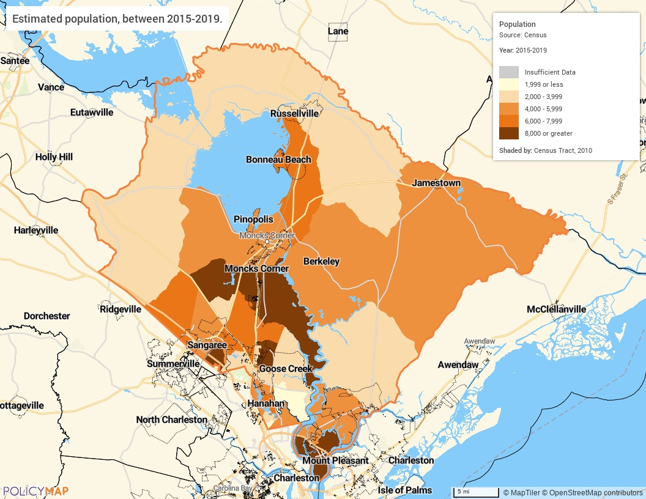
Population Map
Change in Population
The map below displays the population change throughout the County since 2000. The average population growth in the jurisdiction was 43%, but that growth is not evenly distributed throughout the area. Areas on the northern end of the county and near Joint Base Charleston saw a decrease in overall population, sometimes over 10%. As of 2015-2019, the total Berkeley County population was 215,044, which grew by 27% since 2010. The population growth rate was much higher than the state average rate of 11.3% and was much higher than the national average rate of 6.8%
Source: 2015-2019 American Community Survey 5-Year Estimates
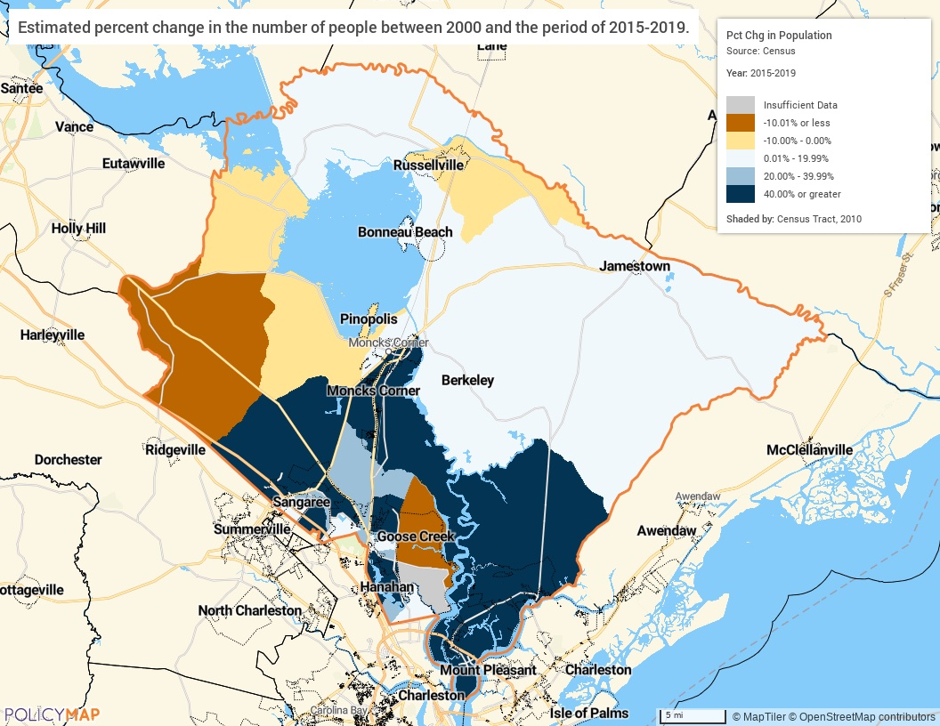
Population Growth
Median Household Income
The following map displays the median household income by census tract throughout the jurisdiction. In 2019, the median household income was $63,309 but the income varied considerably throughout the County. In general, unincorporated Summerville, Town of Moncks Corner, City of Goose Creek, and Daniel Island had median incomes over $60,000. Whereas Cross, Pineville, Russellville, Sangaree, Forty-One, Lebanon, Eadytown, St. Stephen, and parts of Goose Creek and Hanahan had a median household income of $59,999 or less annually.
Source: 2015-2019 American Community Survey 5-Year Estimates
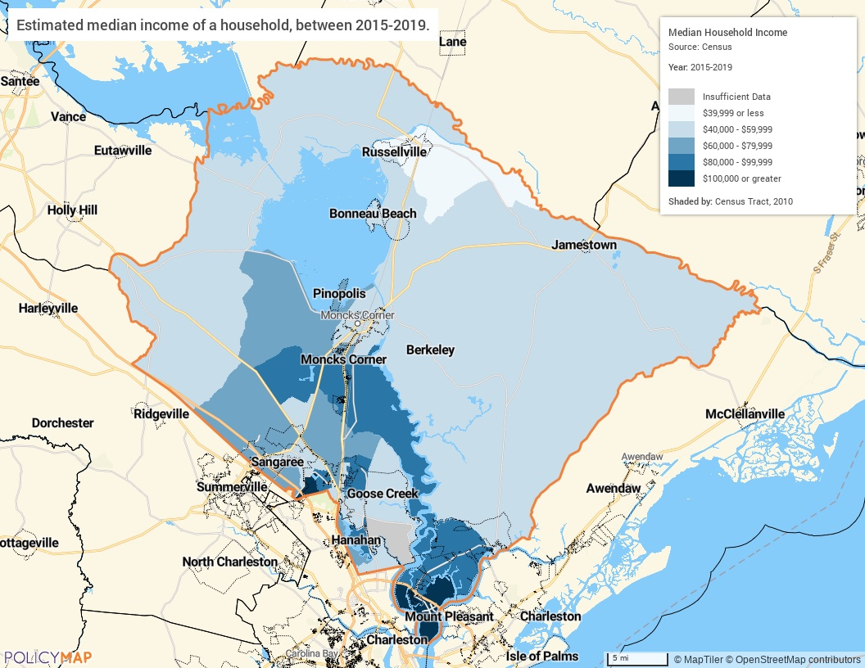
Median Household Income
Poverty
The following map displays the percentage of the population who live below the poverty level by census tract. Unsurprisingly, areas that have higher median income tend to have lower levels of poverty. The tracts in the south with higher median income and population growth have lower levels of poverty. Many rural census tracts to include the Town of St. Stephen, Russellville, Pineville, Lebanon, Eadytown, Pringletown, and Sandridge have 20% or more of their residents who live below the poverty line.
Source: 2015-2019 American Community Survey 5-Year Estimates
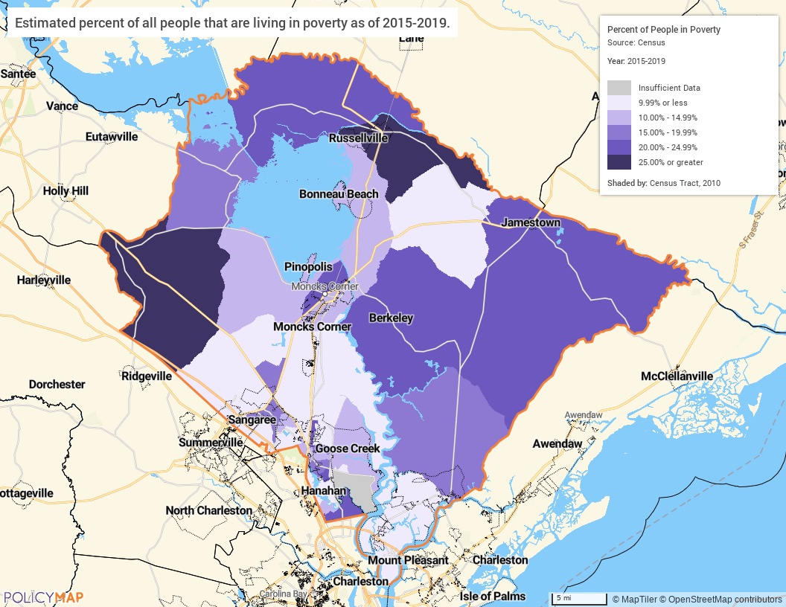
Poverty Level
Number of Households Table
 | 0-30% HAMFI | >30-50% HAMFI | >50-80% HAMFI | >80-100% HAMFI | >100% HAMFI
Total Households | 7,230 | 7,645 | 12,610 | 8,050 | 37,630
Small Family Households | 2,310 | 2,910 | 5,295 | 3,925 | 20,600
Large Family Households | 625 | 770 | 1,125 | 800 | 3,125
Household contains at least one person 62-74 years of age | 1,539 | 1,820 | 3,010 | 1,930 | 7,565
Household contains at least one person age 75 or older | 880 | 915 | 1,385 | 599 | 2,075
Households with one or more children 6 years old or younger | 1,610 | 1,925 | 2,305 | 1,525 | 5,769

Table 6 - Total Households Table

Alternate Data Source Name:
2013-2017 CHAS

Number Households
The above table breaks down family dynamics and income in the jurisdiction using 2017 CHAS data. Small families are much more prevalent, which follows the trend of smaller average household size in the region and the nation. When looking at households in the County by income level, there are a significant number of households in the County which are extremely low-income (0-30% HAMFI), with 7,230 households. Over 2,400 of these extremely low-income households have an elderly resident and 1,610 have one or more children 6 years old or younger. Another 4,660 (6.3%) of households with children under six or elderly person(s) have an income between 30% - 50% of the area median income.

Housing Needs Summary Tables
1. Housing Problems (Households with one of the listed needs)
 | Renter |  |  |  |  | Owner
 | 0-30% AMI | >30-50% AMI | >50-80% AMI | >80-100% AMI | Total | 0-30% AMI | >30-50% AMI | >50-80% AMI | >80-100% AMI | Total
NUMBER OF HOUSEHOLDS
Substandard Housing - Lacking complete plumbing or kitchen facilities | 30 | 10 | 65 | 35 | 140 | 35 | 25 | 10 | 10 | 80
Severely Overcrowded - With >1.51 people per room (and complete kitchen and plumbing) | 75 | 65 | 30 | 10 | 180 | 0 | 4 | 10 | 4 | 18
Overcrowded - With 1.01-1.5 people per room (and none of the above problems) | 115 | 215 | 230 | 30 | 590 | 20 | 50 | 145 | 10 | 225
Housing cost burden greater than 50% of income (and none of the above problems) | 2,275 | 1,295 | 445 | 25 | 4,040 | 1,845 | 1,175 | 775 | 170 | 3,965
Housing cost burden greater than 30% of income (and none of the above problems) | 225 | 1,090 | 2,225 | 560 | 4,100 | 540 | 875 | 2,220 | 1,160 | 4,795
Zero/negative Income (and none of the above problems) | 290 | 0 | 0 | 0 | 290 | 655 | 0 | 0 | 0 | 655
Table 7 – Housing Problems Table

Alternate Data Source Name:
2013-2017 CHAS

Housing Needs Summary
The table above gives an overview of housing problems in the County. Using 2017 CHAS data, it provides the numbers of households experiencing each category of housing problem broken down by income ranges (up to 100% AMI) and owner/renter status. For example, looking at the first data cell (top left) we see that 30 renter households in the jurisdiction made 30% or below the area median income (AMI) and lacked complete plumbing or kitchen facilities.
For both renters and homeowners:
- 220 households live in substandard housing – lacking complete plumbing or kitchen facilities
- 198 households live in severely overcrowded conditions (1.51 people per room) with kitchen and plumbing
- 815 households live in overcrowded conditions
- 8005 households have a cost burden of greater than 50% of household income
- 8,895households (11.8%) have a cost burden greater than 30% of household income
Cost burden is clearly the most common housing problem in the County in terms of sheer numbers – a common trend in many communities across the state and nation today. According to the 2017 CHAS data there were 8,140 renters and 8,760 homeowners in the 0% to 100% AMI range spending more than 30% of their income on housing costs (100% AMI is the area median income). The bigger picture is actually worse, however, because these figures do not include households that earn more than 100% of the median income – a distinction that will be further discussed in the cost burden section below.

2. Housing Problems 2 (Households with one or more Severe Housing Problems: Lacks kitchen or complete plumbing, severe overcrowding, severe cost burden)
 | Renter |  |  |  |  | Owner
 | 0-30% AMI | >30-50% AMI | >50-80% AMI | >80-100% AMI | Total | 0-30% AMI | >30-50% AMI | >50-80% AMI | >80-100% AMI | Total
NUMBER OF HOUSEHOLDS
Having 1 or more of four housing problems | 2,720 | 2,680 | 2,995 | 660 | 9,055 | 2,440 | 2,130 | 3,160 | 1,350 | 9,080
Having none of four housing problems | 560 | 785 | 1,885 | 1,760 | 4,990 | 560 | 2,055 | 4,575 | 4,280 | 11,470
Household has negative income, but none of the other housing problems | 290 | 0 | 0 | 0 | 290 | 655 | 0 | 0 | 0 | 655
Table 8 – Housing Problems 2

Alternate Data Source Name:
2013-2017 CHAS

Severe Housing Problems
The above table shows households with at least one severe housing problem broken out by income and occupancy. The trend in the data is simply the lower the income in a household, the greater presence of severe housing problems.
For both renters and homeowners:
- 18,135 or 51% of households have one or more housing problems that include substandard housing; overcrowding and/or cost burden.
- 16,460 have no housing problems.
- 845 households have negative income.

3. Cost Burden > 30%
 | Renter |  |  |  | Owner
 | 0-30% AMI | >30-50% AMI | >50-80% AMI | Total | 0-30% AMI | >30-50% AMI | >50-80% AMI | Total
NUMBER OF HOUSEHOLDS
Small Related | 1,225 | 1,135 | 1,380 | 3,740 | 815 | 835 | 1,175 | 2,825
Large Related | 355 | 260 | 235 | 850 | 210 | 240 | 220 | 670
Elderly | 260 | 240 | 110 | 610 | 875 | 490 | 455 | 1,820
Other | 1,005 | 820 | 940 | 2,765 | 820 | 265 | 720 | 1,805
Total need by income | 2,845 | 2,455 | 2,665 | 7,965 | 2,720 | 1,830 | 2,570 | 7,120
Table 9 – Cost Burden > 30%

Alternate Data Source Name:
2013-2017 CHAS

Cost Burden
The table above displays 2017 CHAS data on cost-burdened households in the County for the 0% to 80% AMI cohorts. HUD defines cost-burden as paying more than 30% monthly income on housing costs.
Housing Cost-Burden
The following maps below display the percentage of the population who are cost-burdened by census tract using data from the 2015-2019 American Community Survey 5-Year Estimates. Despite higher median household incomes in the County there are still high rates of cost burden, sometimes over 30% for homeowners and 50% for renters.
Overall, cost burdened households are located everywhere in Berkeley County, but the areas most impacted by housing costs are in rural communities like Eadytown, Pineville, Russellville, Forty-One, Longridge, and the Town of St. Stephen. Some census blocks in the Cities of Goose Creek and Hanahan also show a high cost burden for homeowners.
Source: 2015-2019 American Community Survey 5-Year Estimates
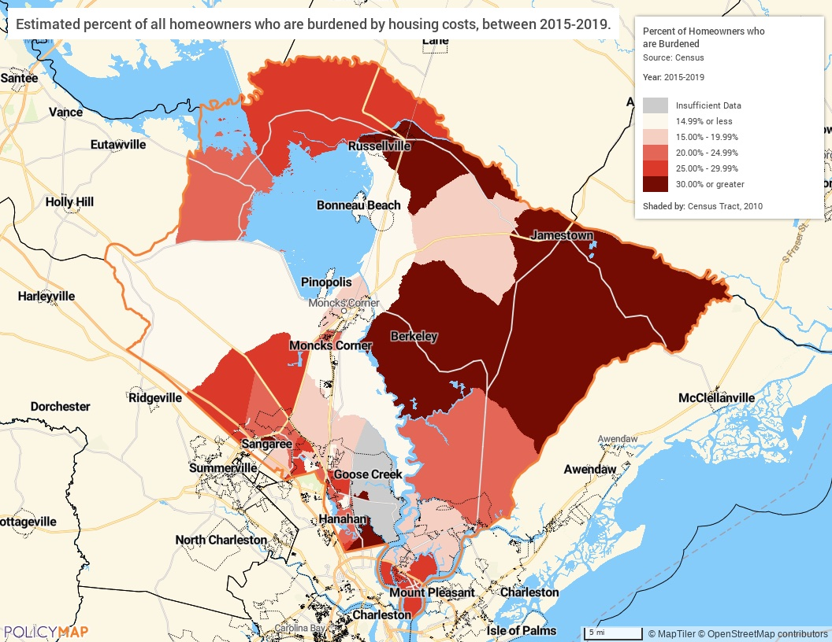
Cost Burdened Homeowners
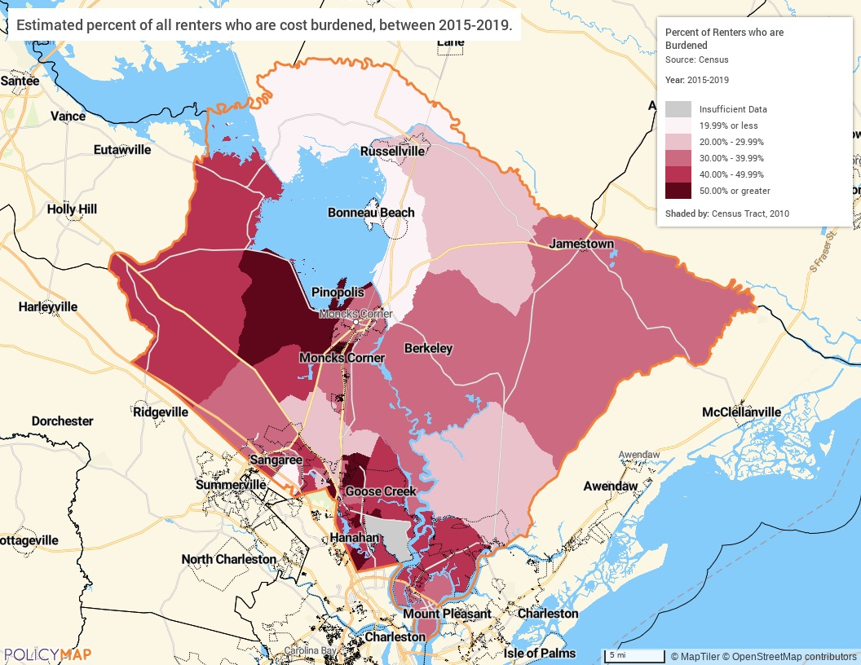
Cost Burdened Renters

4. Cost Burden > 50%
 | Renter |  |  |  | Owner
 | 0-30% AMI | >30-50% AMI | >50-80% AMI | Total | 0-30% AMI | >30-50% AMI | >50-80% AMI | Total
NUMBER OF HOUSEHOLDS
Small Related | 1,040 | 635 | 130 | 1,805 | 545 | 530 | 265 | 1,340
Large Related | 270 | 40 | 130 | 440 | 160 | 120 | 0 | 280
Elderly | 250 | 115 | 20 | 385 | 555 | 265 | 190 | 1,010
Other | 730 | 475 | 150 | 1,355 | 395 | 140 | 230 | 765
Total need by income | 2,290 | 1,265 | 430 | 3,985 | 1,655 | 1,055 | 685 | 3,395
Table 10 – Cost Burden > 50%

Alternate Data Source Name:
2013-2017 CHAS

Severe Cost Burden
The data presented above show the severe cost burden in the County, which is defined as paying more than 50% of household income on housing cost. Cost burden is most common near major roadways, especially for renters located in unincorporated Summerville and the Town of Moncks Corner, and the Cities of Goose Creek and Hanahan.
5. Crowding (More than one person per room)
 | Renter |  |  |  |  | Owner
 | 0-30% AMI | >30-50% AMI | >50-80% AMI | >80-100% AMI | Total | 0-30% AMI | >30-50% AMI | >50-80% AMI | >80-100% AMI | Total
NUMBER OF HOUSEHOLDS
Single family households | 185 | 265 | 265 | 29 | 744 | 30 | 15 | 145 | 4 | 194
Multiple, unrelated family households | 10 | 25 | 45 | 14 | 94 | 0 | 35 | 10 | 8 | 53
Other, non-family households | 0 | 0 | 0 | 0 | 0 | 0 | 4 | 0 | 0 | 4
Total need by income | 195 | 290 | 310 | 43 | 838 | 30 | 54 | 155 | 12 | 251
Table 11 – Crowding Information – 1/2

Alternate Data Source Name:
2013-2017 CHAS

Overcrowding
There are 938 households in the County living in overcrowded conditions. HUD defines an overcrowded household as one having from 1.01 to 1.50 occupants per room and a severely overcrowded household as one with more than 1.50 occupants per room. This type of condition can be seen in both renter and homeowner households. Overcrowding is more prevalent in renter-occupied housing units than in owner-occupied units.
 | Renter |  |  |  | Owner
 | 0-30% AMI | >30-50% AMI | >50-80% AMI | Total | 0-30% AMI | >30-50% AMI | >50-80% AMI | Total
Households with Children Present | 1,130 | 1,180 | 1,305 | 3,615 | 480 | 745 | 1,000 | 2,225
Table 12 – Crowding Information – 2/2

Alternate Data Source Name:
2013-2017 CHAS

Describe the number and type of single person households in need of housing assistance.
According to the 2015-2019 American Community Survey 5-Year Estimates, 22.9% of occupied housing units in the County (17,636 households) are single-person households. Renters are more likely to live in a single-person household than homeowners. Approximately 28.4% of renter-occupied units are single-person households as compared to 20.8% of owner-occupied households.
Elderly residents who live alone may be in particular need of housing assistance. They are often on a fixed income and need assistance to maintain autonomy. In Berkeley County, nearly 92.8% of all households with someone over the age of 65 are single-person households, over 5,778 people.
Estimate the number and type of families in need of housing assistance who are disabled or victims of domestic violence, dating violence, sexual assault and stalking.
Disability
In Berkeley County there are 29,940 individuals who have a disability. They represent 14% of the population. American Indian and Alaska Native, White, Hispanic, and Black residents were the most likely groups to have a disability. The disability rate is highest for older residents, which isn’t surprising as disabilities become more prevalent as people age. Ambulatory difficulty is the most common disability with 15,796 individuals reporting it.
Victims of Rape and Domestic Violence
According to the Berkeley County Sheriff’s online crime map, in 2020 there were 53 cases of rape and 15 cases of sexual assault reported. In 46 of these cases the location of offense was the home. There were also reported 18 cases of child abuse, 42 cases specifically classified as domestic violence, 12 domestic disputes, 74 cases of harassment, 66 of stalking, 2 kidnappings, 43 crimes classified as threatening, and 152 of intimidation.
My Sister’s House, located in Charleston County, is the only domestic violence shelter to serve Berkeley, Charleston, and Dorchester Counties. The organization served 274 women and children, assisted with 790 advocacy cases, and received 1,195 crises calls in 2020. The 40-year-old non-profit has been a safe-haven for women and children that offer shelter, educational and therapeutic activities for children, and group/individual therapy sessions for residents. My Sister’s House also offers free support groups to victims and survivors of domestic violence for individuals throughout the Tri-county area not housed at the shelter. In 2017, the Berkeley County Sheriff’s Office applied for funding to hire a full-time Victim Advocate through the Victim of Crimes Act.
What are the most common housing problems?
Housing cost burden is the most common housing problem in Berkeley County. This is true of both the renter population and owner population. According to 2013-2017 CHAS data, of households who have an income 80% or less of Area Median Income, 7,555 renters and 7,430 owners are faced with housing cost burden or paying more than 30% of income towards housing. Severe housing cost burden, paying more than 50% of income towards housing, affects 4,015 renters and 3,795 owners whose income is 80% or less of Area Median Income. Elderly household types make up 17.8% of renters and homeowners with a cost burden >50%. In total, nearly 17,000 households are financially overstretched due to cost of housing in the County.
Are any populations/household types more affected than others by these problems?
The 2017 CHAS data, while yielding different totals than the recent data from the Census Bureau, provide a more nuanced view into which segments of the population experience housing problems. In general, lower income households experience more housing problems across the board. The extremely low-income income range (30% AMI and below) is statistically more likely to have at least one problem than other income ranges, and extremely low-income renters more so than owners. When those facts intersect, we see that low and extremely low-income renters are more affected by housing problems than other groups. For example, extremely low-income renter households show a greater existence of severe housing cost burden than all other groups.
Describe the characteristics and needs of Low-income individuals and families with children (especially extremely low-income) who are currently housed but are at imminent risk of either residing in shelters or becoming unsheltered 91.205(c)/91.305(c)). Also discuss the needs of formerly homeless families and individuals who are receiving rapid re-housing assistance and are nearing the termination of that assistance
HUD defines extremely low-income households as households that earn 0-30% AMI (area median income), and severe housing cost burden as housing expenses that are greater than 50% of income.
As indicated in 2017 CHAS data in Housing Needs Summary Tables, the lack of affordable housing is by far the greatest housing problem for extremely low-income households and families with children in the region. For extremely low-income households, there are 1,845 homeowner households with severe housing cost burden greater than 50% and 2,275 renter households have severe housing cost burden greater than 50%. That means there are over 4,000 households in the County that are both extremely low income and have severe housing cost burden, which places them at imminent risk of becoming homeless. Furthermore, approximately 1,610 extremely low-income households in the County are households with one or more children 6 years and younger. These families are at imminent risk of homelessness.
If a jurisdiction provides estimates of the at-risk population(s), it should also include a description of the operational definition of the at-risk group and the methodology used to generate the estimates:
No estimate of at-risk populations is available.
Specify particular housing characteristics that have been linked with instability and an increased risk of homelessness
Persons identified to be at increased risk include: persons who are extremely low income; persons with disabilities; persons fleeing domestic violence; homeless persons being discharged from crisis units, hospitals and jails; unaccompanied youth and youth aging out of foster care. Prevention assistance is provided by local organizations such as Salvation Army, East Cooper Community Outreach, and Palmetto Community Action Partnership to persons/households who have already received notice that eviction proceedings have been started in court (rather than just a three-day notice from landlord), since they are the households most likely to be evicted without assistance.

NA-15 Disproportionately Greater Need: Housing Problems – 91.205 (b)(2)
Assess the need of any racial or ethnic group that has disproportionately greater need in comparison to the needs of that category of need as a whole.
Introduction
This section compares the existence of housing problems amongst racial groups against that of the jurisdiction as a whole in an effort to see if any group(s) share a disproportionate burden of the area's housing problems. For this purpose, HUD guidelines deem a disproportionately greater need to exist when persons of a particular racial or ethnic group experience housing problems at a rate at least 10 percentage points higher than the jurisdiction as a whole.
The following series of tables looks at the existence of housing problems amongst different racial and ethnic groups across the 0%-30%, 30%-50%, 50%-80%, and 80%-100% AMI households.
0%-30% of Area Median Income
Housing Problems | Has one or more of four housing problems | Has none of the four housing problems | Household has no/negative income, but none of the other housing problems
Jurisdiction as a whole | 5,160 | 1,120 | 945
White | 2,620 | 615 | 415
Black / African American | 1,910 | 460 | 465
Asian | 80 | 10 | 25
American Indian, Alaska Native | 34 | 0 | 20
Pacific Islander | 0 | 0 | 0
Hispanic | 365 | 0 | 25
Table 13 - Disproportionally Greater Need 0 - 30% AMI

Alternate Data Source Name:
2013-2017 CHAS

*The four housing problems are:
1. Lacks complete kitchen facilities, 2. Lacks complete plumbing facilities, 3. More than one person per room, 4.Cost Burden greater than 30%

30%-50% of Area Median Income
Housing Problems | Has one or more of four housing problems | Has none of the four housing problems | Household has no/negative income, but none of the other housing problems
Jurisdiction as a whole | 4,810 | 2,840 | 0
White | 2,660 | 1,590 | 0
Black / African American | 1,485 | 1,015 | 0
Asian | 90 | 14 | 0
American Indian, Alaska Native | 54 | 0 | 0
Pacific Islander | 0 | 0 | 0
Hispanic | 440 | 134 | 0
Table 14 - Disproportionally Greater Need 30 - 50% AMI

Alternate Data Source Name:
2013-2017 CHAS

*The four housing problems are:
1. Lacks complete kitchen facilities, 2. Lacks complete plumbing facilities, 3. More than one person per room, 4.Cost Burden greater than 30%

50%-80% of Area Median Income
Housing Problems | Has one or more of four housing problems | Has none of the four housing problems | Household has no/negative income, but none of the other housing problems
Jurisdiction as a whole | 6,155 | 6,460 | 0
White | 3,235 | 3,965 | 0
Black / African American | 2,075 | 1,920 | 0
Asian | 205 | 114 | 0
American Indian, Alaska Native | 20 | 20 | 0
Pacific Islander | 0 | 70 | 0
Hispanic | 380 | 280 | 0
Table 15 - Disproportionally Greater Need 50 - 80% AMI

Alternate Data Source Name:
2013-2017 CHAS

*The four housing problems are:
1. Lacks complete kitchen facilities, 2. Lacks complete plumbing facilities, 3. More than one person per room, 4.Cost Burden greater than 30%
80%-100% of Area Median Income
Housing Problems | Has one or more of four housing problems | Has none of the four housing problems | Household has no/negative income, but none of the other housing problems
Jurisdiction as a whole | 2,010 | 6,040 | 0
White | 1,395 | 4,010 | 0
Black / African American | 410 | 1,590 | 0
Asian | 15 | 105 | 0
American Indian, Alaska Native | 0 | 19 | 0
Pacific Islander | 0 | 0 | 0
Hispanic | 195 | 255 | 0
Table 16 - Disproportionally Greater Need 80 - 100% AMI

Alternate Data Source Name:
2013-2017 CHAS

*The four housing problems are:
1. Lacks complete kitchen facilities, 2. Lacks complete plumbing facilities, 3. More than one person per room, 4.Cost Burden greater than 30%
Discussion
By HUD’s definition of a disparity of 10% or higher, several different racial and ethnic groups experience a disproportionately greater need when it comes to housing problems.
0-30% AMI
The jurisdiction wide prevalence of housing problems is 71.4% for this income group. Only one racial group experiences housing problems at a disproportionately higher rate. Approximately 93.6% of Hispanic households with 0-30% AMI has at least one housing problem.
30-50% AMI
Overall, 62.9% of Berkeley County’s residents in this income group have a housing problem and there are three groups who have housing problems at a disproportionately higher rate. Approximately 86.5% of Asian households, 100% of American Indian households and 76.7% of Hispanic households with 30-50% AMI have a housing problem.
50-80% AMI
Throughout Berkeley County 48.8% of residents in this income group have at least one housing problem. Households from one racial group are disproportionately likely to have a housing problem: Asian households. This group has a housing problem rate of 64.3%.
80-100% AMI
For those who earn 80-100% area median income the likelihood that they experience a housing problem is relatively small, only 25%. However, Hispanic households experience housing problems at a disproportionately high rate of 43.3%.
Conclusion
The likelihood that a household experiences a housing problem decreases as incomes rise. Hispanic and Asian households experience housing problems at a disproportionate rate in more than one income group.

NA-20 Disproportionately Greater Need: Severe Housing Problems – 91.205 (b)(2)
Assess the need of any racial or ethnic group that has disproportionately greater need in comparison to the needs of that category of need as a whole.
Introduction
This section compares the existence of severe housing problems amongst racial groups against that of the jurisdiction as a whole to see if any group(s) share a disproportionate burden of the area's severe housing problems. For this purpose, HUD guidelines deem a disproportionately greater need to exist when persons of a particular racial or ethnic group experience severe housing problems at a rate at least 10 percentage points higher than the jurisdiction as a whole.
The following series of tables looks at the existence of severe housing problems amongst different racial and ethnic groups across the 0%-30%, 30%-50%, 50%-80%, and 80%-100% AMI households.
0%-30% of Area Median Income
Severe Housing Problems* | Has one or more of four housing problems | Has none of the four housing problems | Household has no/negative income, but none of the other housing problems
Jurisdiction as a whole | 4,395 | 1,885 | 945
White | 2,225 | 1,005 | 415
Black / African American | 1,670 | 700 | 465
Asian | 65 | 20 | 25
American Indian, Alaska Native | 4 | 30 | 20
Pacific Islander | 0 | 0 | 0
Hispanic | 290 | 75 | 25
Table 17 – Severe Housing Problems 0 - 30% AMI

Alternate Data Source Name:
2013-2017 CHAS

*The four severe housing problems are:
1. Lacks complete kitchen facilities, 2. Lacks complete plumbing facilities, 3. More than 1.5 persons per room, 4.Cost Burden over 50%

30%-50% of Area Median Income
Severe Housing Problems* | Has one or more of four housing problems | Has none of the four housing problems | Household has no/negative income, but none of the other housing problems
Jurisdiction as a whole | 2,845 | 4,800 | 0
White | 1,525 | 2,725 | 0
Black / African American | 900 | 1,605 | 0
Asian | 90 | 14 | 0
American Indian, Alaska Native | 54 | 0 | 0
Pacific Islander | 0 | 0 | 0
Hispanic | 260 | 315 | 0
Table 18 – Severe Housing Problems 30 - 50% AMI

Alternate Data Source Name:
2013-2017 CHAS

*The four severe housing problems are:
1. Lacks complete kitchen facilities, 2. Lacks complete plumbing facilities, 3. More than 1.5 persons per room, 4.Cost Burden over 50%

50%-80% of Area Median Income
Severe Housing Problems* | Has one or more of four housing problems | Has none of the four housing problems | Household has no/negative income, but none of the other housing problems
Jurisdiction as a whole | 1,710 | 10,900 | 0
White | 970 | 6,225 | 0
Black / African American | 585 | 3,405 | 0
Asian | 65 | 260 | 0
American Indian, Alaska Native | 0 | 35 | 0
Pacific Islander | 0 | 70 | 0
Hispanic | 95 | 570 | 0
Table 19 – Severe Housing Problems 50 - 80% AMI

Alternate Data Source Name:
2013-2017 CHAS

*The four severe housing problems are:
1. Lacks complete kitchen facilities, 2. Lacks complete plumbing facilities, 3. More than 1.5 persons per room, 4.Cost Burden over 50%

80%-100% of Area Median Income
Severe Housing Problems* | Has one or more of four housing problems | Has none of the four housing problems | Household has no/negative income, but none of the other housing problems
Jurisdiction as a whole | 290 | 7,760 | 0
White | 160 | 5,240 | 0
Black / African American | 50 | 1,950 | 0
Asian | 4 | 110 | 0
American Indian, Alaska Native | 0 | 19 | 0
Pacific Islander | 0 | 0 | 0
Hispanic | 70 | 380 | 0
Table 20 – Severe Housing Problems 80 - 100% AMI

Alternate Data Source Name:
2013-2017 CHAS

*The four severe housing problems are:
1. Lacks complete kitchen facilities, 2. Lacks complete plumbing facilities, 3. More than 1.5 persons per room, 4.Cost Burden over 50%

Discussion
By HUD’s definition of a disparity of 10% or higher, several different racial and ethnic groups experience a disproportionately greater need when it comes to severe housing problems.
0-30% AMI
The jurisdiction wide prevalence of severe housing problems is 60.8% for this income group. There is one group that experiences severe housing problems at a disproportionate rate, 74.4% of Hispanic households have a severe housing problem
30-50% AMI
Overall, 37.2% of Berkeley County’s residents in this income group have a severe housing problem. There are two racial groups with disproportionately high rates, Asian and American Indian households. Eighty-six percent of Asian households and 100% of American Indian households have severe housing problems in this group.
50-80% AMI
Throughout Berkeley County 13.6% of residents in this income group have at least one severe housing problem. There are no groups disproportionately impacted by severe housing problems.
80-100% AMI
For those who earn 80-100% AMI the likelihood that they experience a severe housing problem is small, only 3.6%. There is one racial group that is disproportionately higher, 15.6% of Hispanic households have a severe housing problem.
Conclusion
The likelihood that a household experiences a severe housing problem decreases as incomes rise. The only racial group that experienced a disproportionately high rate in multiple income groups is Hispanic households.

NA-25 Disproportionately Greater Need: Housing Cost Burdens – 91.205 (b)(2)
Assess the need of any racial or ethnic group that has disproportionately greater need in comparison to the needs of that category of need as a whole.
Introduction:
This section compares the existence of cost burden amongst racial groups against that of the jurisdiction as a whole to see if any group(s) share a disproportionate burden of the area's severe housing problems. For this purpose, HUD guidelines deem a disproportionately greater need to exist when persons of a particular racial or ethnic group experience cost burden at a rate at least 10 percentage points higher than the jurisdiction as a whole.
Housing Cost Burden
Housing Cost Burden | <=30% | 30-50% | >50% | No / negative income (not computed)
Jurisdiction as a whole | 52,470 | 11,275 | 8,455 | 975
White | 37,365 | 6,685 | 4,610 | 440
Black / African American | 11,090 | 3,160 | 2,880 | 465
Asian | 995 | 225 | 215 | 25
American Indian, Alaska Native | 145 | 95 | 60 | 20
Pacific Islander | 70 | 0 | 0 | 0
Hispanic | 2,005 | 795 | 540 | 25
Table 21 – Greater Need: Housing Cost Burdens AMI

Alternate Data Source Name:
2013-2017 CHAS

Discussion:
This section calculates the percentage of those with cost burden and severe cost burden within each racial or ethnic group in the County.
<=30% - Not Cost Burdened
Throughout Berkeley County, approximately 71.7% of residents are not cost burdened according 2013-2017 CHAS data. American Indian households and Hispanic households are disproportionately less likely to not have cost burden with 45.3% and 59.6%, respectively.
30-50% - Cost Burdened
In Berkeley, 15.4% of the population is cost burdened. There is one racial group disproportionately cost burdened. Approximately 29.7% of American Indian or Alaska Native households are cost burdened.
>50% - Severely Cost Burdened
Approximately 11.6% of all households are severely cost burdened. There are no racial or ethnic groups disproportionately impacted by severe cost burden.

NA-30 Disproportionately Greater Need: Discussion – 91.205(b)(2)
Are there any Income categories in which a racial or ethnic group has disproportionately greater need than the needs of that income category as a whole?
Housing Problems
By HUD’s definition of a disparity of 10% or higher, several different racial and ethnic groups experience a disproportionately greater need when it comes to housing problems.
0-30% AMI
The jurisdiction wide prevalence of housing problems is 71.4% for this income group. Only one racial group experiences housing problems at a disproportionately higher rate. Approximately 93.6% of Hispanic households with 0-30% AMI has at least one housing problem.
30-50% AMI
Overall, 62.9% of Berkeley County’s residents in this income group have a housing problem and there are three groups who have housing problems at a disproportionately higher rate. Approximately 86.5% of Asian households, 100% of American Indian households and 76.7% of Hispanic households with 30-50% AMI have a housing problem.
50-80% AMI
Throughout Berkeley County 48.8% of residents in this income group have at least one housing problem. Households from one racial group are disproportionately likely to have a housing problem: Asian households. This group has a housing problem rate of 64.3%.
80-100% AMI
For those who earn 80-100% area median income the likelihood that they experience a housing problem is relatively small, only 25%. However, Hispanic households experience housing problems at a disproportionately high rate of 43.3%.
Conclusion
The likelihood that a household experiences a housing problem decreases as incomes rise. Hispanic and Asian households experience housing problems at a disproportionate rate in more than one income group.

Severe Housing Problems
By HUD’s definition of a disparity of 10% or higher, several different racial and ethnic groups experience a disproportionately greater need when it comes to severe housing problems.
0-30% AMI
The jurisdiction wide prevalence of severe housing problems is 60.8% for this income group. There is one group that experiences severe housing problems at a disproportionate rate, 74.4% of Hispanic households have a severe housing problem
30-50% AMI
Overall, 37.2% of Berkeley County’s residents in this income group have a severe housing problem. There are two racial groups with disproportionately high rates, Asian and American Indian households. Eighty-six percent of Asian households and 100% of American Indian households have severe housing problems in this group.
50-80% AMI
Throughout Berkeley County 13.6% of residents in this income group have at least one severe housing problem. There are no groups disproportionately impacted by severe housing problems.
80-100% AMI
For those who earn 80-100% AMI the likelihood that they experience a severe housing problem is small, only 3.6%. There is one racial group that is disproportionately higher, 15.6% of Hispanic households have a severe housing problem.
Conclusion
The likelihood that a household experiences a severe housing problem decreases as incomes rise. The only racial group that experienced a disproportionately high rate in multiple income groups is Hispanic households.
Cost Burden: See NA-25 Discussion.
If they have needs not identified above, what are those needs?
There are no other needs that have not been identified.
Are any of those racial or ethnic groups located in specific areas or neighborhoods in your community?
In Berkeley County, African American/Black households are much more common in the rural areas and not located near city or town centers. Hispanic households are located primarily near the Naval Weapons Station and in the City of Hanahan and parts of unincorporated Goose Creek.

NA-35 Public Housing – 91.205(b)
Introduction
Public housing was established to provide decent and safe rental housing for eligible low- and moderate-income families, the elderly, and persons with disabilities. Public housing includes federally subsidized, affordable housing that is owned and operated by the public housing authorities. The local housing authority operating in Berkeley County is the South Carolina Regional Housing Authority No. 3 (SCRHA3). SCRHA3 manages two public housing complexes in the County with 78 units at St. Francis Villa Apartments in Moncks Corner and 50 units at Belangia Apartments in St. Stephen. SCRHA3 also administers nearly 550 Housing Choice Vouchers (HCV) across the seven counties it serves, including Berkeley County.
The tables below provide details on public housing programs and units in Berkeley County, as well as demographic information on residents who utilize public housing services.
Totals in Use
Program Type
 | Certificate | Mod-Rehab | Public Housing | Vouchers
 |  |  |  | Total | Project -based | Tenant -based | Special Purpose Voucher
 |  |  |  |  |  |  | Veterans Affairs Supportive Housing | Family Unification Program | Disabled  *
# of units vouchers in use | 0 | 0 | 736 | 548 | 0 | 548 | 0 | 0 | 0

Table 22 - Public Housing by Program Type
*includes Non-Elderly Disabled, Mainstream One-Year, Mainstream Five-year, and Nursing Home Transition

Data Source: | PIC (PIH Information Center)

Characteristics of Residents

Program Type
 | Certificate | Mod-Rehab | Public Housing | Vouchers
 |  |  |  | Total | Project -based | Tenant -based | Special Purpose Voucher
 |  |  |  |  |  |  | Veterans Affairs Supportive Housing | Family Unification Program
Average Annual Income | 0 | 0 | 7,826 | 10,169 | 0 | 10,169 | 0 | 0
Average length of stay | 0 | 0 | 4 | 5 | 0 | 5 | 0 | 0
Average Household size | 0 | 0 | 2 | 2 | 0 | 2 | 0 | 0
# Homeless at admission | 0 | 0 | 0 | 0 | 0 | 0 | 0 | 0
# of Elderly Program Participants (>62) | 0 | 0 | 82 | 61 | 0 | 61 | 0 | 0
# of Disabled Families | 0 | 0 | 139 | 139 | 0 | 139 | 0 | 0
# of Families requesting accessibility features | 0 | 0 | 736 | 548 | 0 | 548 | 0 | 0
# of HIV/AIDS program participants | 0 | 0 | 0 | 0 | 0 | 0 | 0 | 0
# of DV victims | 0 | 0 | 0 | 0 | 0 | 0 | 0 | 0
Table 24 – Characteristics of Public Housing Residents by Program Type
Data Source: | PIC (PIH Information Center)

Race of Residents
Program Type
Race | Certificate | Mod-Rehab | Public Housing | Vouchers
 |  |  |  | Total | Project -based | Tenant -based | Special Purpose Voucher
 |  |  |  |  |  |  | Veterans Affairs Supportive Housing | Family Unification Program | Disabled  *
White | 0 | 0 | 31 | 74 | 0 | 74 | 0 | 0 | 0
Black/African American | 0 | 0 | 704 | 471 | 0 | 471 | 0 | 0 | 0
Asian | 0 | 0 | 0 | 0 | 0 | 0 | 0 | 0 | 0
American Indian/Alaska Native | 0 | 0 | 0 | 1 | 0 | 1 | 0 | 0 | 0
Pacific Islander | 0 | 0 | 1 | 2 | 0 | 2 | 0 | 0 | 0
Other | 0 | 0 | 0 | 0 | 0 | 0 | 0 | 0 | 0

*includes Non-Elderly Disabled, Mainstream One-Year, Mainstream Five-year, and Nursing Home Transition
Table 25 – Race of Public Housing Residents by Program Type
Data Source: | PIC (PIH Information Center)

Ethnicity of Residents
Program Type
Ethnicity | Certificate | Mod-Rehab | Public Housing | Vouchers
 |  |  |  | Total | Project -based | Tenant -based | Special Purpose Voucher
 |  |  |  |  |  |  | Veterans Affairs Supportive Housing | Family Unification Program | Disabled  *
Hispanic | 0 | 0 | 7 | 6 | 0 | 6 | 0 | 0 | 0
Not Hispanic | 0 | 0 | 729 | 542 | 0 | 542 | 0 | 0 | 0

*includes Non-Elderly Disabled, Mainstream One-Year, Mainstream Five-year, and Nursing Home Transition
Table 26 – Ethnicity of Public Housing Residents by Program Type
Data Source: | PIC (PIH Information Center)

Section 504 Needs Assessment: Describe the needs of public housing tenants and applicants on the waiting list for accessible units:
The housing authority recognizes that families with a disability along with the elderly and extremely low-income households are some of the families with the highest needs they serve. While affordability is a main concern, families with a disability also may require accommodations to make living in public housing possible. Currently the waiting list is closed for the HCV program, and while the waiting list is open for public housing developments, the wait time is currently unknown.
It is the policy of South Carolina Regional Housing Authority No. 3 (SCRHA3) to comply with Section 504 of the Rehabilitation Act and the Federal Fair Housing Act to provide reasonable accommodations and modifications upon the request to all applicants, residents, and employees with disabilities. SCRHA3 is an equal housing opportunity provider and does not discriminate against applicants and/or residents with disabilities. It is the policy of the housing authority to provide reasonable accommodations and/or modifications to applicants or residents who have a disability to be able to fully use and enjoy their apartment and the apartment community.
In accordance with Section 504, reasonable accommodations will be made for individuals with disabilities (applicants or residents). Such accommodations may include changes in the method of administering policies, procedures, or services.
Most immediate needs of residents of Public Housing and Housing Choice voucher holders
The most immediate needs of residents in public housing and HCV program holders is housing that is affordable and a higher household income that will help them become self-sustainable and enable them to move out of publicly assisted housing. As seen in the assessment of extremely low-income households (households with 30% AMI or less), the lower the income, the less affordable housing becomes and the more likely a household will experience housing cost burden. Housing cost burden indicates that housing is not affordable.
How do these needs compare to the housing needs of the population at large
While there generally is a high need for affordable housing in the County, because such a high proportion of families served by the SCRHA3 are very low-income, affordable housing is of especially great need for the public housing population. Also compared to the population at-large, the housing authority population is more likely to be elderly and have families with a disability. Elderly families and families with a disability may require accommodations that meet their unique needs to make living in public housing possible.

NA-40 Homeless Needs Assessment – 91.205(c)
Introduction:
Homelessness is a particularly troublesome and complex issue that most communities across the United States must address. A major reason that homelessness is difficult to address is that it has many causes with overlapping and interrelated variables. The cause of any single person’s homelessness often lies, not in a single factor, but at the convergence of many events and conditions. From one perspective, homelessness is an economic problem caused by unemployment, lack of affordable housing options, or poverty. From another perspective, homelessness is a health issue because many homeless persons struggle with mental illness, physical disabilities, HIV/AIDS, substance abuse, or a combination of those health factors. A third perspective is to view homelessness as a social problem with factors such as domestic violence, educational attainment, and race lying at the foundation. In reality, homelessness can be caused by all these issues and they are often interrelated. Due to this complexity, addressing homelessness requires a collaborative and community-based approach.
The Stewart B. McKinney Homeless Assistance Act defines the “homeless” or “homeless individual” or “homeless person” as an individual who lacks a fixed, regular, and adequate night-time residence; and who has a primary night-time residence that is:
- A supervised publicly or privately-operated shelter designed to provide temporary living accommodations (including welfare hotels, congregate shelters, and transitional housing for the mentally ill);
- An institution that provides a temporary residence for individuals intended to be institutionalized; or
- A public or private place not designed for, or ordinarily used as, a regular sleeping accommodation for human beings
Berkeley County is located in the southeastern part of South Carolina. Services providers in the County are part of the 7-county Lowcountry Continuum of Care (COC). Charleston County is the largest population center in the area and borders Berkeley County. In the 2020 Point in Time Count, Berkeley County reported 26 residents experiencing homelessness. They were all unsheltered.
Homeless Needs Assessment
Population | Estimate the # of persons experiencing homelessness on a given night |  | Estimate the # experiencing homelessness each year | Estimate the # becoming homeless each year | Estimate the # exiting homelessness each year | Estimate the # of days persons experience homelessness
 | Sheltered | Unsheltered
Persons in Households with Adult(s) and Child(ren) | 0 | 0 | 0 | 0 | 0 | 0
Persons in Households with Only Children | 0 | 0 | 0 | 0 | 0 | 0
Persons in Households with Only Adults | 0 | 26 | 0 | 0 | 0 | 0
Chronically Homeless Individuals | 0 | 8 | 0 | 0 | 0 | 0
Chronically Homeless Families | 0 | 0 | 0 | 0 | 0 | 0
Veterans | 0 | 3 | 0 | 0 | 0 | 0
Unaccompanied Child | 0 | 0 | 0 | 0 | 0 | 0
Persons with HIV | 0 | 0 | 0 | 0 | 0 | 0
Table 27 - Homeless Needs Assessment

Alternate Data Source Name:
2020 PIT Count

Indicate if the homeless population is: | Partially Rural Homeless

For persons in rural areas who are homeless or at risk of homelessness, describe the nature and extent of unsheltered and sheltered homelessness with the jurisdiction:
The County is rural in nature and includes the Francis Marion National Forest and several cities, towns, and small residential communities disbursed throughout the large county. Data was not collected distinguishing between rural and non-rural homelessness. Berkeley County rural areas have substantial geographic distance and travel time for persons experiencing homelessness trying to receive services in Charleston or North Charleston, SC.
If data is not available for the categories "number of persons becoming and exiting homelessness each year," and "number of days that persons experience homelessness," describe these categories for each homeless population type (including chronically homeless individuals and families, families with children, veterans and their families, and unaccompanied youth):
An individual is defined as “Chronically Homeless” if they have a disability and have lived in a shelter, safe haven, or place not meant for human habitation for 12 continuous months or on four separate occasions in the last three years (must total 12 months). For a family to be defined as chronically homeless, the head of household must meet the chronic definition.
Family includes, but is not limited to, regardless of marital status, actual or perceived sexual orientation, or gender identity, the following:
- A single person, who may be an elderly person, displaced person, disabled person, near-elderly person, or any other single person; or,
- A group of persons residing together, and such group includes, but is not limited to:
- A family with or without children (a child who is temporarily away from the home because of placement in foster care is considered a member of the family);An elderly family;A near-elderly family;A disabled family;A displaced family; and,The remaining member of a tenant family.

Estimate the number and type of families in need of housing assistance for families with children and the families of veterans.
Specific information on residents with families or veterans was not available for Berkeley County.
Describe the Nature and Extent of Homelessness by Racial and Ethnic Group.
The COC has started working on a Racial Disparities project that will include the entire continuum. The purpose of the project is to conduct research regarding Racial Disparities in order to understand the correlation between race and housing for those experiencing homelessness. The Racial Disparities project will help build capacity of the Lowcountry COC by setting the framework for ongoing research, analysis and recommendation for improving our system of care for those experiencing homelessness; as well as assisting with creating local sustainable solutions to a national problem
Describe the Nature and Extent of Unsheltered and Sheltered Homelessness.
Every resident experiencing homelessness in Berkeley County are unsheltered. There are no long-term shelters in the county.

NA-45 Non-Homeless Special Needs Assessment - 91.205 (b,d)
Introduction:
There are four primary groups with non-homeless special needs in the jurisdiction. They are the elderly and frail elderly, those with HIV/AIDS and their families, those with alcohol and/or drug addiction, and the mentally or physically disabled. This section will explain who they are, what their needs are, and how the County is accommodating or should accommodate these needs.

Describe the characteristics of special needs populations in your community:
Elderly: The elderly population faces increased challenges and providing decent, affordable housing is incredibly important. It is medically beneficial and emotionally comforting for this population to remain in a familiar setting and, as a result, strong emphasis is placed on the elderly maintaining a lifestyle that is as independent as possible. Unfortunately, the elderly population is often on a limited income and/or has a disability, which puts financial pressure on them that reduces independence. As prices throughout the community inflate, the elderly population generally lacks the ability to increase their income to match.
According to the most recent data available, there are approximately 41,243 residents over the age of 60 in the County, making up approximately 19.2% of the population. Approximately 14,100 residents over the age of 60 have a disability, or 34.4%, and approximately 3,731 (9.1%) are below the poverty level. Elderly residents are much more likely to live in owner-occupied residences than renter occupied residences, 87% and 13%, respectively. However, many elderly residents are still cost burdened. Approximately 46.8% of elderly renters and 22.6% of owners are cost burdened.
HIV/AIDS: Berkeley County is located in the Lowcountry Public Health Region. According to the South Carolina Department of Health and Environmental Control, in 2016 and 2017 there were 375 new diagnoses of HIV infection in the area. Over three-quarters of the new cases were men and residents between the age of 20 and 29 made up the largest age group of new cases. Same sex interactions between men made up the largest proportion of recent infections, 71%. African American residents made up 66% of new cases. There are 4,745 residents in the Lowcountry Region living with HIV and AIDS, which is 24% of the South Carolina total.
Alcohol and Drug Addiction: Gathering accurate data about alcohol and drug addiction within a community is difficult. Addiction often goes unrecognized because people don’t seek help due to fear of criminal charges and/or the social stigma associated with addiction and other medical issues. Often only when someone overdoses, gets arrested, or seeks treatment are they counted in statistics. The Berkeley County Probate Court Therapeutic Division can order treatment of individuals facing addiction.
Disability: There are 29,940 people in the County who have a disability, which is 14.3% of the population. Unsurprisingly, disability is correlated with age and older residents are more likely to have one or more disabilities. Ambulatory difficulty is the most common disability and independent living difficulty is the second most common disability.
What are the housing and supportive service needs of these populations and how are these needs determined?
Elderly: Providing secure, safe, affordable, and stable housing for the elderly population is vitally important for this population. There are many factors that contribute to a healthy environment for the elderly including, but not limited to, access to health care, shopping, and social networks. A robust public transportation network is incredibly beneficial to assisting the elderly remain active and independent. Additionally, elderly resident’s homes may need modifications to assist with any disabilities that may develop as a result of aging.
HIV/AIDS: Programs and services for individuals affected by HIV/AIDS are provided by Palmetto Community Care, Ryan White Wellness Center and the City of Charleston, located in Charleston County, South Carolina. See discussion below.
Alcohol and Drug Addiction: Individuals with substance abuse problems need a strong network in order to stay healthy and sober. Their housing needs include sober living environments, support for employment, access to health facilities, and easy access to family and friend networks. Additionally, detoxification facilities are necessary when addiction is first recognized.
Disability: Individuals with disabilities encompass a wide range of skill levels and abilities. Therefore, they have many of the same issues as the general population with the added needs that are unique to their capabilities. Individuals with disabilities usually have a fixed income and have limited housing options. The individuals who have more independent skills tend to utilize subsidized housing options. Individuals requiring more support find residences in the public welfare funded community homes either sharing settings or privately-owned personal care settings. Many individuals continue to reside with parents and families throughout adulthood. Regardless of the housing situation, a common thread is the need for continuous support services dependent of the level of capabilities.
Discuss the size and characteristics of the population with HIV/AIDS and their families within the Eligible Metropolitan Statistical Area:
Between January 1 and December 31, 2017, eight cases of AIDS/HIV were diagnosed in Berkeley County according to the South Carolina Department of Environmental Control (DHEC). One hundred seventy-six county residents have died from this disease since DHEC began collecting data.

NA-50 Non-Housing Community Development Needs – 91.215 (f)
Describe the jurisdiction’s need for Public Facilities:
Berkeley County has identified expanding and improving public facilities as one of the primary needs over the next five years. This is essential to addressing the needs of the community, particularly low-income and special needs residents. Like many communities throughout the country, Berkeley County faces challenges maintaining and improving aging facilities.
How were these needs determined?
These needs were determined through consultation with community leaders, the general public, consultants, and through evaluation of past successes and areas for improvement.
Describe the jurisdiction’s need for Public Improvements:
Public improvements have been identified as a primary need for the County and is part of the County’s anti-poverty strategy. Target LMI locations and addresses in the most immediate need will be identified for facility and infrastructure improvements and the reduction of slum and blight.
How were these needs determined?
These needs were determined through consultation with community leaders, the general public, consultants, and through evaluation of past successes and areas for improvement.
Describe the jurisdiction’s need for Public Services:
Public Services offered by the County and partner nonprofit organizations provide for vital and essential services for low- and moderate-income households and families throughout the jurisdiction. The County will allocate CDBG funding for these services and strive to continue improving and expanding these services. Public service program development is a high priority as it will help with economic growth, education and improve living situations of LMI individuals and households throughout the County.
How were these needs determined?
These needs were determined through consultation with community leaders, the general public, consultants, and through evaluation of past successes and areas for improvement.

Housing Market Analysis

MA-05 Overview
Housing Market Analysis Overview:
This Housing Market Analysis looks at the housing market and supply in the County by analyzing trends in structure, age, price, and tenure. This section also looks at the supply of homeless shelter facilities, special needs services and housing, and non-housing community development resources. The analysis in this section is supplemented by GIS maps to provide geographical visualization of the data.

MA-10 Number of Housing Units – 91.210(a)&(b)(2)
Introduction
This section examines the composition of the County’s housing stock in terms of housing type and tenure. Details are provided based on the number of units in the structure, multifamily housing distribution within the jurisdiction, unit size and tenure, as well as an analysis of owner-occupied and renter occupied housing.
All residential properties by number of units
Property Type | Number | %
1-unit detached structure | 54,211 | 64%
1-unit, attached structure | 3,294 | 4%
2-4 units | 2,363 | 3%
5-19 units | 6,175 | 7%
20 or more units | 2,941 | 3%
Mobile Home, boat, RV, van, etc | 15,114 | 18%
Total | 84,098 | 100%
Table 31 – Residential Properties by Unit Number

Alternate Data Source Name:
2015-2019 ACS 5-Yr Estimates

Residential Properties by Number of Units
The table above breaks down the County’s housing stock by the number of units in each structure and by structure type. Traditional single-family, detached homes are most prominent, accounting for 64% of all housing units. Multi-family developments (5 or more units) account for only 10% of all housing units in the County. Finally, 18% of housing units are classified as mobile home, boat, RV, van, etc.
Source: 2015-2019 American Community Survey 5-Year Estimates
Multifamily Development Distribution
The maps below display the distribution of small, medium and large multifamily developments in the jurisdiction. Small multifamily units are buildings with 3-19 units, medium multifamily units are buildings with 20-49 units and large multifamily units are buildings with 50+ units. Large multifamily developments are primarily available in urban settings close to major transportation corridors throughout the County. Most rural census tracts have fewer than 5% of the available housing in multifamily developments.
Source: 2015-2019 American Community Survey 5-Year Estimates
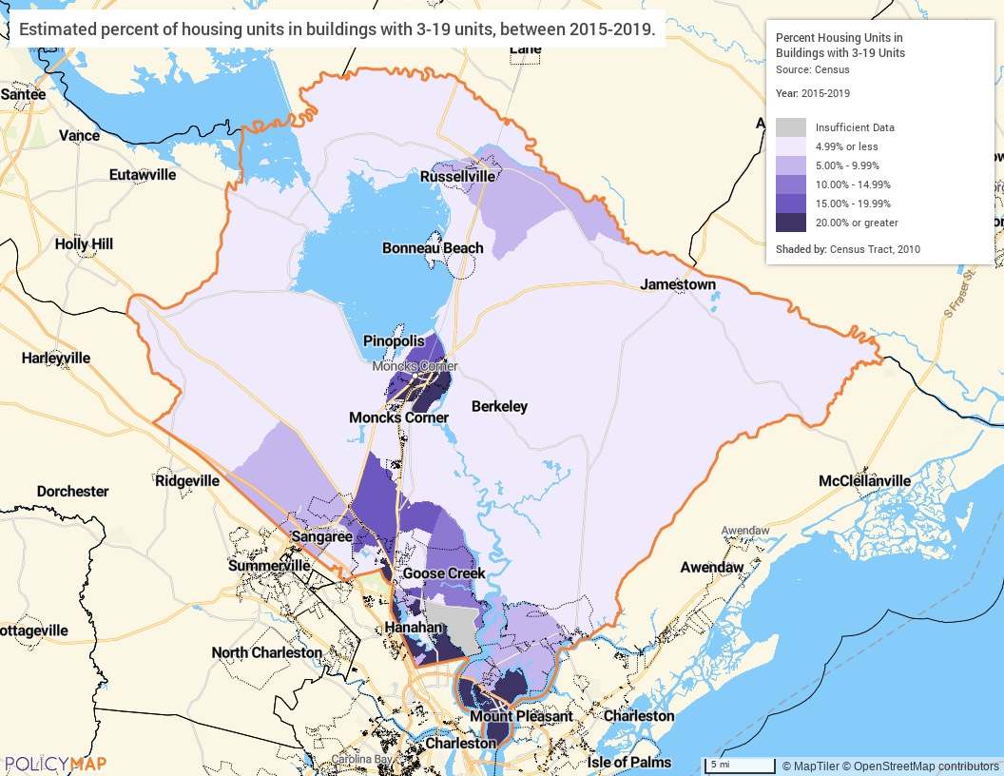
Small Multifamily Developments Map
Small Multifamily Developments
Small Multi-Family Units are available throughout the County, but they are more concentrated along major roadways that move workers from Berkeley County into Charleston and Dorchester Counties. There is a much higher number of small multi-family units in Moncks Corner, Goose Creek, Hanahan, and Daniel Island.
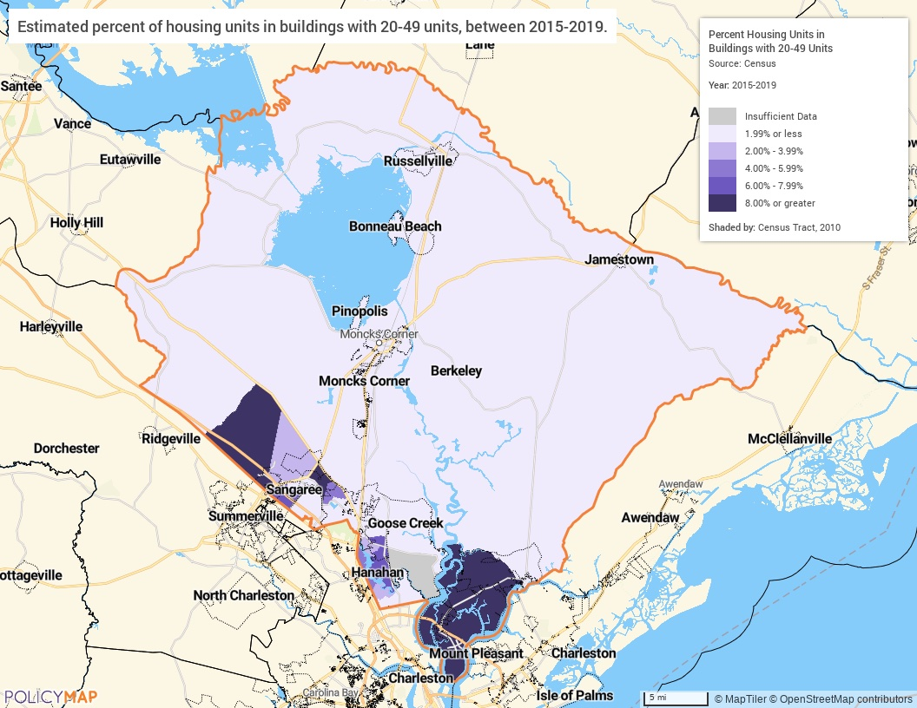
Medium Multifamily Developments Map
Medium Multifamily Developments
Medium multi-family developments are more concentrated in the City of Goose Creek and on Daniel Island.
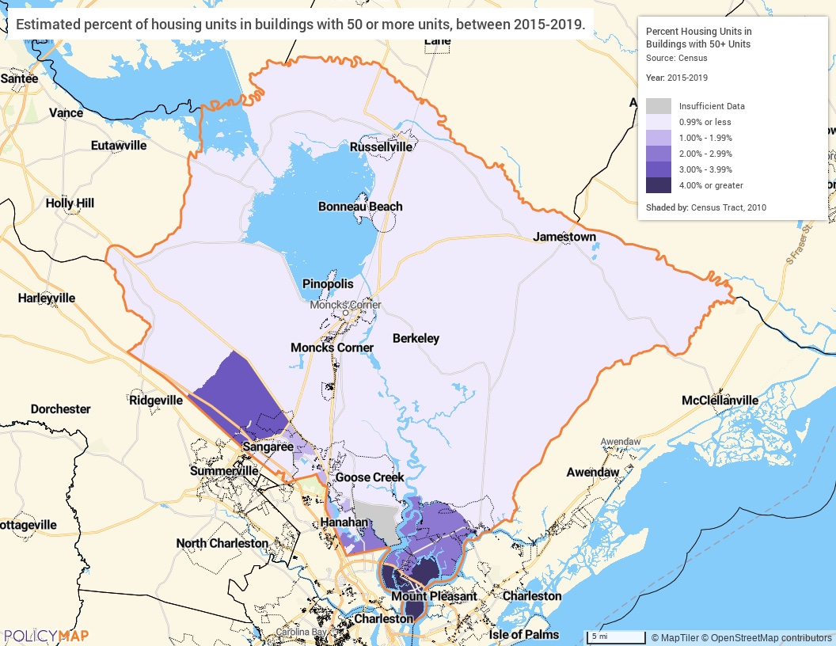
Large Multifamily Developments Map
Large Multifamily Developments
Major large multi-family housing developments are in the unincorporated area of Summerville in Nexton and in Cainhoy, near Charleston, South Carolina. Heavy development continues in these areas.

Unit Size by Tenure
 | Owners |  | Renters
 | Number | % | Number | %
No bedroom | 136 | 0% | 266 | 1%
1 bedroom | 269 | 0% | 2,639 | 12%
2 bedrooms | 5,393 | 10% | 8,129 | 38%
3 or more bedrooms | 49,497 | 90% | 10,552 | 49%
Total | 55,295 | 100% | 21,586 | 100%
Table 32 – Unit Size by Tenure

Alternate Data Source Name:
2015-2019 ACS 5-Yr Estimates

Unit Size by Tenure
One-bedroom units represent a very small percentage of the overall occupied housing units in the County with one percent for owners and 13% for renters. For both owner and renter cohorts, 3 or more bedrooms saw the highest percentage with 90% for owners and 49% for renters. Renters were generally more evenly distributed between 1, 2, and 3 or more-bedroom units, while the bulk of owners occupied 3 or more-bedroom units.
Source: 2015-2019 American Community Survey 5-Year Estimates
Describe the number and targeting (income level/type of family served) of units assisted with federal, state, and local programs.
The South Carolina Regional Housing Authority No. 3 (SCRHA3) primarily targets very low-income and extremely low-income households in the area. The SCRHA3 manages two public housing complexes in the County with 78 units at St. Francis Villa Apartments in Moncks Corner and 50 units at Belangia Apartments in St. Stephen. SCRHA3 also administers Housing Choice Vouchers (HCV) across the seven counties it serves, including Berkeley County.
Provide an assessment of units expected to be lost from the affordable housing inventory for any reason, such as expiration of Section 8 contracts.
None at this time.
Does the availability of housing units meet the needs of the population?
No, there is a lack of decent affordable units throughout the jurisdiction. From a quantitative standpoint, there are ample units in to house the population. However, high home values and rents result in much of the housing stock being out of the affordable range for large portions of the population. Homes in low-poverty areas are considerably more expensive than most residents can afford.
Describe the need for specific types of housing:
More affordable, alternative housing types such as smaller owner-occupied units, larger renter units, and a greater variety of property types. It is important for the County to have a variety of housing types at different price points throughout the County that allow residents access to units that meet their changing needs.

MA-15 Housing Market Analysis: Cost of Housing - 91.210(a)
Introduction
The following section examines the cost of housing for both homeowners and renters within Berkeley County. A review is made of current home values and rents as well as the recent changes in home values and rents. Finally, a closer look is given to the affordability of the existing housing stock for the residents of the jurisdiction.
Cost of Housing
 | Base Year: 2010 | Most Recent Year: 2019 | % Change
Median Home Value | 149,700 | 185,500 | 24%
Median Contract Rent | 666 | 907 | 36%
Table 33 – Cost of Housing

Alternate Data Source Name:
2015-2019 ACS 5-Yr Estimates

Rent Paid | Number | %
Less than $500 | 1,095 | 6%
$500-999 | 6,905 | 35%
$1,000-1,499 | 7,757 | 39%
$1,500-1,999 | 3,285 | 17%
$2,000 or more | 837 | 4%
Total | 19,879 | 100%
Table 34 - Rent Paid

Alternate Data Source Name:
2015-2019 ACS 5-Yr Estimates

Housing Costs
Housing costs have increased substantially in the jurisdiction with home prices increasing by 24% and rents climbing by 36% since 2010.
The table above breaks out the rent paid by price in the County. Approximately 35% of all renters pay between $500 and $999 a month, with 39% of renters paying $1,000-1,499. Later in this section, the report examines rental rates as a percentage of household income to determine the affordability of rental housing.
Home Value
The map below shows the median home value by census tract throughout the County. Home values are generally higher near Charleston or those tracts with easy access to the City of Charleston. Cane Bay and Nexton, new developments in Berkeley County, show higher median home values.
Source: 2015-2019 American Community Survey 5-Year Estimates
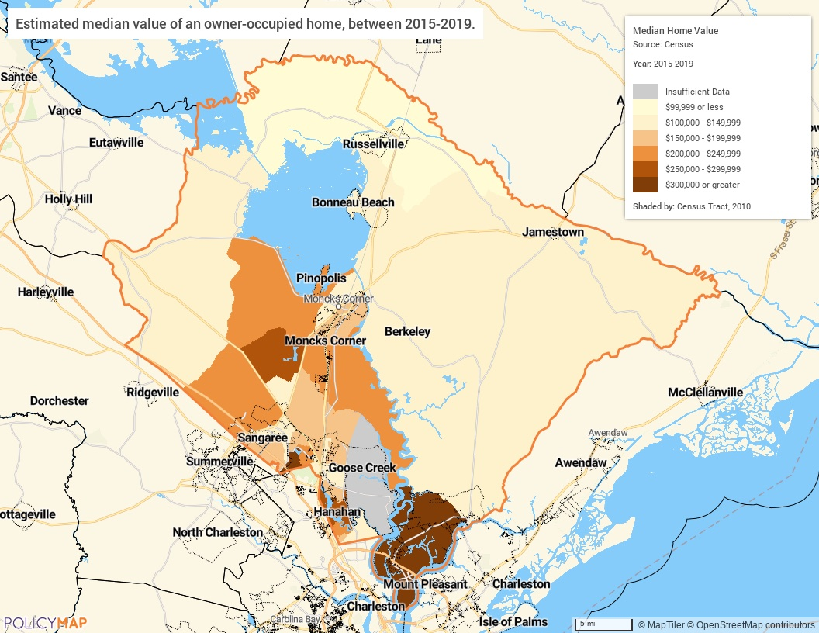
Median Home Value Map

Median Rent
The map below displays the median rent by census tract. Like the median home value above, higher rents are in Cane Bay in Summerville and on Daniel Island and in Cainhoy near Charleston and lower rents are in the rural areas.
Source: 2015-2019 American Community Survey 5-Year Estimates
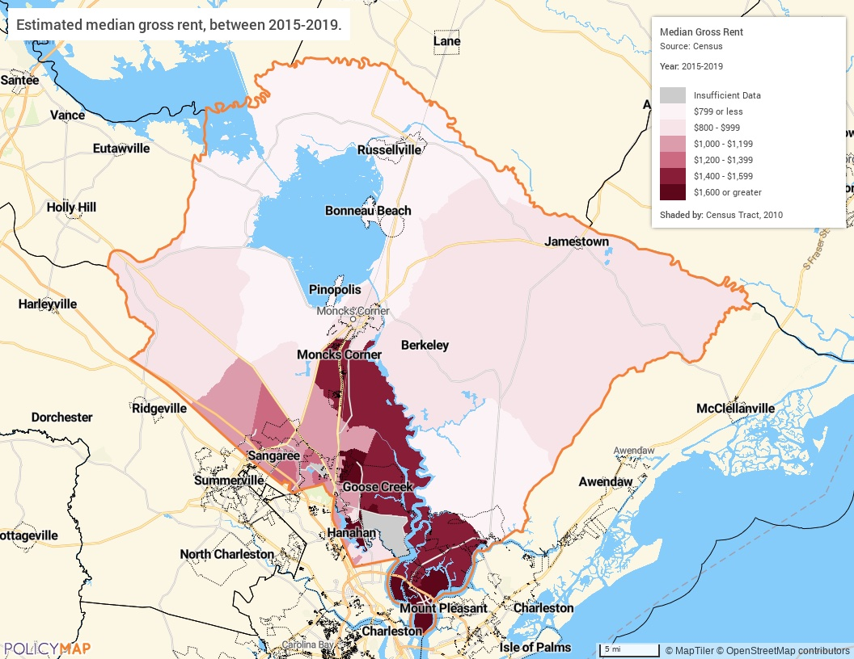
Median Rent Map

Housing Affordability

 | Owner | Estimate | Renter | Estimate
Less than $20,000 | 4273 | 8% | 2843 | 15%
$20,000 to $34,999 | 6166 | 11% | 3841 | 20%
$35,000 to $49,999 | 6259 | 11% | 3543 | 18%
$50,000 to $74,999 | 10603 | 19% | 4823 | 25%
$75,000 or more | 27323 | 50% | 4449 | 23%
Total | 54624 | 100% | 19499 | 100%
Table 1 - Household Income by Tenure
Household Income by Tenure
The above table breaks down the prevalence owner-occupied and rental units by household income. Homeowners tend to have higher incomes than renters, approximately half of all homeowners earn over $75,000. Renters tend to earn less, only 23% are in the highest income group and most earn less than $50,000.
Data Source: 2015-2019 ACS (B25106)

Monthly Rent
Monthly Rent ($) | Efficiency (no bedroom) | 1 Bedroom | 2 Bedroom | 3 Bedroom | 4 Bedroom
Fair Market Rent | 907 | 1,035 | 1,179 | 1,535 | 2,012
High HOME Rent | 903 | 968 | 1,163 | 1,335 | 1,470
Low HOME Rent | 708 | 759 | 911 | 1,053 | 1,175
Table 36 – Monthly Rent

Data Source Comments: | Berkeley County is part of the Charleston-North Charleston, SC MSA.

Fair Market Rent and High/Low HOME Rent Limits
Fair Market Rents (FMRs) are set by HUD and used to determine payment standard amounts for HUD Programs. HUD annually estimates FMRs for Office of Management and Budget (OMB) defined metropolitan areas, some HUD defined subdivisions of OMB metropolitan areas and each nonmetropolitan county.
HOME Rents Limits are based on FMRs published by HUD. HOME Rent Limits are set to determine the rent in HOME-assisted rental units and are applicable to new HOME leases.

Is there sufficient housing for households at all income levels?
No, there is not. Low income residents in particular lack access to safe and affordable housing stock that doesn’t leave them cost burdened or in substandard living conditions.
How is affordability of housing likely to change considering changes to home values and/or rents?
If current trends continue affordability will continue to decrease in the County. Home prices and rents need to not only stabilize but actually go down in order to reduce the number of cost burdened households in Berkeley County.
How do HOME rents / Fair Market Rent compare to Area Median Rent? How might this impact your strategy to produce or preserve affordable housing?
HOME Rents Limits are based on FMRs published by HUD. HOME Rent Limits are set to determine the rent in HOME-assisted rental units and are applicable to new HOME leases. The Median Rent in Berkeley County is $907. This amount is slightly less than the Low HOME Rent for a 2-bedroom or the High Home Rate for a 1-bedroom unit. The County will use this information to help guide projects and priorities in the Strategic Plan and Annual Action Plans.

MA-20 Housing Market Analysis: Condition of Housing – 91.210(a)
Introduction
The tables and maps in this section provide details on the condition of housing units throughout the County by looking at factors such as age, vacancy, and the prevalence of housing problems.
As defined by HUD, the four housing problems are:
- A home which lacks complete or adequate kitchen facilities
- A home which lacks complete or adequate plumbing facilities
- A home which is overcrowded (having more than one person per room)
- A household that is cost burdened (paying 30% or more of their income towards housing costs)
Definitions
Berkeley County follows the International Building Code as the base code for structures located within its boundaries. All homes must meet the minimum habitability standards for residential structures to include sanitary facilities with sink, lavatory, shower or tub and water closet in good working order. The homes must have hot and cold running water and heating facilities to allow for room temperature to be 68° in the winter. Electrical service must be operable and meet safety requirements, cooking equipment should be in working order and smoke detectors installed. The home must be connected to an approved and functional sanitary waste system and the structural integrity of the home must not be compromised.
Substandard housing is a dwelling unit that is either dilapidated or unsafe, thus endangering the health and safety of the occupant, or that does not have adequate plumbing or heating facilities.
Condition of Units
Condition of Units | Owner-Occupied |  | Renter-Occupied
Condition of Units | Number | % | Number | %
With one selected Condition | 11,190 | 20% | 8,556 | 40%
With two selected Conditions | 188 | 0% | 457 | 2%
With three selected Conditions | 19 | 0% | 20 | 0%
With four selected Conditions | 0 | 0% | 0 | 0%
No selected Conditions | 43,898 | 79% | 12,553 | 58%
Total | 55,295 | 99% | 21,586 | 100%
Table 37 - Condition of Units

Alternate Data Source Name:
2015-2019 ACS 5-Yr Estimates

Housing Conditions
The table above details the number of owner and renter households that have at least one housing condition. As stated previously, HUD describes four housing conditions as being problems: 1) the home lacks complete or adequate kitchen facilities, 2) the home lacks complete or adequate plumbing facilities 3) the home is overcrowded - defined as more than one person per room, 4) the household is cost burdened by paying more than 30% of their income towards housing costs.
Twenty percent of all owner-occupied housing units face at least one housing condition while 40% of all renters have at least one housing condition. Generally speaking, there are relatively few households with multiple housing problems, and when compared to the affordability statistics provided earlier in this section, it is clear that most housing problems are housing cost burden.

Year Unit Built
Year Unit Built | Owner-Occupied |  | Renter-Occupied
Year Unit Built | Number | % | Number | %
2000 or later | 23,294 | 42% | 7,896 | 37%
1980-1999 | 18,926 | 34% | 7,078 | 33%
1950-1979 | 12,122 | 22% | 6,237 | 29%
Before 1950 | 953 | 2% | 375 | 2%
Total | 55,295 | 100% | 21,586 | 101%
Table 38 – Year Unit Built

Alternate Data Source Name:
2015-2019 ACS 5-Yr Estimates

Year Unit Built
There is a relatively large percentage of housing units built since 2000. Since 2000, the County has added 23,294 owner-occupied units (42%) and 7,896 renter-occupied units (37%). The County, however, had 24% of owner-occupied units and 31% of renter-occupied units built before 1980. Homes built before 1980 are at risk of having lead-based paint inside of them.
Source: 2015-2019 American Community Survey 5-Year Estimates
Age of Housing
The maps below depict the prevalence of older housing units in the County. The first set of maps identifies the percentage of housing units built prior to 1940 while the second set of maps depicts housing units built prior to 1980. The darker shaded areas have higher concentrations of the older housing stock.
Source: 2015-2019 American Community Survey 5-Year Estimates
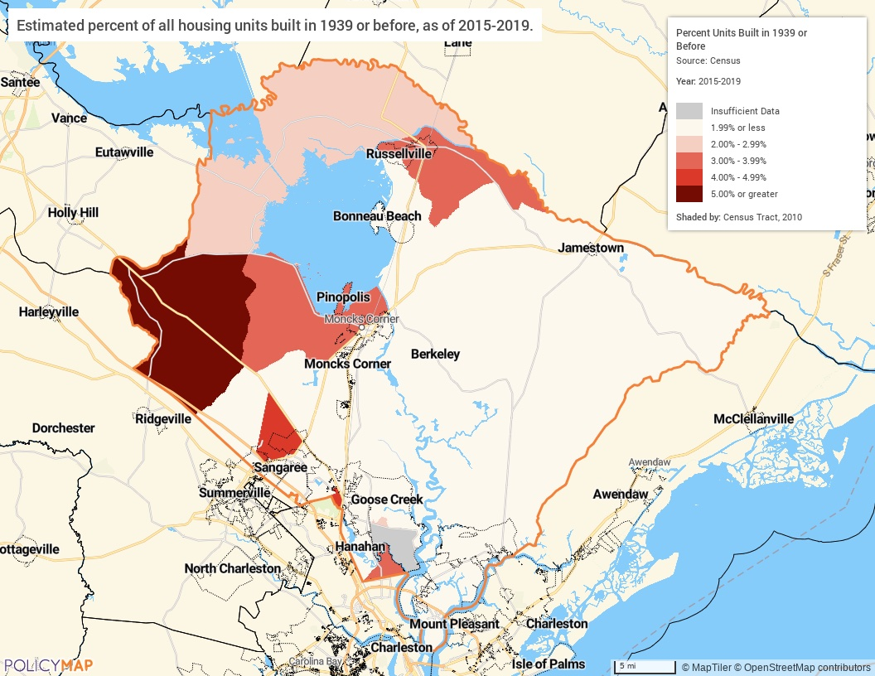
Housing Units Built Before 1940 Map

Housing Units Built Before 1940
Residential structures built prior to 1940 are more concentrated in the City of Hanahan and unincorporated Berkeley County in the Hanahan area. The Town of Moncks Corner, Santee Circle, Pringletown, Lebanon, Longridge, and Sandridge communities also show a higher level of pre-1940 construction.
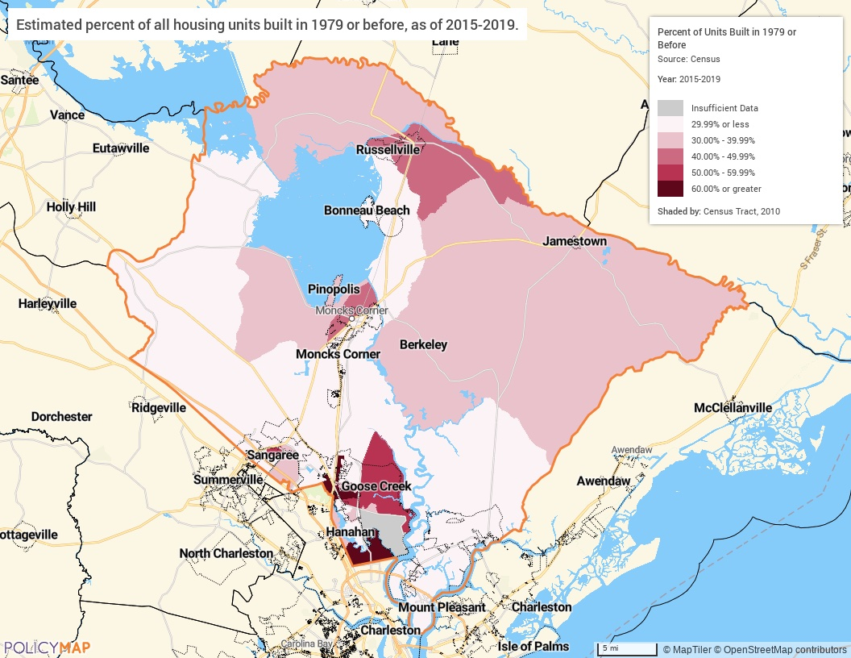
Housing Units Built Before 1980 Map

Risk of Lead-Based Paint Hazard

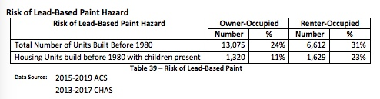
Risk of Lead-Based Paint Hazards (Table)

Lead-Based Paint Hazard
As mentioned previously, any housing unit built prior to 1980 may contain lead-based paint in portions of the home. The most common locations are window and door frames, walls, and ceilings, and in some cases throughout the entire home. Thus, it is generally accepted that these homes at least have a risk of lead-based paint hazards and should be tested in accordance with HUD standards. The greatest potential for lead-based paint and other environmental and safety hazards is in homes built before 1980. According to 2017 CHAS within the County there are 19,687 housing units built before 1980 and 2,949 with children present.

Vacancy Rate
The map below shows the average housing vacancy rates throughout the County. The darker shaded areas have higher vacancy rates, while the lighter shaded areas have lower vacancy rates. In most census tracts throughout the County vacancy rates are at least 10%; however, they are highest in the rural tracts.
Source: 2015-2019 American Community Survey 5-Year Estimates
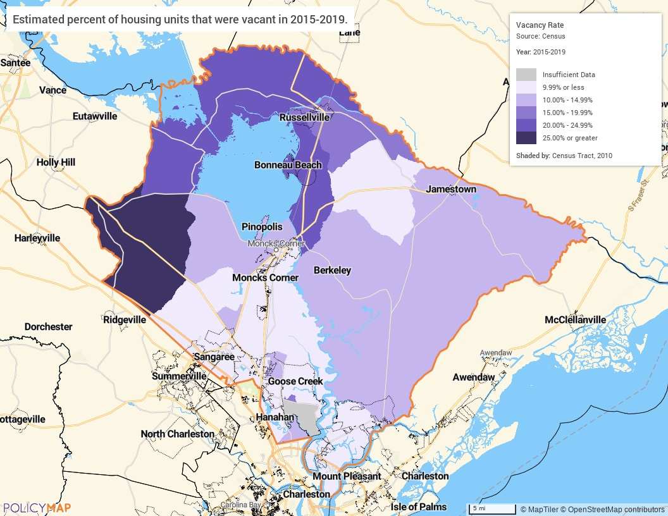
Vacancy Rate

Need for Owner and Rental Rehabilitation
As previously stated, a majority of the residential buildings have been constructed since 1980, and as such, are less likely to fall into the category of substandard. Code enforcement officers work to bring properties in violation into compliance.
However, generally older units begin to face these issues as the units age. As indicated in the Age of Housing table and maps, throughout Berkeley County, 24% of all owner-occupied housing units and 31% of all renter-occupied units were built prior to 1980 – comprising nearly 20,000 housing units in the County that may need rehabilitation.
Estimated Number of Housing Units Occupied by Low or Moderate Income Families with LBP Hazards
The greatest potential for lead-based paint and other environmental and safety hazards to children and their families exists in the approximate 1,328 homes built before 1940, and over 18,000 housing units built between 1940 and 1980. To promote safe and decent housing, it is important to identify and address these environmental hazards and safety issues present in these older homes. An estimated 25,080 persons live in poverty and are more likely to be in housing that was built prior to 1980 and frequently in dilapidated condition.

MA-25 Public and Assisted Housing – 91.210(b)
Introduction
The South Carolina Regional Housing Authority No. 3 is the local housing authority serving Berkeley County. Its mission is to promote housing stability by providing the tools necessary for families to identify, secure and maintain affordable housing and to increase the opportunity for self-sufficiency through employment and lifestyle skill development. Throughout the seven counties it serves it operates 787 public housing units and administers over 570 Housing Choice Vouchers for families in need of rental assistance. SCRHA3 manages two public housing complexes in the County with 78 units at St. Francis Villa Apartments in Moncks Corner and 50 units at Belangia Apartments in St. Stephen.
Totals Number of Units
Program Type
 | Certificate | Mod-Rehab | Public Housing | Vouchers
 |  |  |  | Total | Project -based | Tenant -based | Special Purpose Voucher
 |  |  |  |  |  |  | Veterans Affairs Supportive Housing | Family Unification Program | Disabled  *
# of units vouchers available |  |  | 787 | 572 |  |  | 0 | 0 | 0
# of accessible units

*includes Non-Elderly Disabled, Mainstream One-Year, Mainstream Five-year, and Nursing Home Transition
Table 41 – Total Number of Units by Program Type
Data Source: | PIC (PIH Information Center)

Describe the supply of public housing developments:
Describe the number and physical condition of public housing units in the jurisdiction, including those that are participating in an approved Public Housing Agency Plan:
SCRHA3 manages two public housing complexes in the County with 78 units at St. Francis Villa Apartments in Moncks Corner and 50 units at Belangia Apartments in St. Stephen.
St. Francis Villa Apartments in Moncks Corner received a PHA inspection score of 87 and is in good condition as reported by HUD in 9/9/2019. Belangia Apartments in St. Stephen does not currently have a PHA inspection score.

Public Housing Condition
Public Housing Development | Average Inspection Score
MONCKS CORNER | 84
Table 42 - Public Housing Condition

Describe the restoration and revitalization needs of public housing units in the jurisdiction:
HUD provides physical inspection scores for PHA developments across the country. The physical condition scoring process is based on three elements within the property, which are:
1. Inspectable areas: site, building exterior, building system, common areas and dwelling units;
2. Inspectable items: walls, kitchens, bathrooms and other things to be inspected in the inspectable area; and
3. Observed deficiencies.
A score of 55 or below means that the property is in poor condition, and properties in excellent condition have a score of 90 and over. The Moncks Corner public housing development received a PHA inspection score of 87 and is in good condition as reported by HUD in 10/4/2017. Belangia Apartments in St. Stephen does not currently have a PHA inspection score.
Describe the public housing agency's strategy for improving the living environment of low- and moderate-income families residing in public housing:
SCRHA3’s emphasis is to create stable housing for LMI families in the region. It will promote housing stability by providing all the necessary tools available to help them maintain this stability. Two of the main strategies involved are helping them find suitable employment and lifestyle skill development.

MA-30 Homeless Facilities and Services – 91.210(c)
Introduction
Homeless facilities and services in the area are provided primarily in the City of Charleston, which is outside of Berkeley County. The County does not have data on facilities and services within the County.
Facilities and Housing Targeted to Homeless Households
 | Emergency Shelter Beds |  | Transitional Housing Beds | Permanent Supportive Housing Beds
 | Year Round Beds (Current & New) | Voucher / Seasonal / Overflow Beds | Current & New | Current & New | Under Development
Households with Adult(s) and Child(ren) | 0 | 0 | 0 | 0 | 0
Households with Only Adults | 0 | 0 | 0 | 0 | 0
Chronically Homeless Households | 0 | 0 | 0 | 0 | 0
Veterans | 0 | 0 | 0 | 0 | 0
Unaccompanied Youth | 0 | 0 | 0 | 0 | 0
Table 43 - Facilities and Housing Targeted to Homeless Households

Data Source Comments:

Describe mainstream services, such as health, mental health, and employment services to the extent those services are use to complement services targeted to homeless persons
N/A
List and describe services and facilities that meet the needs of homeless persons, particularly chronically homeless individuals and families, families with children, veterans and their families, and unaccompanied youth. If the services and facilities are listed on screen SP-40 Institutional Delivery Structure or screen MA-35 Special Needs Facilities and Services, describe how these facilities and services specifically address the needs of these populations.
There are many services in the Charleston area that service people in the tri-county area that are experiencing homelessness. The challenge is for those in Berkeley County who need to travel to Charleston to receive the service.

MA-35 Special Needs Facilities and Services – 91.210(d)
Introduction
There are four primary groups with non-homeless special needs in the jurisdiction. They are the elderly and frail elderly, those with HIV/AIDS and their families, those with alcohol and/or drug addiction, and the mentally or physically disabled. This section will explain who they are, what their needs are, and how the jurisdiction is accommodating (or should accommodate) those needs.

Including the elderly, frail elderly, persons with disabilities (mental, physical, developmental), persons with alcohol or other drug addictions, persons with HIV/AIDS and their families, public housing residents and any other categories the jurisdiction may specify, and describe their supportive housing needs
Elderly: The supportive housing needs for this population can vary widely depending on the health and fitness of the individuals. In general, with aging disabilities and other health issues become more common. Because of this, supportive housing must include access to health professionals and housing modifications to assist the resident. It is important to help residents stay independent and in their own homes for as long as possible if they prefer that.
HIV/AIDS: Medical and social support is important for residents living with HIV/AIDS. While there have been great advances in the medical treatment of HIV/AIDS, it is still important to provide specialized support. Family and friends must be accessible and medical facilities should be nearby.
Alcohol and/or Drug Addiction: Individuals dealing with addiction often require housing options that will provide a safe, sober place for recovery. A strong network is necessary to maximize the chance they will stay healthy and sober. It is important that these persons have access to health services, support groups, employment assistance, and access to family and friends. Additionally, detoxification facilities are necessary when addiction is first recognized.
Mental and Physical Disabilities: Individuals with disabilities encompass a wide range of skill levels and abilities. Therefore, the have many of the same issues as the general population with the added needs that are unique to their situation. Often times, individuals with disabilities have a fixed income and limited housing options. Individuals with more independent skills can utilize subsidized housing but individuals that need more support or specialized housing have fewer options. Many individuals continue to reside with parents and families throughout adulthood, which can put additional financial burden on the family. Regardless of the housing situation, a common thread is the need to continuous support services dependent on the level of capabilities. The Berkeley Community Health Center, with support of the South Carolina Department of Mental Health, provides emergency services, case management, outpatient counseling and psychiatric treatment for children, adolescents, adults, and families in Berkeley County.
Describe programs for ensuring that persons returning from mental and physical health institutions receive appropriate supportive housing
There are limited programs within Berkeley County that ensure that persons returning from mental and physical health institutions receive appropriate supportive housing. Many of these services are conducted in the Charleston Metropolitan Region. Below is a list of programs that assist with this goal:
The South Carolina Regional Housing Authority No. 3 (SCRHA3) provides reasonable accommodations and modifications upon the request to all applicants, residents, and employees who have a disability to be able to fully use and enjoy their apartment and the apartment community.
Operation Home provides critical home repairs and wheel chair ramps for elderly. They are not physically located in Berkeley county, but do serve the area.
Oxford House has 3 houses in Goose Creek (24 total beds) providing transitional housing for people recovering from drug/alcohol addiction
Walking Women Welfare opened a transitional house in Berkeley county for homeless women, but I do not know anything about them or their legitimacy
Berkeley County is exploring ways to expand programs to ensure that persons returning from mental and physical health institutions receive appropriate supportive housing.
Specify the activities that the jurisdiction plans to undertake during the next year to address the housing and supportive services needs identified in accordance with 91.215(e) with respect to persons who are not homeless but have other special needs. Link to one-year goals. 91.315(e)
To address the housing and supportive service needs in the community, the County has made it a goal to serve this population in the Strategic Plan. The goal is:
3A Provide Supportive Services for Special Needs
The special needs community in the County has been identified as those who are elderly, persons with a disability, persons with alcohol or drug addiction, persons who are victims of domestic violence, persons at risk of becoming homeless or experiencing homelessness and persons living with HIV/AIDS. Supportive services help to improve the quality of life for the special needs population and work to keep them from being homeless.
For entitlement/consortia grantees: Specify the activities that the jurisdiction plans to undertake during the next year to address the housing and supportive services needs identified in accordance with 91.215(e) with respect to persons who are not homeless but have other special needs. Link to one-year goals. (91.220(2))
N/A See above.

MA-40 Barriers to Affordable Housing – 91.210(e)
Negative Effects of Public Policies on Affordable Housing and Residential Investment
Though public policies are meant to address the overall needs of citizens in Berkeley County, there are times where they may have a negative effect on certain aspects of the community, which in this case, are affordable housing and residential investment. Affordable housing and public and private residential investments are key components in furthering fair housing in any community. In part, to identify these negative effects and further the purposes of the Fair Housing Act, the U.S. Department of Housing and Urban Development (HUD) made it a legal requirement that entitlement grantees, such as Berkeley County, to affirmatively further fair housing. The primary tool communities have for identifying contributing factors for these barriers to fair housing is the Analysis of Impediments to Fair Housing Choice (AI).
The County adopted the 2015 Berkeley Comprehensive Plan 5-Year Review, which gave an assessment and review of the community profile and housing needs in the County. The plan identified several guiding principles which directly tied into affordable housing.
The main issue affecting housing affordability was significant population growth in a relatively short span of time. This growth increased development pressures to protect rural historic communities while supplying more housing. Heightened scrutiny on the type of development in the County was also a concern. To address this, the County identified several goals that would help to reduce barriers to affordable housing. They were:
- Berkeley County will support the provision of community services, essential for all population groups.
- Berkeley County will support the development of affordable housing and diverse housing types.
- Berkeley County will plan and implement mitigation strategies to protect existing communities and neighborhoods from physical deterioration due to natural hazards and/or neglect.
- Berkeley County will promote the development of complete communities within the Principal Growth Area as designated on the plan’s Future Land Use Map.
For more information on the 2015 Berkeley Comprehensive Plan 5-Year Review, see Berkeley County’s website at: https://www.berkeleycountysc.gov/drupal/dept/planning/plan

MA-45 Non-Housing Community Development Assets – 91.215 (f)
Introduction
This section provides insight into the economic development landscape of the County. Unemployment, commuting times, education, and business activity are all analyzed in this section.
Economic Development Market Analysis
Business Activity
Business by Sector | Number of Workers | Number of Jobs | Share of Workers  % | Share of Jobs  % | Jobs less workers  %
Agriculture, Mining, Oil & Gas Extraction | 415 | 327 | 0 | 1 | 1
Arts, Entertainment, Accommodations | 8,441 | 6,204 | 9 | 11 | 2
Construction | 8,068 | 4,837 | 8 | 8 | 0
Education and Health Care Services | 18,594 | 8,417 | 19 | 14 | -5
Finance, Insurance, and Real Estate | 4,333 | 2,368 | 4 | 4 | 0
Information | 1,678 | 581 | 2 | 1 | -1
Manufacturing | 11,914 | 6,034 | 12 | 10 | -2
Other Services | 4,672 | 1,569 | 5 | 3 | -2
Professional, Scientific, Management Services | 12,035 | 9,341 | 12 | 16 | 4
Public Administration | 6,487 | 2,237 | 7 | 4 | -3
Retail Trade | 11,382 | 8,395 | 12 | 14 | 2
Transportation and Warehousing | 6,142 | 5,486 | 6 | 9 | 3
Wholesale Trade | 2,291 | 2,655 | 2 | 5 | 3
Total | 96,452 | 58,451 | -- | -- | --
Table 45 - Business Activity

Alternate Data Source Name:
2014-2018 ACS (Workers), 2018 LEHD (Jobs)

Data Source Comments: | The Business Activity table above compares the number of workers to the number of jobs in the city. At this time, the most recent data set for the number of jobs was 2018 from the Longitudinal Employer-Household Dynamics (LEHD), US Census Bureau. Data from the 2014-2018 ACS 5-Year estimates was used for comparison.

Labor Force
Total Population in the Civilian Labor Force | 105,593
Civilian Employed Population 16 years and over | 100,320
Unemployment Rate | 3.80
Unemployment Rate for Ages 16-24 | 12.70
Unemployment Rate for Ages 25-65 | 4.10
Table 46 - Labor Force

Alternate Data Source Name:
2015-2019 ACS 5-Yr Estimates

Data Source Comments: | Unemployment Rate data is from October 2020. All other data including Unemployment Rate by Age is from the 2015-2019 ACS.

2010 | 2011 | 2012 | 2013 | 2014 | 2015 | 2016 | 2017 | 2018 | 2019
10.0 | 9.6 | 8.4 | 7.0 | 6.0 | 5.5 | 4.6 | 3.8 | 3.4 | 2.5
Table 1 - Unemployment Rate Over Time, 2010-2019 BLS
Jan | Feb | Mar | Apr | May | Jun | Jul | Aug | Sep | Oct
2.6 | 2.7 | 2.8 | 10.8 | 11.0 | 8.3 | 8.6 | 6.3 | 4.5 | 3.8
Table 1 - Unemployment Rate Over Time, January 2020 to October 2020 BLS
Unemployment
Countywide, the unemployment rate is 3.8% for all persons in the civilian workforce. Approximately 12.7% of persons between the ages of 16 and 24 are unemployed. The County’s total overall unemployment rate is lower than the state unemployment rate of 5.8%
In the following map, unemployment is higher in the rural areas of the County.
Source: 2015-2019 American Community Survey 5-Year Estimates
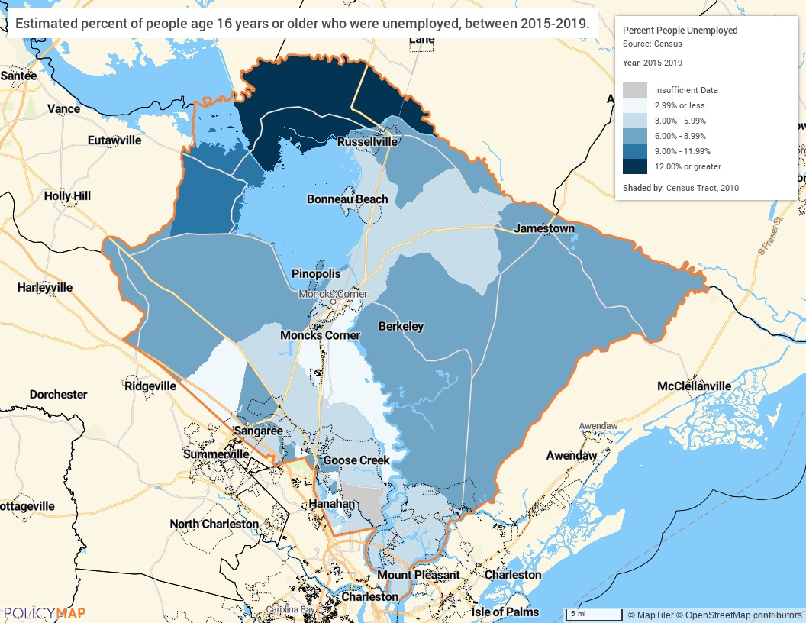
Unemployment Rate Map

Occupations by Sector | Number of People
Management, business and financial | 34,001
Farming, fisheries and forestry occupations | 129
Service | 18,401
Sales and office | 21,892
Construction, extraction, maintenance and repair | 11,124
Production, transportation and material moving | 14,773
Table 47 – Occupations by Sector

Alternate Data Source Name:
2015-2019 ACS 5-Yr Estimates

Occupations by Sector
The largest employment sector is in the management, business and financial sector, employing 34,001 persons throughout the County. This sector is followed by the sales and office sector with 21,892 persons employed and the service sector with 18,401.
Travel Time
Travel Time | Number | Percentage
< 30 Minutes | 53,775 | 54%
30-59 Minutes | 37,593 | 38%
60 or More Minutes | 7,302 | 7%
Total | 98,670 | 100%
Table 48 - Travel Time

Alternate Data Source Name:
2015-2019 ACS 5-Yr Estimates

Commute Travel Time
Fifty-five percent of all persons commuting to work have a commute of less than 30 minutes each way. Approximately 7% of all employed persons have a commute of 60 minutes or more, to and from work each day. Compared to elsewhere in the jurisdiction, higher average commute times are much more likely from the rural tracts into larger city centers in Charleston and Dorchester counties.
Source: 2015-2019 American Community Survey 5-Year Estimates
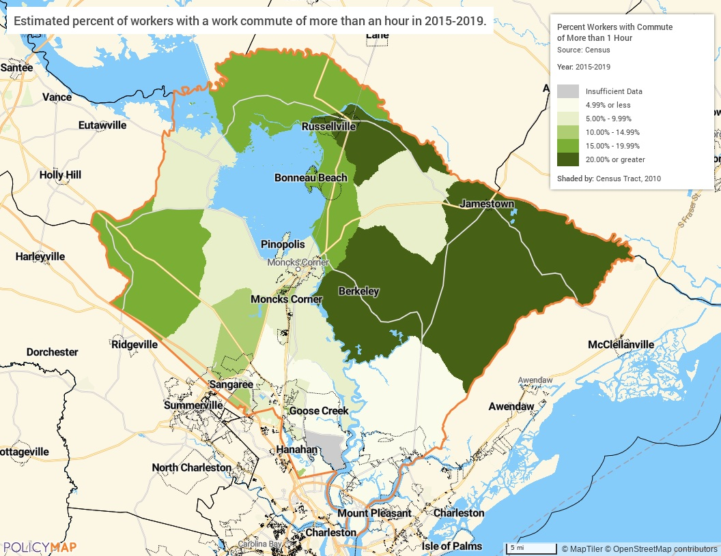
Commute Travel Time Greater Than One Hour

In-Area Labor Force Efficiency (All Jobs) | Count | Share
Living in the Selection Area | 91,852 | 100.0%
Living and Employed in the Selection Area | 23,627 | 25.7%
Living in the Selection Area but Employed Outside | 68,225 | 74.3%
In-Area Employment Efficiency (All Jobs) | Count | Share
Employed in the Selection Area | 58,451 | 100.0%
Employed and Living in the Selection Area | 23,627 | 40.4%
Employed in the Selection Area but Living Outside | 34,824 | 59.6%
Data Source: 2018 LEHD
Table 1 - Inflow & Outflow of Workers
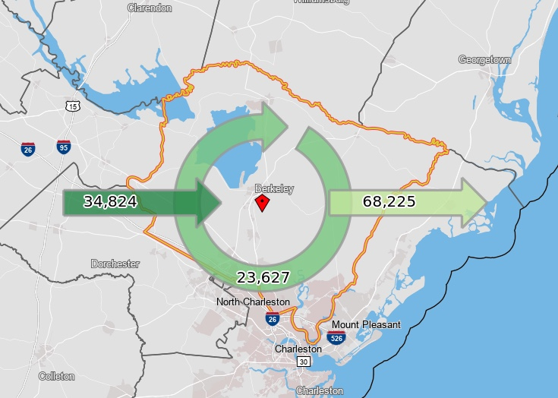
Inflow Outflow of Workers in Berkeley County, 2018

Education:
Educational Attainment by Employment Status (Population 16 and Older)
Educational Attainment | In Labor Force
Educational Attainment | Civilian Employed | Unemployed | Not in Labor Force
Less than high school graduate | 5,662 | 967 | 4,760
High school graduate (includes equivalency) | 22,211 | 1,686 | 8,820
Some college or Associate's degree | 31,044 | 1,232 | 8,254
Bachelor's degree or higher | 24,534 | 977 | 3,640
Table 49 - Educational Attainment by Employment Status

Alternate Data Source Name:
2015-2019 ACS 5-Yr Estimates

Educational Attainment by Age
 | Age
 | 18–24 yrs | 25–34 yrs | 35–44 yrs | 45–65 yrs | 65+ yrs
Less than 9th grade | 202 | 822 | 915 | 1,496 | 1,665
9th to 12th grade, no diploma | 2,381 | 2,368 | 1,732 | 3,661 | 2,558
High school graduate, GED, or alternative | 7,449 | 8,101 | 6,397 | 17,927 | 9,668
Some college, no degree | 7,424 | 8,237 | 7,610 | 11,984 | 6,282
Associate's degree | 1,070 | 3,604 | 3,754 | 5,875 | 2,582
Bachelor's degree | 1,886 | 6,220 | 5,646 | 8,489 | 3,388
Graduate or professional degree | 115 | 2,229 | 2,368 | 4,643 | 2,734
Table 50 - Educational Attainment by Age

Alternate Data Source Name:
2015-2019 ACS 5-Yr Estimates

Educational Attainment – Median Earnings in the Past 12 Months
Educational Attainment | Median Earnings in the Past 12 Months
Less than high school graduate | 25,751
High school graduate (includes equivalency) | 32,279
Some college or Associate's degree | 38,305
Bachelor's degree | 50,694
Graduate or professional degree | 64,132
Table 51 – Median Earnings in the Past 12 Months

Alternate Data Source Name:
2015-2019 ACS 5-Yr Estimates

Median Earnings by Educational Attainment
Not surprisingly, the median earnings of individuals in the County are closely tied to educational attainment. Median earnings increase as individuals attain higher education. A person with a bachelor’s degree can expect to earn nearly twice that of a person without a high school degree. A person with a graduate or professional degree can expect to earn more than twice somebody with only a high school degree.
Based on the Business Activity table above, what are the major employment sectors within your jurisdiction?
In Berkeley County, the “Education and Health Care Services” is the largest sector for the number employees and the “Professional, Scientific, Management Services” sector is the largest for jobs. Other major sectors include Manufacturing and Retail Trade.
Describe the workforce and infrastructure needs of the business community:
There are four identified workforce and infrastructure needs in Berkeley County:
- Transportation;
- Access to training and higher education to close the skills gap;
- Access to adequate broadband; and,
- Affordable housing.
Transportation: With limited bus routes only running a few hours in the morning and afternoon, it is a challenge to align timing with shifts for certain employers. For residents in the rural areas of the county, changing buses multiple times is often needed. There are no bus routes to several of the larger industries and industrial parks. Plans for the Bus Rapid Transit (BRT) Line is still decades out from reaching the upper rural part of Berkeley County and will still only connect Moncks Corner through Goose Creek, North Charleston, and downtown Charleston. Many of the higher wage employers do not fall on the BRT route.
Training and Higher Education: The need for better communication between the Berkeley County School District (BCSD), institutions of higher education/technical colleges, and industry is paramount to providing the necessary trainings for skill development to fill the current workforce needs now and into the future. This includes better messaging to youth on all opportunities outside traditional secondary education. More short-term programs and internships are needed that can train citizens in high demand sectors such as welding, plumbing, electrical work, and lean manufacturing, like ManuFirst SC. The ManuFirst SC Certificate Program provides 62 hours of training in the areas of safety, quality practices and measurement, manufacturing processes and production, maintenance awareness, and OSHA-10.
Broadband: Access to broadband positively affects residents with increased accessibility to online resources, training, healthcare and e-commerce transactions. Adequate access to broadband helps larger industries where a majority of transactions now involve electronic data exchange, thus making it more challenging to recruit large industries to rural areas in the county. Broadband can streamline operations and efficiency for small businesses. There is a lack of broadband access in the rural areas surrounding the Town of St. Stephen and the upper part of Lake Moultrie.
Affordable housing: Rising housing costs have put a growing strain on the workforce where 4,040 renters and 3,965 homeowners are spending half their income on housing costs. Wages have not kept pace with cost of housing. Public and private investments are needed to build quality workforce housing near employment centers to lower housing and transportation cost burden.
Describe any major changes that may have an economic impact, such as planned local or regional public or private sector investments or initiatives that have affected or may affect job and business growth opportunities during the planning period. Describe any needs for workforce development, business support or infrastructure these changes may create.
There have been many recent successful private and public partnerships in Berkeley County that have had a positive impact for job growth such as the partnership with Volvo Cars to create ManuFirst, a 4-week course that provides the necessary training to qualify candidates for entry level manufacturing positions. The training program is offered to the Tri-County (Berkeley-Charleston-Dorchester County Region) through Trident Technical College. Another private and public partnership more recently announced is the implantation of new welding labs and programs at two rural high schools (Cross and Timberland) in Berkeley County that will be open to high school students and offer an adult vocational training program in the evenings. This partnership with Berkeley County, BCSD and W International, a new industry seeking hundreds of welders, will provide free welding training for Berkeley County residents.
Additional planning is needed to address the industrial, residential, and infrastructure growth and to develop employment centers in proximity to population centers. This planned growth should include an expansion of available resources such as education and training, libraries, community centers, healthcare, and basic needs.
How do the skills and education of the current workforce correspond to employment opportunities in the jurisdiction?
The 2017 – 2022 Talent Demand Analysis released by the Charleston Chamber of Commerce reported the annual job openings beyond the local graduate output is in production/mechanical; software/IT; hospitality; and, construction. Local employers report employees and applicants lack soft skills and smaller manufacturing employers are having difficulty filling available openings as employees leave for more pay with larger industries. Skilled trade workers are in high demand in specialty trades, healthcare, construction, transportation/logistics, IT, and manufacturing.
Describe any current workforce training initiatives, including those supported by Workforce Investment Boards, community colleges and other organizations. Describe how these efforts will support the jurisdiction's Consolidated Plan.
Berkeley County noted six workforce training initiatives currently underway.
- New Welding Programs at Cross and Timberland High Schools. The program is open to students during the day and adults in the evenings and are free to Berkeley County residents.
- ManuFirst SC – A training program originally developed for Volvo Car USA in Berkeley County, has been expanded statewide. The certificate program provides 62 hours of free training in the areas of safety, quality practices and measurement, manufacturing processes and production, maintenance awareness, and OSHA-10.
- The Workforce Innovation and Opportunity Act (WIOA) provides occupational skills training for in-demand sectors. These trainings provide opportunities to eligible individuals who can complete trainings and fill in some of the gaps in the in-demand occupations. WIOA partners with community colleges and other local workforce partners to offer this program and facilitate trainings.
- SC Codes - A collaboration by SC Dept of Commerce’s Office of Innovation and Build Carolina, is a free online coding education platform to enable SC residents to gain a technology skill set to improve their employment potential in the tech arena. SC Codes is available at no cost to any resident of South Carolina. SC Codes partners with community groups, industry, and coding mentors to improve the population’s digital literacy skills.
- ReadySC™ a part of the SC Technical College System offers training for employees of new or expanding businesses.
- SC Works Trident, a Berkeley Charleston Dorchester Council of Governments program, offers youth and adult on-the job training and education.
All these initiatives align with the consolidated plan.
Does your jurisdiction participate in a Comprehensive Economic Development Strategy (CEDS)?
Yes
If so, what economic development initiatives are you undertaking that may be coordinated with the Consolidated Plan? If not, describe other local/regional plans or initiatives that impact economic growth.
The Berkeley-Charleston-Dorchester Region CEDS identified five goals that can be coordinated with the Consolidated Plan.
- Grow and support Region’s economic base around existing and new sectors that provide long-term economic resiliency and growth
- Continue to provide a hospitable and healthy business climate to attract the right investments
- Ensure that all residents of the Region have access to a variety of education and training opportunities
- Work to further increase intergovernmental cooperation and coordination in order to strengthen regional unity and success
- Seek to protect and preserve the cultural and natural resources for the future generations of the Tri-County area, as well as seek to provide an affordable place to live.

MA-50 Needs and Market Analysis Discussion
Are there areas where households with multiple housing problems are concentrated? (include a definition of "concentration")
HUD identifies four specific data points that constitute "housing problems": cost burden, overcrowding, lack of complete plumbing facilities, and lack of complete kitchen facilities. Within the jurisdiction as a whole, 0.3% of occupied units lack complete plumbing, 0.3% occupied units lack complete kitchen facilities, 1.9% are overcrowded, and 27.6% are cost burdened. For the purposes of this section, areas of concentration are census tracts that have two or more housing problems that are substantially higher than the regional average or, more specifically, a lack of complete plumbing over 5.0%, lack of complete kitchen facilities over 5.0%, overcrowding over 10%, and cost burdened over 50%.
There are four census tracts in Berkeley County where housing problems are concentrated:
205.03
- Lack of Complete Plumbing: 9.0%
- Lack of Complete Kitchen: 5.5%
- Renter Cost Burden: 56.7%
201.02
- Lack of Complete Plumbing: 9.2%
- Lack of Complete Kitchen: 7.6%
207.25
- Homeowner Cost Burden: 50%
- Renter Cost Burden: 78.3%
Are there any areas in the jurisdiction where racial or ethnic minorities or low-income families are concentrated? (include a definition of "concentration")
Racial and Ethnic Minorities
In Berkeley County the most populous racial minority is Black or African American. This population makes up 23.8% of the County. Hispanic residents also have a relatively large population and make up 6.6% of the County. For the purpose of this section a concentration is defined as a census tract with a Black or African American, non-Hispanic, population over 33.8% and/or a Hispanic population over 16.6%. By this definition there are several tracts with a concentration of racial or ethnic minorities. See the below list and maps.
Black of African American, non-Hispanic
- 201.01 - 55.1%
- 201.02 - 41.0%
- 202.01 - 53.0%
- 202.02 - 75.1%
- 204.01 - 40.2%
- 204.05 - 59.4%
- 205.04 - 51.2%
- 205.05 - 35.2%
- 208.06 - 34.9%
- 208.08 - 34.2%
- 208.11 - 37.3%
Hispanic
- 208.10 - 22.3%
- 210.00 - 20.2%
Low Income
A census tract is considered a concentration of low-income households if the median household income (MHI) is 80% or less of the County MHI. The MHI in Berkeley County is $63,309 and low income is $50,647. There are 12 census tracts with a concentration of low-income households. See the below list and map.
- 201.01 - $40,434
- 202.01 - $30,417
- 202.02 - $40,896
- 204.01 - $40,540
- 205.04 - $50,216
- 205.06 - $50,047
- 207.12 - $46,686
- 208.11 - $41,265
- 210.00 - $41,506
What are the characteristics of the market in these areas/neighborhoods?
There is no uniform market characteristics for the areas that show concentrations of low-income or racial/ethnic minorities. Areas with a high number of low-income households tend to be more rural and lack transportation options to urban centers. The tracts with large Hispanic and Black/African American populations are more urban and are concentrated near the County’s border with Charleston.
Are there any community assets in these areas/neighborhoods?
Rural Census Tracts: There are limited assets in many of the census tracts identified. Small populations, which means an incredibly limited tax base, prevents significant development in the area. Smaller communities have access to public community parks.
Urban Tracts: These tracts have access to urban centers and military facilities through transportation modes that provide job opportunities. Public and private resources are more heavily concentrated in Charleston County. The landscape of Berkeley County along and near Interstate 26 in Summerville is changing with more manufacturing facilities and large planned residential developments and town centers under construction.
Are there other strategic opportunities in any of these areas?
Yes, these areas provide opportunities to improve the lives of the citizens, particularly in the urban areas. Unfortunately, providing resources and attracting economic opportunities to rural areas is more difficult and expensive.

MA-60 Broadband Needs of Housing occupied by Low- and Moderate-Income Households - 91.210(a)(4), 91.310(a)(2)
Describe the need for broadband wiring and connections for households, including low- and moderate-income households and neighborhoods.
Internet is an essential communications and information platform that allows users to take advantage of the increased interconnectedness of business, education, commerce, and day to day utility. Reliable access to the internet is becoming a necessity to thrive in the modern economic environment. Communities that lack broadband access struggle to keep pace with the country. Locations without broadband access impedes its population’s ability to take advantage of the educational and entrepreneurial opportunities available online. This is particularly problematic for LMI areas where economic opportunities are already often lacking. Studies suggest a strong correlation between increased high-speed internet access and increased education and employment opportunities, especially in small cities and rural areas.
Berkeley County does not have significant gaps in broadband coverage in the residential areas. Most of the county has multiple options of internet providers, to include LMI areas. The average Berkeley County household has at least two (2) options for broadband-quality Internet service; however, an estimated 12,000 locals still don't have access to more than one provider and may have to rely on low-grade wireless.
The following map shows broadband access throughout the County. Broadband access is defined as advertised internet speeds of 768 kilobits per second or higher. FCC data shows three major infrastructure options within Berkeley County: cable, DSL, and fiber.
See map: Broadband Access
Describe the need for increased competition by having more than one broadband Internet service provider serve the jurisdiction.
Once broadband access has been obtained, it is important to ensure there is competition among service providers. Any resource that has a de facto monopoly on an area may not be incentivized to provide standard and consistent services. Berkeley County has a total of seven (7) Internet providers offering residential service (Source: BroadbandNow). Xfinity and AT&T (DSL) are the strongest providers in Berkeley County so far as coverage. The average Berkeley County household has two (2) options for broadband-quality Internet service. These providers frequently overlap around the county:
AT&T Internet (DSL and Fiber)
Spectrum (Cable)
Xfinity (Cable)
Earthlink (DSL and Fiber)
Home Telecom (Fiber, Cable, and DSL)
Viasat Internet (formerly Exede) (Satellite)
HughesNet (Satellite)
The following map shows the number of broadband service providers by census tract. Most of the residential areas in the county have two (2) options of high-speed internet with competitive providers, though there are some tracts with lower populations that only have access to one provider. While this is the latest data available from the FCC, substantial efforts have been made in response to the global pandemic known as the Coronavirus or COVID-19 in South Carolina. According to the SC Department of Education (SCDE), funds from the federal CARES Act were appropriated to fund free hotspots and monthly internet access for poverty student households. Similar pricing was also negotiated for school district-funded purchases of hotspots and internet for any households not eligible for the free offer and for the period January to June 2021. In addition, the SCDE is posting information on low-cost internet service available to eligible families.
See map: Highspeed Internet Providers
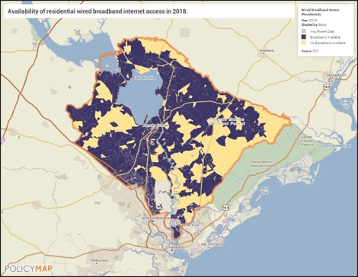
Broadband Access
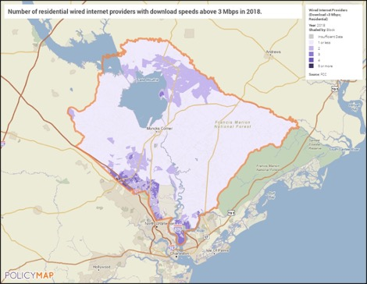
Highspeed Internet Providers

MA-65 Hazard Mitigation - 91.210(a)(5), 91.310(a)(3)
Describe the jurisdiction’s increased natural hazard risks associated with climate change.
Berkeley County has historically been prone to various natural hazard events including flooding, hail, thunderstorm winds, tropical storms, hurricanes, winter storms, drought and others. The potential impacts of climate change—including an increase in prolonged periods of excessively high temperatures, more heavy precipitation, more severe storms or droughts—are often most significant for vulnerable communities. The County is located near the coast and is impacted by the coastal effects. According to the Intergovernmental Panel on Climate Change (IPCC), by the middle of the century the average summer temperature is expected to rise four degrees. This rise in temperature could lead to altered weather and precipitation patterns, a rise in severe storms, an increased risk of catastrophic floods, increased electricity costs, and ruined crops. Additionally, any increase in the ocean levels or increased storm activity will lead to people moving from the coast. These environmental changes may eventually lead people away from the coast. However, coastal populations have historically continued to see an increase in population from year to year. An increase of people may drive up housing costs, reduce the availability of jobs, and tax resources, while a decrease in population could cause labor shortages, decrease in competition for services, driving up costs and reducing quality, and reduced resources for locals. Coastal areas must continue to address their geographic challenges by anticipating, planning, and adapting to risks from flooding, sea level rise, and storm surge.
Describe the vulnerability to these risks of housing occupied by low- and moderate-income households based on an analysis of data, findings, and methods.
Low- and moderate-income residents are at particular risk due to having less available resources to combat the impacts of natural disasters. A dramatic rise in electricity or housing costs could put them at imminent risk of homelessness or living in substandard conditions. Residents in rural communities will have less access to public support in case of emergencies and will have fewer resources to repair or prevent damage to their homes.
Berkeley County strives to inform and prepare the general public for multi-hazard mitigation There are online venues (including the Berkeley County website and Facebook, SC Emergency Management Division (SCEMD) website and social media pages, the SC Voluntary Organizations Active in Disaster (SCVOAD) website and social media pages, and the Trident VOAD Facebook page) that disseminate numerous informational guidebooks, videos, and emergency resources to build disaster resiliency in the community.

Strategic Plan

SP-05 Overview
Strategic Plan Overview
The community planning and development strategies in this Strategic Plan are intended to help guide decision-making and to assure that the County’s resources are coordinated in the best possible manner to meet the needs in the community. The Countywide goal of community planning and development programs is to develop viable communities by providing a suitable living environment for its citizens, especially for low- and moderate-income (LMI) individuals and the special needs population.
The County allocates its federal community development funds to those areas of the County that qualify for CDBG funds based on income. The greatest obstacle to meeting unmet needs and underserved populations is the lack of funds to address all the needs of the community. Through a series of community needs meetings, a community survey and input from stakeholder organizations in the area, the County was able to determine that the priority needs of the community were:
- Expand & Improve Public Facilities
- Reduce Slum & Blight in Residential Areas
- Public Services & Quality of Life Improvements

SP-10 Geographic Priorities – 91.215 (a)(1)
Geographic Area
Table 52 - Geographic Priority Areas
1 | Area Name: | Countywide
1 | Area Type: | Local Target area
1 | Other Target Area Description:
1 | HUD Approval Date:
1 | % of Low/ Mod:
1 | Revital Type: | Comprehensive
1 | Other Revital Description:
1 | Identify the neighborhood boundaries for this target area. | Berkeley County boundaries
1 | Include specific housing and commercial characteristics of this target area. | According to the 2015-2019 ACS, approximately 25.6% or 19,687 housing units were built before 1980 in the County. The largest type of housing is 1-unit, detached housing with over 54,000 units, or 64% of all the units in the County. The average median value of homes in the County is $185,500, however median home values were not the same throughout the County as rural areas saw lower values than more urban areas.
1 | How did your consultation and citizen participation process help you to identify this neighborhood as a target area? | There is a need to expand and improve public infrastructure & facilities, reduce slum & blight in residential areas and provide public services & quality of life improvements throughout the County. These needs were identified through a series of community meetings, a community survey and a stakeholder survey with nonprofit organizations and local government departments.
1 | Identify the needs in this target area. | There is a need to expand and improve public infrastructure & facilities, reduce slum & blight in residential areas and provide public services & quality of life improvements in the County.
1 | What are the opportunities for improvement in this target area? | The expansion and improvement of adequate public infrastructure and facilities is essential to addressing the needs of the County’s LMI neighborhoods. Activities that reduce slum and blight will help to control environmental hazards, remove dilapidated buildings and overgrown lots. Public service program development will help with economic growth, education and improve living situations of LMI individuals and households throughout the County.
1 | Are there barriers to improvement in this target area? | Access to adequate funding is a barrier to improvement in the County.

General Allocation Priorities
Describe the basis for allocating investments geographically within the jurisdiction (or within the EMSA for HOPWA)
There is a need to expand and improve public facilities, reduce slum & blight and provide public services & quality of life improvements throughout low- and moderate-income areas in the County.

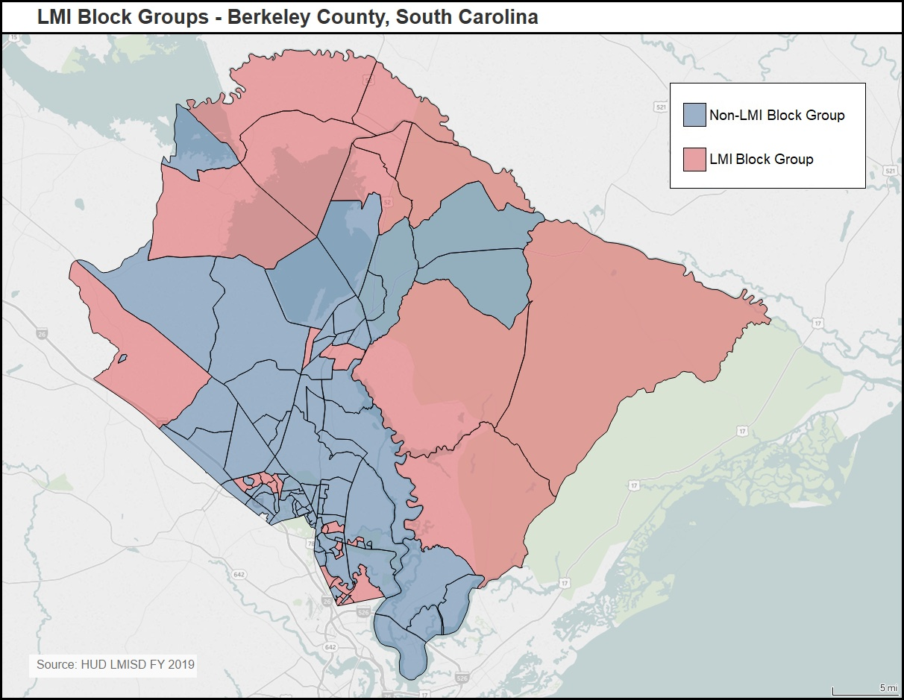
LMI Block Group Tracts

SP-25 Priority Needs - 91.215(a)(2)
Priority Needs
Table 53 – Priority Needs Summary
1 | Priority Need Name | Expand & Improve Public Facilities
1 | Priority Level | High
1 | Population | Extremely Low  Low  Moderate  Elderly  Persons with Physical Disabilities
1 | Geographic Areas Affected | Countywide
1 | Associated Goals | 1A Improve Access to Public Facilities
1 | Description | Public facilities improvements to community centers in low- to moderate-income areas.
1 | Basis for Relative Priority | The expansion and improvement of adequate public facilities is essential to addressing the needs of the County’s low-income neighborhoods.
2 | Priority Need Name | Reduce Slum & Blight in Residential Areas
2 | Priority Level | High
2 | Population | Extremely Low  Low  Moderate  Elderly  Persons with Physical Disabilities
2 | Geographic Areas Affected | Countywide
2 | Associated Goals | 2A Reduce Slum & Blight in Residential Areas
2 | Description | Activities that reduce slum and blight will help to control environmental hazards, remove dilapidated buildings and overgrown lots.
2 | Basis for Relative Priority | There is a need to reduce slum and blight in LMI residential areas of the County to improve safety and improve the living situation
3 | Priority Need Name | Public Services & Quality of Life Improvements
3 | Priority Level | High
3 | Population | Extremely Low  Low  Moderate  Elderly  Persons with Physical Disabilities
3 | Geographic Areas Affected | Countywide
3 | Associated Goals | 3A Provide Supportive Services for Special Needs P  3B Provide Vital Services for LMI Households  3C Provide for Improvements to Owner-occupied Hous
3 | Description | Public Services offered by partner nonprofit organizations provide for vital and essential services for low- and moderate-income households and families throughout the jurisdiction. The County will allocate CDBG funding for these services and strive to continue improving and expanding these services. The County will provide for improvements to owner-occupied housing through local partnerships.
3 | Basis for Relative Priority | Public service program development is a high priority as it will help with economic growth, education and improve living situations of LMI individuals and households throughout the County. Improvements to owner-occupied housing is a priority in the County.

SP-30 Influence of Market Conditions – 91.215 (b)
Influence of Market Conditions
Affordable Housing Type | Market Characteristics that will influence  the use of funds available for housing type
Tenant Based Rental Assistance (TBRA) | N/A
TBRA for Non-Homeless Special Needs | N/A
New Unit Production | The County will support development through the improvement and expansion of public infrastructure and facilities which will in turn encourage housing development in the area. As the population steadily increases throughout the County, there is a need for more housing that is affordable for low- and moderate-income households.
Rehabilitation | The relatively large number of housing units that are old and aging remains a concern. According to the 2015-2019 ACS, approximately 25.6% or 19,687 housing units were built before 1980 in the County. That is a significant amount of homes that are aging.
Acquisition, including preservation | There is a need to remove old, vacant or dilapidated housing from the community. As mentioned above, there is a significant amount of homes in the County that may need rehabilitation or demolition. For this purpose, the County will reduce slum and blight through demolition of buildings and housing code enforcement and foreclosed property care.
Table 54 – Influence of Market Conditions

SP-35 Anticipated Resources - 91.215(a)(4), 91.220(c)(1,2)
Introduction
In 2021, Berkeley County became an entitlement community, eligible for federal funding from the US Department of Housing and Urban Development (HUD). This section outlines Community Development Block Grant (CDBG) funding the County anticipates receiving on an annual basis for the 2021-2025 period covered by this Consolidated Plan. The CDBG program works to ensure decent affordable housing, to provide vital services to the most vulnerable people in the County’s communities, and to create jobs through the expansion and retention of businesses.
The County anticipates an annual allocation for CDBG funds of approximately $1,227,757 for each year of the Five-Year Consolidated Plan period.
Minor Amendment: The County was notified by HUD on May 17, 2021 that there was an error in the PY 2021 CDBG allocation. The allocation was revised from $1,209,927 to the new amount of $1,227,757 which was an increase of $17,830. The additional funds were added to the admin project, which does not exceed the 20% admin cap.
Anticipated Resources
Program | Source of Funds | Uses of Funds | Expected Amount Available Year 1 |  |  |  | Expected Amount Available Remainder of ConPlan  $ | Narrative Description
Program | Source of Funds | Uses of Funds | Annual Allocation: $ | Program Income: $ | Prior Year Resources: $ | Total:  $ | Expected Amount Available Remainder of ConPlan  $ | Narrative Description
CDBG | public - federal | Acquisition  Admin and Planning  Economic Development  Housing  Public Improvements  Public Services | 1,227,757 | 0 | 0 | 1,227,757 | 4,911,028 | The expected amount available for remainder of the ConPlan is 4x more years of the annual allocation. MINOR AMENDMENT: The annual allocation is the revised amount noticed by HUD on May 17, 2021.
Table 55 - Anticipated Resources

Explain how federal funds will leverage those additional resources (private, state and local funds), including a description of how matching requirements will be satisfied
The federal funds listed above represent the annual allocation received by Berkeley County to support the activities outlined in the 2021 Annual Action Plan, as well as the anticipated funding for the remainder of the Consolidated Plan (2021-2025). Estimates of funding are based on 2021 HUD CDBG funds received and it is anticipated to remain at around the same level for the period covered by this Plan.
Berkeley County is continually working to expand resources that will help to address the needs of the community. The use of federal funds is crucial in helping to leverage additional funds. Recently the County has been able to secure federal funding from the Department of Justice to address high crime areas and assist victims of crimes. Recent state funding includes grants from the SC Department of Health and Environmental Control, SC Department of Commerce, SC Rural Infrastructure Authority and SC Department of Parks and Recreation for various community development and infrastructure improvements throughout the County.
If appropriate, describe publically owned land or property located within the jurisdiction that may be used to address the needs identified in the plan
The various Berkeley County Libraries provide a space for community participation with the County when meeting with the public on CDBG programming.

SP-40 Institutional Delivery Structure – 91.215(k)
Explain the institutional structure through which the jurisdiction will carry out its consolidated plan including private industry, non-profit organizations, and public institutions.
Responsible Entity | Responsible Entity Type | Role | Geographic Area Served
BERKELEY COUNTY | Government | public facilities  public services | Jurisdiction
South Carolina Regional Housing Authority No. 3 | PHA | Rental | Region
Lowcountry Homeless Coalition dba Crisis Ministries, Inc. | Continuum of care | Homelessness  public services | Region
Changed Lives Ministry | Non-profit organizations | Homelessness  public services | Jurisdiction
Hope Repair | Non-profit organizations | Rental  public services | Jurisdiction
Operation Home | Non-profit organizations | Rental  public services | Jurisdiction
City of Goose Creek | Government | public services | Jurisdiction
TOWN OF ST. STEPHEN | Government | public services | Jurisdiction
City of Hanahan | Government | public services | Jurisdiction
TOWN OF MONCKS CORNER | Government | public services | Jurisdiction
TOWN OF BONNEAU | Government | public services | Jurisdiction
TOWN OF JAMESTOWN | Government | public services | Jurisdiction
East Cooper Community Outreach | Non-profit organizations | public services | Jurisdiction
Charleston Trident Urban League | Non-profit organizations |  | Region
BERKELEY HABITAT FOR HUMANITY | Non-profit organizations | Ownership  Rental | Jurisdiction
Berkeley County School District | Government | Homelessness  public services | Jurisdiction
Grace Impact Development Center | Non-profit organizations | public services | Jurisdiction
Habitat for Humanity | Non-profit organizations | Ownership | Jurisdiction
Table 56 - Institutional Delivery Structure

Assess of Strengths and Gaps in the Institutional Delivery System
Berkeley County continually works to include organizations that address the various needs of the citizens of the County. Chief among these organizations are the South Carolina Regional Housing Authority No. 3 (PHA) and Lowcountry Homeless Coalition (COC).
Berkeley County's institutional structure of numerous nonprofits, government agencies, developers, and public health institutions that target LMI communities has been an advantage for the county. This may also cause issues and/or a weakness in developing and determining funding priorities. There is also the issue of getting the information about what services are available to those who are in need, in particular the rural parts of the County. Due to the nature of the rural community, County citizens that live further away from urban areas, and in unincorporated areas of the County often experience less access to service providers.
Availability of services targeted to homeless persons and persons with HIV and mainstream services
Homelessness Prevention Services | Available in the Community | Targeted to Homeless | Targeted to People with HIV
Homelessness Prevention Services
Counseling/Advocacy | X
Legal Assistance | X
Mortgage Assistance | X
Rental Assistance | X
Utilities Assistance | X

Street Outreach Services
Law Enforcement | X
Mobile Clinics | X
Other Street Outreach Services | X

Supportive Services
Alcohol & Drug Abuse | X
Child Care | X
Education | X
Employment and Employment Training | X
Healthcare | X
HIV/AIDS | X
Life Skills | X
Mental Health Counseling | X
Transportation | X

Other
X
Table 57 - Homeless Prevention Services Summary

Describe how the service delivery system including, but not limited to, the services listed above meet the needs of homeless persons (particularly chronically homeless individuals and families, families with children, veterans and their families, and unaccompanied youth)
A network of local homeless services and housing providers are involved in the planning and coordination of programs and service delivery systems that reach across the County to assist the needs of homeless persons. This is mainly headed by Lowcountry Homeless Coalition, which is the local Continuum of Care (COC).
Lowcountry Homeless Coalition uses the Homeless Management Information System (HMIS) and intakes into the Coordinated Entry System. Data from the centralized HMIS and intakes entered into the Coordinated Entry System by COC members provide important details of individuals and families experiencing homelessness (including household composition, ages, disability status, length of time homeless, and overall vulnerability). The system informs programs and agencies of the needs and recommended housing interventions for this population in Berkeley County and across the six counties in the COC.
Describe the strengths and gaps of the service delivery system for special needs population and persons experiencing homelessness, including, but not limited to, the services listed above
As the local Continuum of Care (COC) serving the region, Lowcountry Homeless Coalition coordinates with many partner organizations and agencies that work to meet the needs of the homeless population. The County also works with a large network of partners and nonprofits to serve the special needs population. These nonprofits and organizations also helped to consult with the overall needs assessment in the County through a series of community needs meetings held at the County public libraries. An online stakeholder survey was also taken by various organizations in the County.
Due to the nature of the rural community, County citizens that live further away from urban areas, and in unincorporated areas of the County experience less access to service providers due to their location in Charleston County. As well, homeless counts are difficult in rural communities, and do not fully capture details on homelessness, resulting in incomplete assessments of the homeless in rural communities.
Provide a summary of the strategy for overcoming gaps in the institutional structure and service delivery system for carrying out a strategy to address priority needs
Berkeley County will continue to play an active role in providing leadership and cooperation in the provision of opportunities which address the priority needs of its citizens. To overcome gaps in the institutional structure and service delivery systems the County will rely on its partners listed in this section to help implement its goals and activities to address the priority needs of its citizens.

SP-45 Goals Summary – 91.215(a)(4)
Goals Summary Information
Sort Order | Goal Name | Start Year | End Year | Category | Geographic Area | Needs Addressed | Funding | Goal Outcome Indicator
1 | 1A Improve Access to Public Facilities | 2021 | 2025 | Non-Housing Community Development |  | Expand & Improve Public Facilities | CDBG: $4,540,487 | Public Facility or Infrastructure Activities other than Low/Moderate Income Housing Benefit:  10000 Persons Assisted
2 | 2A Reduce Slum & Blight in Residential Areas | 2021 | 2025 | Non-Housing Community Development |  | Reduce Slum & Blight in Residential Areas | CDBG: $998,298 | Buildings Demolished:  15 Buildings
3 | 3A Provide Supportive Services for Special Needs P | 2021 | 2025 | Non-Homeless Special Needs |  | Public Services & Quality of Life Improvements | CDBG: $200,000 | Public service activities other than Low/Moderate Income Housing Benefit:  1000 Persons Assisted
4 | 3B Provide Vital Services for LMI Households | 2021 | 2025 | Non-Housing Community Development |  | Public Services & Quality of Life Improvements | CDBG: $200,000 | Public service activities other than Low/Moderate Income Housing Benefit:  1000 Persons Assisted
5 | 3C Provide for Improvements to Owner-occupied Hous | 2021 | 2025 | Affordable Housing |  | Public Services & Quality of Life Improvements | CDBG: $200,000 | Homeowner Housing Rehabilitated:  10 Household Housing Unit
Table 58 – Goals Summary

Goal Descriptions
1 | Goal Name | 1A Improve Access to Public Facilities
1 | Goal Description | Improve access to public facilities that will benefit LMI persons and households and the special needs population.
2 | Goal Name | 2A Reduce Slum & Blight in Residential Areas
2 | Goal Description | Reduce slum and blight in the County through demolition of buildings and housing code enforcement and foreclosed property care.
3 | Goal Name | 3A Provide Supportive Services for Special Needs P
3 | Goal Description | Provide supportive services for special needs populations in the jurisdiction.
4 | Goal Name | 3B Provide Vital Services for LMI Households
4 | Goal Description | Provide vital services for LMI persons and households. These public services include youth, senior, and economic development programs.
5 | Goal Name | 3C Provide for Improvements to Owner-occupied Hous
5 | Goal Description | Provide for Improvements to Owner-occupied Housing throughout the County for LMI households.

Estimate the number of extremely low-income, low-income, and moderate-income families to whom the jurisdiction will provide affordable housing as defined by HOME 91.315(b)(2)
The County estimates it will work to provide affordable housing to low- and moderate-income households over the 5-Year Plan:
Homeowner Housing Rehabilitated: 10 Household Housing Units.

SP-50 Public Housing Accessibility and Involvement – 91.215(c)
Need to Increase the Number of Accessible Units (if Required by a Section 504 Voluntary Compliance Agreement)
Currently the South Carolina Regional Housing Authority No. 3 (SCRHA3) is not expanding the number of accessible units in compliance with Section 504. However, it is the policy of the SCRHA3 to comply with Section 504 of the Rehabilitation Act and the Federal Fair Housing Act to provide reasonable accommodations and modifications upon the request to all applicants, residents, and employees with disabilities. SCRHA3 is an equal housing opportunity provider and does not discriminate against applicants and/or residents with disabilities. It is the policy of the housing authority to provide reasonable accommodations and/or modifications to applicants or residents who have a disability to be able to fully use and enjoy their apartment and the apartment community.
In accordance with Section 504, reasonable accommodations will be made for individuals with handicaps or disabilities (applicants or residents). Such accommodations may include changes in the method of administering policies, procedures, or services.
Activities to Increase Resident Involvements
The SCRHA3 has supportive services that help to increase residents’ involvement with activities at the public housing community. Supportive services provide opportunities for personal growth, leadership advancement and community engagement; resident job training and employment placement; case management and supportive group environments; and health and wellness initiatives. These programs include:
Youth Enrichment Scholarships (YES): This program provides assistance with registration fees to connect residents with community and school-based activities and resources.
Benefit Access: This program provides access to resources needed by families to achieve and maintain self-sufficiency.
Resident Training Program: This program provides job training and employment opportunities through hands-on experience and job coaching.
Is the public housing agency designated as troubled under 24 CFR part 902?
No
Plan to remove the ‘troubled’ designation
N/A

SP-55 Barriers to affordable housing – 91.215(h)
Barriers to Affordable Housing
Though public policies are meant to address the overall needs of citizens in Berkeley County, there are times where they may have a negative effect on certain aspects of the community, which in this case, are affordable housing and residential investment. Affordable housing and public and private residential investments are key components in furthering fair housing in any community. In part, to identify these negative effects and further the purposes of the Fair Housing Act, the U.S. Department of Housing and Urban Development (HUD) made it a legal requirement that entitlement grantees, such as Berkeley County, to affirmatively further fair housing. The primary tool communities have for identifying contributing factors for these barriers to fair housing is the Analysis of Impediments to Fair Housing Choice (AI).
The County adopted the 2015 Berkeley Comprehensive Plan 5-Year Review, which gave an assessment and review of the community profile and housing needs in the County. The plan identified several guiding principles which directly tied into affordable housing.
The main issue affecting housing affordability was significant population growth in a relatively short span of time. This growth increased development pressures to protect rural historic communities while supplying more housing. Heightened scrutiny on the type of development in the County was also a concern. To address this, the County identified several goals that would help to reduce barriers to affordable housing. They were:
- Berkeley County will support the provision of community services, essential for all population groups.
- Berkeley County will support the development of affordable housing and diverse housing types.
- Berkeley County will plan and implement mitigation strategies to protect existing communities and neighborhoods from physical deterioration due to natural hazards and/or neglect.
- Berkeley County will promote the development of complete communities within the Principal Growth Area as designated on the plan’s Future Land Use Map.
For more information on the 2015 Berkeley Comprehensive Plan 5-Year Review, see Berkeley County’s website at: https://www.berkeleycountysc.gov/drupal/dept/planning/plan
Strategy to Remove or Ameliorate the Barriers to Affordable Housing
The County will provide for repairs/rehabilitation to owner-occupied housing to help low-to-moderate income homeowners in the County protect their property and investment.
Also, to identify negative effects and further the purposes of the Fair Housing Act, the U.S. Department of Housing and Urban Development (HUD) made it a legal requirement that entitlement grantees affirmatively further fair housing. The primary tool communities have for identifying contributing factors that lead to negative effects on the community is the Analysis of Impediments of Fair Housing Choice (AI). Berkeley County will begin work on an AI as required by HUD.

SP-60 Homelessness Strategy – 91.215(d)
Reaching out to homeless persons (especially unsheltered persons) and assessing their individual needs
Berkeley County is located in the southeastern part of South Carolina. Services providers in the County are part of the 6-County Lowcountry Homeless Coalition, which is the local Continuum of Care (COC). The City Charleston is the largest population center in the area and borders Berkeley County. While the homeless population is relatively high within Charleston, Berkeley County reported 26 homeless persons in the 2020 Point-in-Time Count. This is in part due to the nature of reporting homelessness in rural areas as much of the areas in Berkeley County are unincorporated and rural. For this purpose, the County will rely heavily on its service agencies and nonprofits to help identify homeless in the County and help enter them into the local care of the COC.
Lowcountry Homeless Coalition uses the Homeless Management Information System (HMIS) and intakes into the Coordinated Entry System. Data from the centralized HMIS and intakes into the Coordinated Entry System provide important details of individuals and families experiencing homelessness (including household composition, ages, disability status, length of time homeless, and overall vulnerability) inform programs and agencies of the needs and recommended housing interventions for this population in Berkeley County and across the six counties in the COC. This process is intended to be done as quickly as possible to help families avoid becoming homeless.
HMIS is the local information technology system used to collect client-level data and data on the provision of housing and services to homeless individuals and families and persons at risk of homelessness. The Coordinated Entry System is a process developed to ensure that all people experiencing a housing crisis have fair and equal access and are quickly identified, assessed for, referred, and connected to housing and assistance based on their strengths and needs.
Addressing the emergency and transitional housing needs of homeless persons
As reported by the Lowcountry Homeless Coalition in HUD’s 2020 COC Homeless Assistance Programs Housing Inventory Count Report, the Coalition’s network offers more than 300 emergency shelter beds and almost 120 transitional housing beds for homeless persons in the region. None of these are reported to be located in Berkeley County.
The County will work to identify partners that can help satisfy the emergency and transitional housing needs of the homeless in the County. Currently, through the Coalition the County may utilize its homeless prevention programs which include rental assistance, financial assistance for rental application fees, utility payments, last month’s rent, moving costs, and a variety of other housing services.
Helping homeless persons (especially chronically homeless individuals and families, families with children, veterans and their families, and unaccompanied youth) make the transition to permanent housing and independent living, including shortening the period of time that individuals and families experience homelessness, facilitating access for homeless individuals and families to affordable housing units, and preventing individuals and families who were recently homeless from becoming homeless again.
Berkeley County and Lowcountry Homeless Coalition are committed to helping homeless persons, especially those who are chronically homeless and homeless families with children make the transition from homelessness to permanent housing and independent living. The issues with chronically homeless persons can be many and/or interrelated and therefore the County and the COC will work together with its network of service providers to help them receive all the referrals and resources they require to keep them sheltered and return to independent living. Helping to make sure families with children make the transition to permanent housing and independent living is especially crucial as prolonged exposure to poverty makes it that much more difficult for children to get out of poverty in the future. With the help of County partners and the COC members, priority will be given to programs that help children in LMI households with education enrichment, youth development programming, and wellness programs.
Help low-income individuals and families avoid becoming homeless, especially extremely low-income individuals and families who are likely to become homeless after being discharged from a publicly funded institution or system of care, or who are receiving assistance from public and private agencies that address housing, health, social services, employment, education or youth needs
Berkeley County and the Lowcountry Homeless Coalition recognize that low-income individuals and families who have been recently discharged or are about to be discharged from public institutions and/or systems of care are at high risk of becoming homeless. To ensure that they receive the proper resources and services necessary to avoid becoming homeless, the County and COC will rely on its network of experienced and capable service providers, who are in many ways connected to these institutions and systems of care. Some of these providers are Florence Crittenton, Family Promise, One80Place, Charleston Trident Urban League, Origin, Community Action Partnership, and Changed Lives Ministries.

SP-65 Lead based paint Hazards – 91.215(i)
Actions to address LBP hazards and increase access to housing without LBP hazards
The County will follow all regulations as required by HUD and the Residential Lead-Based Paint Hazard Reduction Act of 1992. A certified inspection of a facility built prior to 1978 will determine the presence of lead-based paint. If lead-based paint is found to exist, a risk assessment is conducted to determine the type, severity and location of the hazards. The findings of the risk assessment may direct abatement as the solution to best protect children from lead exposure.
Lead poisoning is one of the most common and preventable health hazards to children today. Research indicates that even a low level of lead in a child’s blood can have harmful effects on their physical and developmental health. The most common source of lead poisoning is exposure to lead-based paint, usually in a child’s home. Lead exposure occurs when children ingest chips of lead-based paint, paint-contaminated dust, paint contaminated soil, or inhalation of lead-based paint dust particles (usually occurring from home renovation, or maintenance). Lead-based paint hazards are defined as any condition that causes exposure to lead which would result in adverse human health effects. Typical exposure comes from:
- Lead-based paint dust.
- Lead-based paint contaminated soil.
- Lead-contaminated paint that is deteriorated or present in accessible surfaces, friction surfaces, or impact surfaces.
Additionally, the South Carolina Department of Health and Environmental Control (DHEC) investigates’ childhood lead poisoning throughout the state, although this is limited to childhood lead poisoning prevention and detection activities.
How are the actions listed above related to the extent of lead poisoning and hazards?
According to the 2015-2019 ACS, there were a total of 19,687 housing units in Berkeley County that were built in 1979 or earlier. That represents over a quarter (25.6) of all the housing units in the County. As there is a significant number of pre-1978 dwellings, the County will require that all housing programs follow lead-based paint hazard regulations as required by HUD, especially when working on a structure built before 1978.
How are the actions listed above integrated into housing policies and procedures?
The County will follow all regulations as required by HUD and the Residential Lead-Based Paint Hazard Reduction Act of 1992. A certified inspection of a facility built prior to 1978 will determine the presence of lead-based paint. If lead-based paint is found to exist, a risk assessment is conducted to determine the type, severity and location of the hazards. The findings of the risk assessment may direct abatement as the solution to best protect children from lead exposure.

SP-70 Anti-Poverty Strategy – 91.215(j)
Jurisdiction Goals, Programs and Policies for reducing the number of Poverty-Level Families
The priority needs set in the Consolidated Plan speak directly to addressing poverty in Berkeley County. Many of the public service activities recommended for funding in the Plan focus on a wide range of assistance for LMI households and special needs populations. The County will identify target LMI locations and address the most immediate needs of those communities through investment in public facilities and infrastructure improvements, reduction of slum and blight in residential areas and vital services that improve the quality of life of County citizens.
It is vital that the County prioritize economic development within this population. The purpose of economic development is to create jobs and/or job opportunities for low-income individuals that will assist them in moving from poverty to financial independence, no longer requiring public assistance.
Youth programs are also an important part of economic and community development. These programs provide at-risk youth with after school programs and mentoring which benefit the youth by building capacity and exposing them to life away from poverty. Programs considered for funding will focus on providing youth the opportunity to develop necessary life and work skills to help lift themselves and their families out of poverty.
The County will also provide for repairs/rehabilitation to low- to moderate-income owner-occupied housing to help homeowners in the County protect their property and investment.
How are the Jurisdiction poverty reducing goals, programs, and policies coordinated with this affordable housing plan
Improving the quality of life of its LMI citizens is one of the priority needs identified by Berkeley County. This also includes reducing poverty across the County. Public services offered by the County and its partner nonprofits for LMI households work to directly address poverty. For this purpose, the County will expand public services for LMI and special needs households. These programs are primarily economic development activities, youth development and senior programs at this time. Providing LMI households with the education and skills necessary to make a decent living wage directly affects their ability to obtain affordable housing and stay out of poverty. The County will also provide for repairs/rehabilitation to owner-occupied housing to help homeowners in the County protect their property and investment. Finally, the reduction of slum and blight in residential areas will help to reduce poverty for County citizens by removing old and/or dilapidated buildings which will make the area safer and invite investment into the area.

SP-80 Monitoring – 91.230
Describe the standards and procedures that the jurisdiction will use to monitor activities carried out in furtherance of the plan and will use to ensure long-term compliance with requirements of the programs involved, including minority business outreach and the comprehensive planning requirements
The CDBG Monitoring Plan is designed specifically to apply to monitoring of funded projects in Berkeley County that address one or more of HUD’s national objectives of benefiting low-to-moderate income persons, aid in the prevention or elimination of slums or blight; and/or meet an urgent need. Monitoring is used to evaluate regulatory performance in the administrative, financial and programmatic areas.
Berkeley County views monitoring as an ongoing process involving continuous communication with the subrecipient, project manager and evaluation of financial records. Such a process involves frequent telephone/email contacts, written communications, analysis of reports and audits, and periodic meetings. It is the responsibility of County staff to keep fully informed concerning the compliance with program requirements and the extent to which technical assistance is needed by any subrecipient or internal project manager.
CDBG subrecipients will sign binding contracts that outline program requirements. County staff will monitor grant recipients and department projects with specific program requirements, including applicable federal requirements, such as disability accessibility, fair housing, lead-based paint, and Davis-Bacon. Staff will monitor in the areas of general management, performance goals, finance management, data collection and reporting, eligibility determination, nondiscrimination, program outreach, timely project and financial reporting, and coordination with other programs.
Monitoring will consist of both desktop and on-site reviews. On-site reviews will consist of at least a grant close-out site visit which will include an in-depth review of project and client files. A sample review of program participant records that raise questions concerning the accuracy of the data provided during project reporting will indicate the need for further follow-up and examination of more client records. Quarterly desktop monitoring of project reporting includes a review of contractual commitments, financial documentation, determination of cost eligibility, drawdown rates, and outcome/performance measurement review. Through on-site and desktop monitoring, the compliance reviewer can determine whether the participant's performance meets program requirements and improve performance by providing guidance and making recommendations. The specific purposes of monitoring are to:
- Validate the accuracy of information presented by the applicant;
- Determine compliance for those activities where there is sufficient information to make eligibility and/or national objective determinations;
- Evaluate the reasonableness of judgments made for those activities that necessarily involve high levels of program participant judgment;
- Establish the subrecipient’s ability to ensure that activities carried out meet compliance requirements;
- Verify the accuracy of the program participant's records; and,
- Identify apparent causes of any problem(s) and offer recommendations for corrective actions.
Due to the necessity of disbursing CDBG funds quickly, County staff will constantly monitor each project for timely expenditure of funds. Subrecipients that are not spending their grant funds in a timely manner are strongly encouraged to make spending corrections or risk losing current and future funding through the County HUD funding.
Activities will be reviewed on an annual basis when the CAPER is prepared. Staff will use their discretion to implement a method to calculate types of projects or applicants for federal funding that may be more vulnerable and require additional monitoring in the coming year(s).
Due to the SP-80 limitations for narrative input, a PDF of this section has been uploaded to the AD-25 Grantee Unique Appendices

Expected Resources

AP-15 Expected Resources – 91.220(c)(1,2)
Introduction
In 2021, Berkeley County became an entitlement community, eligible for federal funding from the US Department of Housing and Urban Development (HUD). This section outlines Community Development Block Grant (CDBG) funding the County anticipates receiving on an annual basis for the 2021-2025 period covered by this Consolidated Plan. The CDBG program works to ensure decent affordable housing, to provide vital services to the most vulnerable people in the County’s communities, and to create jobs through the expansion and retention of businesses.
The County anticipates an annual allocation for CDBG funds of approximately $1,227,757 for each year of the Five-Year Consolidated Plan period.
Minor Amendment: The County was notified by HUD on May 17, 2021 that there was an error in the PY 2021 CDBG allocation. The allocation was revised from $1,209,927 to the new amount of $1,227,757 which was an increase of $17,830. The additional funds were added to the admin project, which does not exceed the 20% admin cap.

Anticipated Resources
Program | Source of Funds | Uses of Funds | Expected Amount Available Year 1 |  |  |  | Expected Amount Available Remainder of ConPlan  $ | Narrative Description
Program | Source of Funds | Uses of Funds | Annual Allocation: $ | Program Income: $ | Prior Year Resources: $ | Total:  $ | Expected Amount Available Remainder of ConPlan  $ | Narrative Description
CDBG | public - federal | Acquisition  Admin and Planning  Economic Development  Housing  Public Improvements  Public Services | 1,227,757 | 0 | 0 | 1,227,757 | 4,911,028 | The expected amount available for remainder of the ConPlan is 4x more years of the annual allocation. MINOR AMENDMENT: The annual allocation is the revised amount noticed by HUD on May 17, 2021.
Table 59 - Expected Resources – Priority Table

Explain how federal funds will leverage those additional resources (private, state and local funds), including a description of how matching requirements will be satisfied
The federal funds listed above represent the annual allocation received by Berkeley County to support the activities outlined in the 2021 Annual Action Plan, as well as the anticipated funding for the remainder of the Consolidated Plan (2021-2025). Estimates of funding are based on 2021 HUD CDBG funds received and it is anticipated to remain at around the same level for the period covered by this Plan.
Berkeley County is continually working to expand resources that will help to address the needs of the community. The use of federal funds is crucial in helping to leverage additional funds. Recently the County has been able to secure federal funding from the Department of Justice to address high crime areas and assist victims of crimes. Recent state funding includes grants from the SC Department of Health and Environmental Control, SC Department of Commerce, SC Rural Infrastructure Authority and SC Department of Parks and Recreation for various community development and infrastructure improvements throughout the County.

If appropriate, describe publically owned land or property located within the jurisdiction that may be used to address the needs identified in the plan
The various Berkeley County Libraries provide a space for community participation with the County when meeting with the public on CDBG programming.

Annual Goals and Objectives

AP-20 Annual Goals and Objectives
Goals Summary Information
Sort Order | Goal Name | Start Year | End Year | Category | Geographic Area | Needs Addressed | Funding | Goal Outcome Indicator
1 | 1A Improve Access to Public Facilities | 2021 | 2025 | Non-Housing Community Development | Countywide | Expand & Improve Public Facilities | CDBG: $928,438 | Public Facility or Infrastructure Activities other than Low/Moderate Income Housing Benefit: 2000 Persons Assisted
2 | 2A Reduce Slum & Blight in Residential Areas | 2021 | 2025 | Non-Housing Community Development | Countywide | Reduce Slum & Blight in Residential Areas | CDBG: $100,000 | Buildings Demolished: 3 Buildings
Table 60 – Goals Summary

Goal Descriptions
1 | Goal Name | 1A Improve Access to Public Facilities
1 | Goal Description | Improve access to public facilities that will benefit LMI persons and households and the special needs population.
2 | Goal Name | 2A Reduce Slum & Blight in Residential Areas
2 | Goal Description | Reduce slum and blight in the County through demolition of buildings, housing code enforcement and foreclosed property care.

Projects

AP-35 Projects – 91.220(d)
Introduction
The following are proposed CDBG projects for FY 2021 including related objectives, and anticipated outcomes and accomplishments of those activities.
In the 2021 program year, the County will only address public facilities and slum and blight removal. The County is not using CDBG funds for public services in the 2021 Action Plan.
Minor Amendment: The County was notified by HUD on May 17, 2021 that there was an error in the PY 2021 CDBG allocation. Funding was increased by $17,830, all of which was added to admin. Even with this addition of funds to admin, the admin cap of 20% was not exceeded.
Projects
# | Project Name
1 | CDBG: Program Administration (2021)
2 | CDBG: Public Facilities (2021)
3 | CDBG: Demolition (2021)
Table 61 – Project Information

Describe the reasons for allocation priorities and any obstacles to addressing underserved needs
In addressing the needs of low- and moderate-income households and the special needs population, the County’s CDBG program will administer the projects listed in the table above. The projects will work towards addressing the three priority needs in the County. These priorities are:
- Expand & Improve Public Facilities
- Reduce Slum & Blight in Residential Areas
- Public Services & Quality of Life Improvements

AP-38 Project Summary
Project Summary Information

1 | Project Name | CDBG: Program Administration (2021)
1 | Target Area | Countywide
1 | Goals Supported | 1A Improve Access to Public Facilities  2A Reduce Slum & Blight in Residential Areas
1 | Needs Addressed | Expand & Improve Public Facilities  Reduce Slum & Blight in Residential Areas  Public Services & Quality of Life Improvements
1 | Funding | CDBG: $199,319
1 | Description | Program administration of the CDBG program. MINOR AMENDMENT: The County was notified by HUD on May 17, 2021 that there was an error in the PY 2021 CDBG allocation. Funding was increased by $17,830, all of which was added to admin. Even with this addition of funds to admin, the admin cap of 20% was not exceeded.
1 | Target Date | 6/30/2022
1 | Estimate the number and type of families that will benefit from the proposed activities | N/A
1 | Location Description | Countywide
1 | Planned Activities | The activities of the administration include program planning and fair housing promotion.
2 | Project Name | CDBG: Public Facilities (2021)
2 | Target Area | Countywide
2 | Goals Supported | 1A Improve Access to Public Facilities
2 | Needs Addressed | Expand & Improve Public Facilities
2 | Funding | CDBG: $928,438
2 | Description | The County will provide funding for improvements to public facilities throughout the County.
2 | Target Date | 6/30/2022
2 | Estimate the number and type of families that will benefit from the proposed activities | Persons assisted with public facilities improvements: 2,000
2 | Location Description | Countywide
2 | Planned Activities | Planned activities for improvements to public facilities throughout the County include:  Town of Monks Corner - Miracle League Ball Field: $405,850.31  - Construct a ballfield accessible to the physically and mentally challenged  - Including dugout, bleachers, pavilion, parking, fencing and landscaping  Habitat for Humanity - Infrastructure for Affordable Housing: $200,975.25  This activity will only be used to purchase land for the development of affordable housing and not for the construction of new housing. The cost breakdown of the purchase of undeveloped land on Hutchinson Ln. in Moncks Corner will be:  - Purchase Property - $23,475.25  - Engineering - $12,500  - Road widening and resurface - $52,500  - Sewer line extension - $65,000  - Water line extension - $35,000  - Inspections/contingencies - $12,500  City of Goose - Creek Senior Center Rehab: $131,834.76  - Update existing facility to enhance and improve accessibility  - Promote more efficient day-to-day operations and programs  Tri-Community - Center Community Center Rehab: $189,777.64  The Tri-Community Center is located in an LMI area and confirmed by mapping of the service area. The target area is 53.7% LMI (450150201021). Please see the low/mod service area in the AD-25 Grantee Unique Appendices.  - Update existing facility to serve as a Special Medical Needs Shelter and Point of Distribution site during hazardous weather/emergency events  - Improvements include ADA compliance and centralized HVAC
3 | Project Name | CDBG: Demolition (2021)
3 | Target Area | Countywide
3 | Goals Supported | 2A Reduce Slum & Blight in Residential Areas
3 | Needs Addressed | Reduce Slum & Blight in Residential Areas
3 | Funding | CDBG: $100,000
3 | Description | Removal of slum and blight in LMI residential areas throughout the County and in the City of Hanahan.
3 | Target Date | 6/30/2022
3 | Estimate the number and type of families that will benefit from the proposed activities | Buildings demolished: 3
3 | Location Description | Countywide
3 | Planned Activities | Removal of slum and blight activities include:  The national objective will be Slum and Blight Spot (SBS) and does not go towards meeting your 70% required LMI set-aside.  Berkeley County - Unincorporated County Demolition Projects: $70,000  City of Hanahan - City Demolition Projects: $30,000

AP-50 Geographic Distribution – 91.220(f)
Description of the geographic areas of the entitlement (including areas of low-income and minority concentration) where assistance will be directed
Berkley County will implement its projects countywide based on its priority needs:
- Expand & Improve Public Facilities
- Reduce Slum & Blight in Residential Areas
- Public Services & Quality of Life Improvements
Attention will be directed to low- and moderate-income households and the special needs population.
Geographic Distribution
Target Area | Percentage of Funds
Countywide | 100
Table 62 - Geographic Distribution

Rationale for the priorities for allocating investments geographically
Berkley County will implement its projects countywide based on its priority needs and income of beneficiaries.

Affordable Housing

AP-55 Affordable Housing – 91.220(g)
Introduction
Berkeley County will not provide funding directly for the development of new housing, however improvements to public infrastructure and public facilities will help encourage and support development of affordable housing throughout the community.
One Year Goals for the Number of Households to be Supported
Homeless | 0
Non-Homeless | 0
Special-Needs | 0
Total | 0
Table 64 - One Year Goals for Affordable Housing by Support Requirement

One Year Goals for the Number of Households Supported Through
Rental Assistance | 0
The Production of New Units | 0
Rehab of Existing Units | 0
Acquisition of Existing Units | 0
Total | 0
Table 65 - One Year Goals for Affordable Housing by Support Type

AP-60 Public Housing – 91.220(h)
Introduction
Public housing was established to provide decent and safe rental housing for eligible low- and moderate-income families, the elderly, and persons with disabilities. Public housing includes federally subsidized, affordable housing that is owned and operated by the public housing authorities. The local housing authority operating in Berkeley County is the South Carolina Regional Housing Authority No. 3 (SCRHA3). SCRHA3 manages two public housing complexes in the County with 78 units at St. Francis Villa Apartments in Moncks Corner and 50 units at Belangia Apartments in St. Stephen. SCRHA3 also administers over 1,300 Housing Choice Vouchers (HCV) across the seven counties it serves, including Berkeley County.
Actions planned during the next year to address the needs to public housing
SCRHA3’s emphasis is to create stable housing for LMI families in the region. It will promote housing stability by providing all the necessary tools available to help them maintain this stability. Two of the main strategies involved are helping them find suitable employment and lifestyle skill development.
Actions to encourage public housing residents to become more involved in management and participate in homeownership
The SCRHA3 has supportive services that help to increase residents’ involvement with activities at the public housing community. Supportive services provide opportunities for personal growth, leadership advancement and community engagement; resident job training and employment placement; case management and supportive group environments; and health and wellness initiatives. These programs include:
Youth Enrichment Scholarships (YES): This program provides assistance with registration fees to connect residents with community and school-based activities and resources.
Benefit Access: This program provides access to resources needed by families to achieve and maintain self-sufficiency.
Resident Training Program: This program provides job training and employment opportunities through hands-on experience and job coaching.
If the PHA is designated as troubled, describe the manner in which financial assistance will be provided or other assistance
SCRHA3 is not designated as troubled.

AP-65 Homeless and Other Special Needs Activities – 91.220(i)
Introduction
Berkeley County is located in the southeastern part of South Carolina. Services providers in the County are part of the 7-county Lowcountry Continuum of Care (COC). The COC is made up of individuals and organizations serving those experiencing homelessness and plans, develops, and implements strategies to address homelessness throughout its jurisdiction. It is responsible for planning activities, setting strategic priorities, operating the Coordinated Entry System (CES), conducting the HUD-required Point-in-Time Count, and developing written standards for providing assistance with HUD funds.
The County will provide supportive services for special needs populations in the jurisdiction, which includes the homeless population. Funding will be directed to programs that will help this population stay out of homelessness and become self-sustainable.
Describe the jurisdictions one-year goals and actions for reducing and ending homelessness including:
Reaching out to homeless persons (especially unsheltered persons) and assessing their individual needs
Berkeley County is located in the southeastern part of South Carolina. Services providers in the County are part of the 6-County Lowcountry Homeless Coalition, which is the local Continuum of Care (COC). The City Charleston is the largest population center in the area and borders Berkeley County. While the homeless population is relatively high within Charleston, Berkeley County reported 26 homeless persons in the 2020 Point-in-Time Count. This is in part due to the nature of reporting homelessness in rural areas as much of the areas in Berkeley County are unincorporated and rural. For this purpose, the County will rely heavily on its service agencies and nonprofits to help identify homeless in the County and help enter them into the local care of the COC.
Lowcountry Homeless Coalition uses the Homeless Management Information System (HMIS) and intakes into the Coordinated Entry System. Data from the centralized HMIS and intakes into the Coordinated Entry System provide important details of individuals and families experiencing homelessness (including household composition, ages, disability status, length of time homeless, and overall vulnerability) inform programs and agencies of the needs and recommended housing interventions for this population in Berkeley County and across the six counties in the COC. This process is intended to be done as quickly as possible to help families avoid becoming homeless.
HMIS is the local information technology system used to collect client-level data and data on the provision of housing and services to homeless individuals and families and persons at risk of homelessness. The Coordinated Entry System is a process developed to ensure that all people experiencing a housing crisis have fair and equal access and are quickly identified, assessed for, referred, and connected to housing and assistance based on their strengths and needs.
Addressing the emergency shelter and transitional housing needs of homeless persons
As reported by the Lowcountry Homeless Coalition in HUD’s 2020 COC Homeless Assistance Programs Housing Inventory Count Report, the Coalition’s network offers more than 300 emergency shelter beds and almost 120 transitional housing beds for homeless persons in the region. None of these are reported to be located in Berkeley County.
The County will work to identify partners that can help satisfy the emergency and transitional housing needs of the homeless in the County. Currently, through the Coalition the County may utilize its homeless prevention programs which include rental assistance, financial assistance for rental application fees, utility payments, last month’s rent, moving costs, and a variety of other housing services.
Helping homeless persons (especially chronically homeless individuals and families, families with children, veterans and their families, and unaccompanied youth) make the transition to permanent housing and independent living, including shortening the period of time that individuals and families experience homelessness, facilitating access for homeless individuals and families to affordable housing units, and preventing individuals and families who were recently homeless from becoming homeless again
Berkeley County and Lowcountry Homeless Coalition are committed to helping homeless persons, especially those who are chronically homeless and homeless families with children make the transition from homelessness to permanent housing and independent living. The issues with chronically homeless persons can be many and/or interrelated and therefore the County and the COC will work together with its network of service providers to help them receive all the referrals and resources they require to keep them sheltered and return to independent living. Helping to make sure families with children make the transition to permanent housing and independent living is especially crucial as prolonged exposure to poverty makes it that much more difficult for children to get out of poverty in the future. With the help of County partners and the COC members, priority will be given to programs that help children in LMI households with education enrichment, youth development programming, and wellness programs.
Helping low-income individuals and families avoid becoming homeless, especially extremely low-income individuals and families and those who are: being discharged from publicly funded institutions and systems of care (such as health care facilities, mental health facilities, foster care and other youth facilities, and corrections programs and institutions); or, receiving assistance from public or private agencies that address housing, health, social services, employment, education, or youth needs
Berkeley County and the Lowcountry Homeless Coalition recognize that low-income individuals and families who have been recently discharged or are about to be discharged from public institutions and/or systems of care are at high risk of becoming homeless. To ensure that they receive the proper resources and services necessary to avoid becoming homeless, the County and COC will rely on its network of experienced and capable service providers, who are in many ways connected to these institutions and systems of care. Some of these providers are Florence Crittenton, Family Promise, One80Place, Charleston Trident Urban League, Origin, Community Action Partnership, and Changed Lives Ministries.

AP-75 Barriers to affordable housing – 91.220(j)
Introduction:
Although public policies are made with the intention to positively address the needs of citizens in a jurisdiction, there are times where they may have an unforeseen negative effect on certain aspects of the community, which in this case is affordable housing and residential investment. Public policies that affect affordable housing and residential investment negatively, in turn becomes a barrier to creating affordable housing in the area. Affordable housing and public and private residential investments are key components in furthering fair housing in any community.
The County adopted the 2015 Berkeley Comprehensive Plan 5-Year Review, which gave an assessment and review of the community profile and housing needs in the County. The plan identified several guiding principles which directly tied into affordable housing.
Some of the issues of affecting housing affordability was significant population growth, increasing development pressures to protect rural historic communities, and the type of development that was to occur in the County. To address this, the County identified several goals that would help to reduce barriers to affordable housing. They were:
- Berkeley County will support the provision of community services, essential for all population groups.
- Berkeley County will support the development of affordable housing and diverse housing types.
- Berkeley County will plan and implement mitigation strategies to protect existing communities and neighborhoods from physical deterioration due to natural hazards and/or neglect.
- Berkeley County will promote the development of complete communities within the Principal Growth Area as designated on the plan’s Future Land Use Map.
For more information on the 2015 Berkeley Comprehensive Plan 5-Year Review, see Berkeley County’s website at: https://www.berkeleycountysc.gov/drupal/dept/planning/plan
Actions it planned to remove or ameliorate the negative effects of public policies that serve as barriers to affordable housing such as land use controls, tax policies affecting land, zoning ordinances, building codes, fees and charges, growth limitations, and policies affecting the return on residential investment
In the upcoming year the County will also develop an Analysis of Impediments to Fair Housing Choice (AI) in the Community. AI is the primary tool communities have for identifying contributing factors for these barriers to fair and affordable housing.
The County will provide for repairs/improvements to owner-occupied housing to help homeowners in the County protect their property and investment.
Also, to identify negative effects and further the purposes of the Fair Housing Act, the U.S. Department of Housing and Urban Development (HUD) made it a legal requirement that entitlement grantees affirmatively further fair housing. The primary tool communities have for identifying contributing factors that lead to negative effects on the community is the Analysis of Impediments of Fair Housing Choice (AI). Berkeley County will begin work on an AI as required by HUD.

AP-85 Other Actions – 91.220(k)
Introduction:
Berkeley County is dedicated to improving the lives of its citizens, particularly the LMI and special needs population to enjoy a decent quality of life in the County. The County’s CDBG program does this by community development programs which involve public services, expansion and improvements to public infrastructure and facilities, and housing rehabilitation to help homeowners. Below are other actions planned by the County to meet the needs of the community.
Actions planned to address obstacles to meeting underserved needs
The County coordinates its partners and local nonprofits and administers the CDBG program to help deliver services and programs to its underserved citizens. These programs all work to address the three priority needs of the County, which are: 1) Expand & Improve Public Facilities, 2) Reduce Slum & Blight in Residential Areas and 3) Public Services & Quality of Life Improvements.
Actions planned to foster and maintain affordable housing
The County will provide for repairs/improvements to owner-occupied housing to help low-to-moderate income homeowners in the County protect their property and investment. Rehab may include bringing homes into compliance with local building codes, perform needed repairs, weatherize homes and remove health and safety hazards.
Actions planned to reduce lead-based paint hazards
The County will follow all regulations as required by HUD and the Residential Lead-Based Paint Hazard Reduction Act of 1992. A certified inspection of a facility built prior to 1978 will determine the presence of lead-based paint. If lead-based paint is found to exist, a risk assessment is conducted to determine the type, severity and location of the hazards. The findings of the risk assessment may direct abatement as the solution to best protect children from lead exposure.
Actions planned to reduce the number of poverty-level families
The County will identify target LMI locations and address the most immediate needs of those communities through investment in public facilities and public infrastructure improvements, reduction of slum and blight in residential areas and vital services that improve the quality of life of County citizens.
Improving the quality of life of its LMI citizens is one of the priority needs identified by Berkeley County. This also includes reducing poverty across the County. Public services offered by the County and its partner nonprofits for LMI households work to directly address poverty. For this purpose, the County will expand public services for LMI and special needs households. These programs are primarily economic development activities and youth development programs at this time. Providing LMI households with the education and skills necessary to make a decent living wage directly affects their ability to obtain affordable housing and stay out of poverty. The County will also provide for improvements to owner-occupied housing to help LMI homeowners in the County protect their property and investment. Finally, the reduction of slum and blight in residential areas will help to reduce poverty for County citizens by removing old and/or dilapidated buildings which will make the area safer and invite investment into the area.
Actions planned to develop institutional structure
Berkeley County will continue to work with organizations that address the various needs of the citizens of the County. Nonprofits will be selected to assist with vital public services and funded by the County. Each funded organization will be provided an overview of the CDBG program, and the County will continue to monitor and work with them. The County will also work closely with the South Carolina Regional Housing Authority No. 3 (PHA) and Lowcountry Homeless Coalition (COC) in planning to meet the needs of its citizens.
Actions planned to enhance coordination between public and private housing and social service agencies
Berkeley County will continue to coordinate with the South Carolina Regional Housing Authority No. 3 (PHA) to meet the needs of citizens in publicly assisted housing in the County. The PHA’s emphasis is to create stable housing for LMI families in the region. It will promote and maintain housing stability by providing all the necessary tools available to help families maintain stability. Two of the main strategies utilized will be helping families find suitable employment and programs for lifestyle skill development.
The County will also work with Lowcountry Homeless Coalition (COC) in planning to meet the needs of the homeless population. The County will refer to the COC and its members to address homelessness in Berkeley County.

Program Specific Requirements

AP-90 Program Specific Requirements – 91.220(l)(1,2,4)
Introduction:
This section describes the program specific requirements of the County’s CDBG program.
Community Development Block Grant Program (CDBG)
Reference 24 CFR 91.220(l)(1)

Projects planned with all CDBG funds expected to be available during the year are identified in the Projects Table. The following identifies program income that is available for use that is included in projects to be carried out.

1. The total amount of program income that will have been received before the start of the next program year and that has not yet been reprogrammed | 0
2. The amount of proceeds from section 108 loan guarantees that will be used during the year to address the priority needs and specific objectives identified in the grantee's strategic plan. | 0
3. The amount of surplus funds from urban renewal settlements | 0
4. The amount of any grant funds returned to the line of credit for which the planned use has not been included in a prior statement or plan | 0
5. The amount of income from float-funded activities | 0
Total Program Income: | 0

Other CDBG Requirements
1. The amount of urgent need activities | 0

2. The estimated percentage of CDBG funds that will be used for activities that benefit persons of low and moderate income.Overall Benefit - A consecutive period of one, two or three years may be used to determine that a minimum overall benefit of 70% of CDBG funds is used to benefit persons of low and moderate income. Specify the years covered that include this Annual Action Plan. | 70.00%

Appendix - Alternate/Local Data Sources
1 | Data Source Name  2006-2010 ACS, 2015-2019 ACS
1 | List the name of the organization or individual who originated the data set.  US Census Bureau
1 | Provide a brief summary of the data set.  The American Community Survey (ACS) is an ongoing survey that provides data every year -- giving communities the current information they need to plan investments and services. Information from the survey generates data that help determine how more than $400 billion in federal and state funds are distributed each year. The ACS is accessed through the Census website, which provides data about the United States, Puerto Rico and the Island Areas.
1 | What was the purpose for developing this data set?  Information from the ACS help determine how more than $400 billion in federal and state funds are distributed each year to help communities, state governments, and federal programs.
1 | How comprehensive is the coverage of this administrative data? Is data collection concentrated in one geographic area or among a certain population?  Berkeley County, SC
1 | What time period (provide the year, and optionally month, or month and day) is covered by this data set?  2006-2010 ACS, 2015-2019 ACS 5-Year Estimates
1 | What is the status of the data set (complete, in progress, or planned)?  Complete
2 | Data Source Name  2013-2017 CHAS
2 | List the name of the organization or individual who originated the data set.  US Census Bureau, American Community Survey (ACS) and U.S. Department of Housing and Urban Development (HUD)
2 | Provide a brief summary of the data set.  Each year, the U.S. Department of Housing and Urban Development (HUD) receives custom tabulations of American Community Survey (ACS) data from the U.S. Census Bureau. These data, known as the "CHAS" data (Comprehensive Housing Affordability Strategy), demonstrate the extent of housing problems and housing needs, particularly for low income households.
2 | What was the purpose for developing this data set?  The CHAS data are used by local governments to plan how to spend HUD funds, and may also be used by HUD to distribute grant funds.
2 | How comprehensive is the coverage of this administrative data? Is data collection concentrated in one geographic area or among a certain population?  Berkeley County, SC
2 | What time period (provide the year, and optionally month, or month and day) is covered by this data set?  2013-2017 CHAS
2 | What is the status of the data set (complete, in progress, or planned)?  Complete
3 | Data Source Name  2015-2019 ACS 5-Yr Estimates
3 | List the name of the organization or individual who originated the data set.  US Census Bureau
3 | Provide a brief summary of the data set.  The American Community Survey (ACS) is an ongoing survey that provides data every year -- giving communities the current information they need to plan investments and services. Information from the survey generates data that help determine how more than $400 billion in federal and state funds are distributed each year. The ACS is accessed through the Census website, which provides data about the United States, Puerto Rico and the Island Areas.
3 | What was the purpose for developing this data set?  Information from the ACS help determine how more than $400 billion in federal and state funds are distributed each year to help communities, state governments, and federal programs.
3 | How comprehensive is the coverage of this administrative data? Is data collection concentrated in one geographic area or among a certain population?  Berkeley County, SC
3 | What time period (provide the year, and optionally month, or month and day) is covered by this data set?  2015-2019 ACS 5-Year Estimates
3 | What is the status of the data set (complete, in progress, or planned)?  Complete
4 | Data Source Name  2014-2018 ACS (Workers), 2018 LEHD (Jobs)
4 | List the name of the organization or individual who originated the data set.  2014-2018 ACS and 2018 Longitudinal Employee-Household Dynamics: United States Census Bureau
4 | Provide a brief summary of the data set.  The American Community Survey (ACS) is an ongoing survey that provides data every year -- giving communities the current information they need to plan investments and services. Information from the survey generates data that help determine how more than $400 billion in federal and state funds are distributed each year. The ACS is accessed through the Census website, which provides data about the United States, Puerto Rico and the Island Areas.  The Longitudinal Employer-Household Dynamics (LEHD) program is part of the Center for Economic Studies at the U.S. Census Bureau. The LEHD program produces new, cost effective, public-use information combining federal, state and Census Bureau data on employers and employees under the Local Employment Dynamics (LED) Partnership.
4 | What was the purpose for developing this data set?  ACS: Information from the ACS help determine how more than $400 billion in federal and state funds are distributed each year to help communities, state governments, and federal programs.  LEHD: Information from the LEHD help state and local authorities who increasingly need detailed local information about their economies to make informed decisions. The LEHD Partnership works to fill critical data gaps and provide indicators needed by state and local authorities. LEHD’s mission is to provide new dynamic information on workers, employers, and jobs with state-of-the-art confidentiality protections and no additional data collection burden.
4 | How comprehensive is the coverage of this administrative data? Is data collection concentrated in one geographic area or among a certain population?  Berkeley County, SC
4 | What time period (provide the year, and optionally month, or month and day) is covered by this data set?  2014-2018 ACS (Workers), 2018 LEHD (Jobs)
4 | What is the status of the data set (complete, in progress, or planned)?  Complete
5 | Data Source Name  HUD 2020 FMR and HOME Rents
5 | List the name of the organization or individual who originated the data set.  US Department of Housing and Urban Development (HUD)
5 | Provide a brief summary of the data set.  Fair Market Rents (FMRs) are set by HUD and used to determine payment standard amounts for HUD Programs. HUD annually estimates FMRs for the Office of Management and Budget (OMB) defined metropolitan areas, some HUD defined subdivisions of OMB metropolitan areas and each nonmetropolitan county.  HOME Rents Limits are based on FMRs published by HUD. HOME Rent Limits are set to determine the rent in HOME-assisted rental units and are applicable to new HOME leases.
5 | What was the purpose for developing this data set?  Fair Market Rents (FMRs) are used to determine payment standard amounts for HUD Programs.  HOME Rent Limits are the maximum amount that may be charged for rent in HOME-assisted rental units and are applicable to new HOME leases.
5 | How comprehensive is the coverage of this administrative data? Is data collection concentrated in one geographic area or among a certain population?  Berkeley County is part of the Charleston-North Charleston, SC MSA
5 | What time period (provide the year, and optionally month, or month and day) is covered by this data set?  2020
5 | What is the status of the data set (complete, in progress, or planned)?  Complete
6 | Data Source Name  PIC (PIH Information Center)
6 | List the name of the organization or individual who originated the data set.  US Department of Housing and Urban Development (HUD)
6 | Provide a brief summary of the data set.  IMS/PIC is responsible for maintaining and gathering data about all of PIH's inventories of HAs, Developments, Buildings, Units, HA Officials, HUD Offices and Field Staff and IMS/PIC Users.
6 | What was the purpose for developing this data set?  IMS/PIC PIH's inventories of HAs, Developments, Buildings, Units, HA Officials, HUD Offices and Field Staff and IMS/PIC Users help housing authorities and local government agencies to determine the needs of the users and identify gaps in the system of service delivery.
6 | How comprehensive is the coverage of this administrative data? Is data collection concentrated in one geographic area or among a certain population?  Berkeley County, SC
6 | What time period (provide the year, and optionally month, or month and day) is covered by this data set?  2020
6 | What is the status of the data set (complete, in progress, or planned)?  Complete
7 | Data Source Name  2019 Housing Inventory Count
7 | List the name of the organization or individual who originated the data set.  US Department of Housing and Urban Development (HUD)
7 | Provide a brief summary of the data set.  The Housing Inventory Count Reports provide a snapshot of a CoC’s HIC, an inventory of housing conducted annually during the last ten days in January, and are available at the national and state level, as well as for each CoC. The reports tally the number of beds and units available on the night designated for the count by program type, and include beds dedicated to serve persons who are homeless as well as persons in Permanent Supportive Housing.
7 | What was the purpose for developing this data set?  HIC provides the inventory of housing conducted annually during the last ten days in January. The reports tally the number of beds and units available on the night designated for the count by program type, and include beds dedicated to serve persons who are homeless.
7 | How comprehensive is the coverage of this administrative data? Is data collection concentrated in one geographic area or among a certain population?  COC SC-500 (Low Country)
7 | What time period (provide the year, and optionally month, or month and day) is covered by this data set?  2019
7 | What is the status of the data set (complete, in progress, or planned)?  Complete
8 | Data Source Name  2020 PIT Count
8 | List the name of the organization or individual who originated the data set.  Berkeley County is located in the southeastern part of South Carolina. Services providers in the County are part of the 7-county Lowcountry Continuum of Care (COC).
8 | Provide a brief summary of the data set.  This Data is based on point-in-time information provided to HUD by the CoC. The PIT Count data is a snapshot of the homeless population in the area on any given night.
8 | What was the purpose for developing this data set?  The PIT Count data is a snapshot of the homeless population in the area on any given night. This data will help services providers to identify the needs of the homeless population in the area.
8 | How comprehensive is the coverage of this administrative data? Is data collection concentrated in one geographic area or among a certain population?  COC SC-500 (Low Country)
8 | What time period (provide the year, and optionally month, or month and day) is covered by this data set?  2020
8 | What is the status of the data set (complete, in progress, or planned)?  Complete
9 | Data Source Name  Bureau of Labor Statistics
9 | List the name of the organization or individual who originated the data set.  Bureau of Labor Statistics (BLS)
9 | Provide a brief summary of the data set.  BLS unemployment rates are from the BLS Local Area Unemployment Statistics (LAUS). This program produces monthly and annual employment, unemployment, and labor force data for Census regions and divisions, States, counties, metropolitan areas, and many cities, by place of residence.
9 | What was the purpose for developing this data set?  The purpose of the BLS data is to collect, analyze, and disseminate essential economic information to support public and private decision making.
9 | How comprehensive is the coverage of this administrative data? Is data collection concentrated in one geographic area or among a certain population?  Berkeley County, SC
9 | What time period (provide the year, and optionally month, or month and day) is covered by this data set?  2020
9 | What is the status of the data set (complete, in progress, or planned)?  Complete

